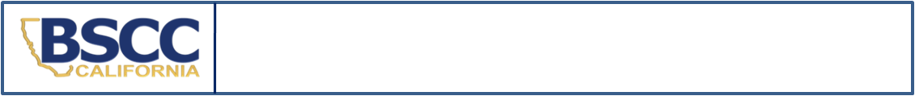
California Board of State and Community Corrections
2022 Status Offender and Non Offender Detention Report

- SEND IN A SEPARATE REPORT FOR EACH STATUS OFFENDER OR NON OFFENDER HELD IN DETENTION.
- SUBMIT REPORT BY THE 10TH OF THE MONTH FOLLOWING STATUS OFFENDER’S OR NON OFFENDER’S RELEASE.
SECTION A. Facility Information
Facility Name:
County:
SECTION B. Youth Information
Youth’s Name: | Gender: M F | Youth’s County ID#:
Intake Date (m/d/yy): | Intake Time (Please indicate if this time is AM or PM):
Detention Hearing Date (m/d/yy):  Indicate N/A if not applicable. | Detention Hearing Time:  (Please indicate if this time is AM or PM)
Release Date (m/d/yy): | Release Time (Please indicate if this time is AM or PM):
TOTAL TIME IN SECURE DETENTION:
Less than 24 Hours 24 Hours or More
SECTION C. Offense Information
Please Check Reason for Detention Below  Indicate Pre- or Post-Disposition at Right | Disposition  (CHECK ONLY ONE)
 | Pre-Disposition | Post-Disposition
Runaway
Indicate Residency: CA Resident Out-of-State Resident (Interstate Compact Filed? YES NO )
Truancy
Curfew
Beyond Control of Parents
Possession of Alcohol - B&P Code 25662(a)
Bench Warrant
Committed to Juvenile Hall (Found in Contempt of Court)  Court Date Court Time  **Attach a copy of the Minute Order specifying terms AND the Valid Court Order Checklist. Please submit separate form for each admission if youth is committed to several weekends. | N/A
Non Offender (indicate below which type of hold applies):
WIC §300 Dependent / Material Witness
SECTION D. Reporting Information
Name and Title of Reporting Person: | Phone: | Date:
Name and Title of Reporting Person: | E-Mail:
Name and Title of Facility Manager: | Phone: | Date:
Name and Title of Facility Manager: | E-Mail:

Submit completed form: |  | This form may be downloaded at https://www.bscc.ca.gov/s_fsoservices/  in the Youth in Juvenile Detention Facilities section
email: | analyst@bscc.ca.gov
mail: | Board of State and Community Corrections
 | ATTN: FSO Report Analyst
 | 2590 Venture Oaks Way, Suite 200 | Questions? Email or call
 | Sacramento, CA 95833 | analyst@bscc.ca.gov or (916) 323-8621

