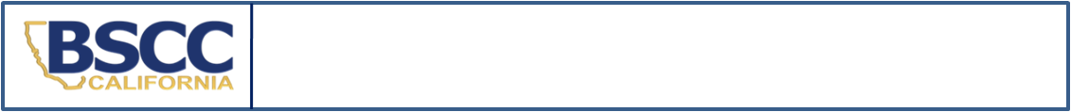
California Board of State and Community Corrections
Detention of Non-Delinquents in Juvenile Detention Facilities
2022 Calendar Year Annual Survey

THIS IS A ONCE PER CALENDAR YEAR SURVEY AND IS DUE BY February 28, 2022
PLEASE COMPLETE ALL SECTIONS
SECTION I. Facility Information
Facility Name:
County:
Type of Facility: | Juvenile Hall Camp Special Purpose Juvenile Hall SYTF
SECTION II. Status Offenders
PLEASE CHECK THE APPROPRIATE BOX FOR YOUR FACILITY:
YES* | NO | Please check “Yes” or “No” for the following question regarding status offenders as defined in Section 601, WIC:
This facility may hold status offenders, as defined in Section 601 WIC or
non offenders during the calendar year 2022.
*If YES, please submit, upon the individual’s release, a Status Offender and Non Offender Detention Report to the Board of State and Community Corrections (BSCC) for each status offender or non offender held. If a youth is detained for subsequent weekends, please submit a separate report for each detention period. Please notify the BSCC if your facility changes how it will handle status offenders during the 2022 calendar year.
If you are not sure that you will be holding status offenders or non offenders, but the potential exists, please indicate YES above. When such an individual is released, please submit a Status Offender and Non Offender Detention Report.

SECTION III. Federal Youth
PLEASE CHECK THE APPROPRIATE BOX FOR YOUR FACILITY:
YES* | NO | Please check the appropriate box for the following questions regarding youth held for the Federal Government:
 |  | This facility may hold Federal Youth during the calendar year of 2022.
*If YES, please submit, upon the individual’s release, a Federal Youth Detention Report to the BSCC for each “Federal Government hold” youth. Please notify the BSCC if your facility changes how it will handle federal youth during the 2022 calendar year.
If you are not sure that you will be holding federal youth, but the potential exists, please indicate YES above. When a federal youth is released, please submit a Federal Youth Detention Report.

SECTION IV. Contact Information
PLEASE COMPLETE ALL OF THE FOLLOWING INFORMATION
Name and Title of Reporting Person | Phone: | Date:
 | E-Mail:
Name and Title of Facility Administrator | Phone: | Date:
 | E-Mail:

Submit completed form: |  | This form may be downloaded at https://www.bscc.ca.gov/s_fsoservices/  in the Youth in Juvenile Detention Facilities section
email: | analyst@bscc.ca.gov
mail: | Board of State and Community Corrections
 | ATTN: FSO Report Analyst
 | 2590 Venture Oaks Way, Suite 200
 | Sacramento, CA 95833
Questions?
Contact Status Offender and Federal Youth Analyst at analyst@bscc.ca.gov or (916) 323-8621

