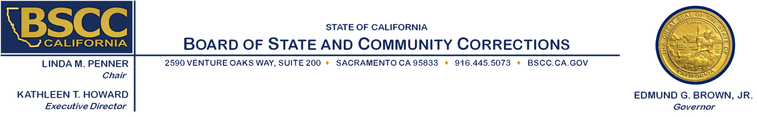

Strengthening Law Enforcement and Community Relations Grant

Executive Steering Committee

**Thursday, June 2, 2016**

**9:30 a.m. to 5:00 p.m.**

2590 Venture Oaks Way

Sacramento, CA 95833

**Review of Scores and Development of Funding Recommendations**

**Agenda Items** **Approximate Times**

1. Welcome and Introductions 9:30 am - 9:45 am
2. Rating Process Overview 9:45 am -10:00 am
3. Review of Proposal Scores and Recommendations 10:00 am - 4:45 pm

***Working Lunch***

1. Public Comment 4:45 pm - 5:00 pm
2. Adjourn 5:00 pm

***Note:*** *Agenda items may be taken out of order.*

**Meeting Contact Information:**

Please contact Ricardo Goodridge at (916) 341-5160 or [Ricardo.Goodridge@bscc.ca.gov](mailto:Ricardo.Goodridge@bscc.ca.gov) for additional information about this notice, to submit written material regarding an agenda item or to request special accommodations for persons with disabilities. This agenda and additional information about the Board of State and Community Corrections may be found on our website at [www.bscc.ca.gov](http://www.bscc.ca.gov).