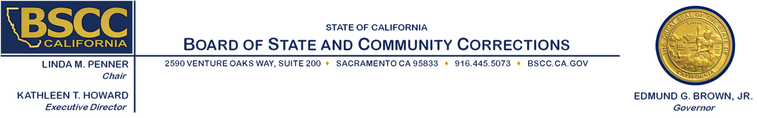

Strengthening Law Enforcement and Community Relations

Executive Steering Committee (ESC) Meeting

Thursday, December 17, 2015

9:30 a.m. to 5:00 p.m.

2590 Venture Oaks Way

Sacramento, CA 95833

**Agenda Items** **Approximate Times**

1. Welcome and Introductions 9:30 am – 9:35 am
2. November 9-10, 2015 Meeting Recap 9:35 am – 9:45 am
3. Develop Framework for the Request for Proposals (RFP) 9:45 am – 11:30 am

**Working Lunch**

1. Rating Criteria and Factors 11:30 am – 4:30 pm

1. Future ESC Meetings 4:30 pm – 4:40 pm
2. Recap 4:40 pm – 4:50 pm
3. Public Comment 4:50 pm – 5:00 pm
4. Adjourn 5:00 pm

**Note:** There will be an opportunity for public comment prior to any action taken by the committee. Agenda items may be taken out of order.

**Meeting Contact Information**:

Please contact Ricardo Goodridge at (916) 341-5160 or [Ricardo.Goodridge@bscc.ca.gov](mailto:Ricardo.Goodridge@bscc.ca.gov) for additional information about this notice, to submit written material regarding an agenda item or to request special accommodations for persons with disabilities. This agenda and additional information about the Board of State and Community Corrections may be found on our website at [www.bscc.ca.gov](http://www.bscc.ca.gov).