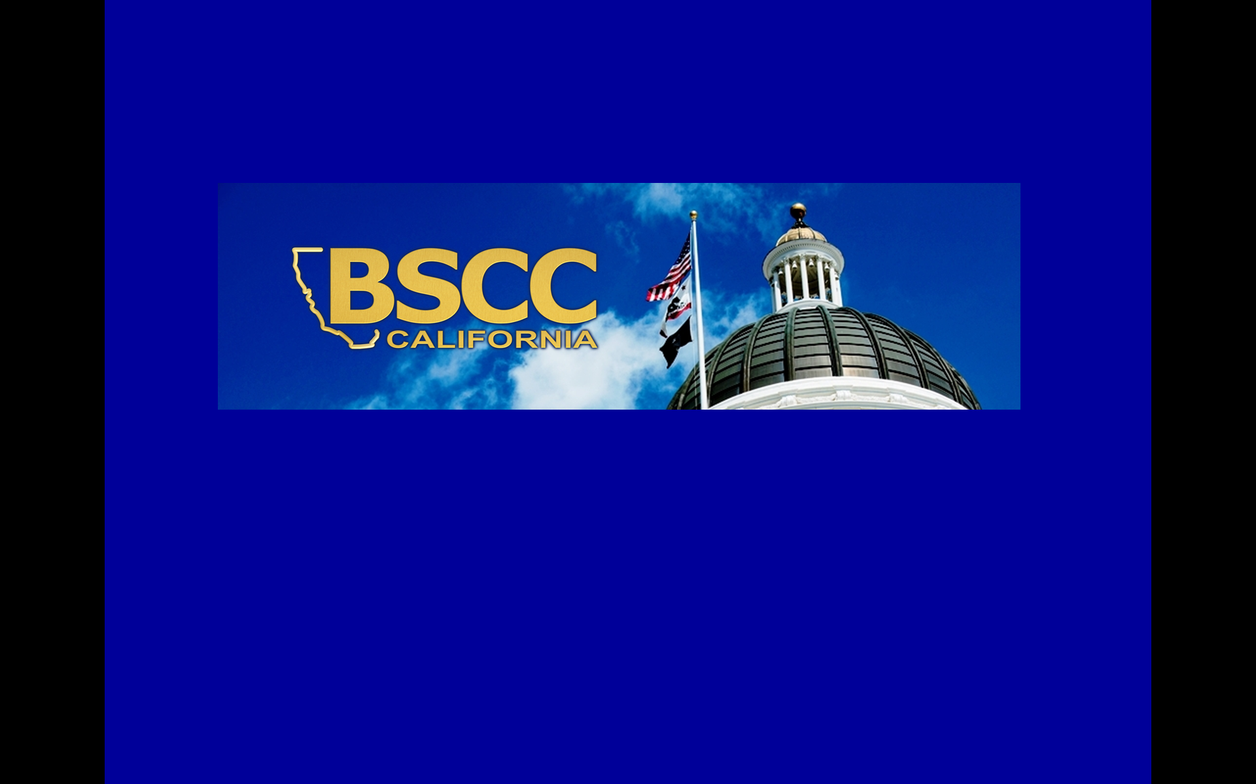
FOR IMMEDIATE RELEASE  July 7, 2015 | CONTACT: Joyce Carroll, 916.323.6152  joyce.carroll@bscc.ca.gov
Registration Opens for Social Innovation Bond Workshops
SACRAMENTO – Registration has begun for three statewide workshops the Board of State and Community Corrections will hold to provide information about a new “pay for success” grant that leverages private investment in recidivism reduction programs.
The Social Innovation Bond workshops will be held July 21 in Sacramento, July 22 in Fresno and July 23 in Santa Ana. To register please click here.
The Social Innovation Financing Program requires investors, local government agencies and service providers to agree on outcome goals for specific programs. Repayment on the private investment is based on reaching those targets.
This program to deliver offender services in California is the result of Assembly Bill 1837, which provided $5 million for a competitive bid process. The BSCC will select three counties to receive grant funding of not less than $500,000 and not more than $2 million. Counties are required to provide a 100 percent match.
Local government agencies and project partners will enter into a multi-year contract that defines outcomes, evaluation methods and repayment terms based on achieving desired goals. The first SIB in the United States was in 2012 at Rikers Island in New York City, where Goldman Sachs made a $9.6 million loan to support therapeutic services to incarcerated teens. The loan will be repaid based on savings the NYC Department of Corrections will realize by an expected drop in recidivism.
The workshops will include a panel of experts on Social Innovation Bonds who can explain how they work. The BSCC will also have available experts who can talk with participants about project ideas.
For more information contact Joyce Carroll at 916-323-6152 or joyce.carroll@bscc.ca.gov.

###

