<http://www.bscc.ca.gov/index.php> (under Recent News)

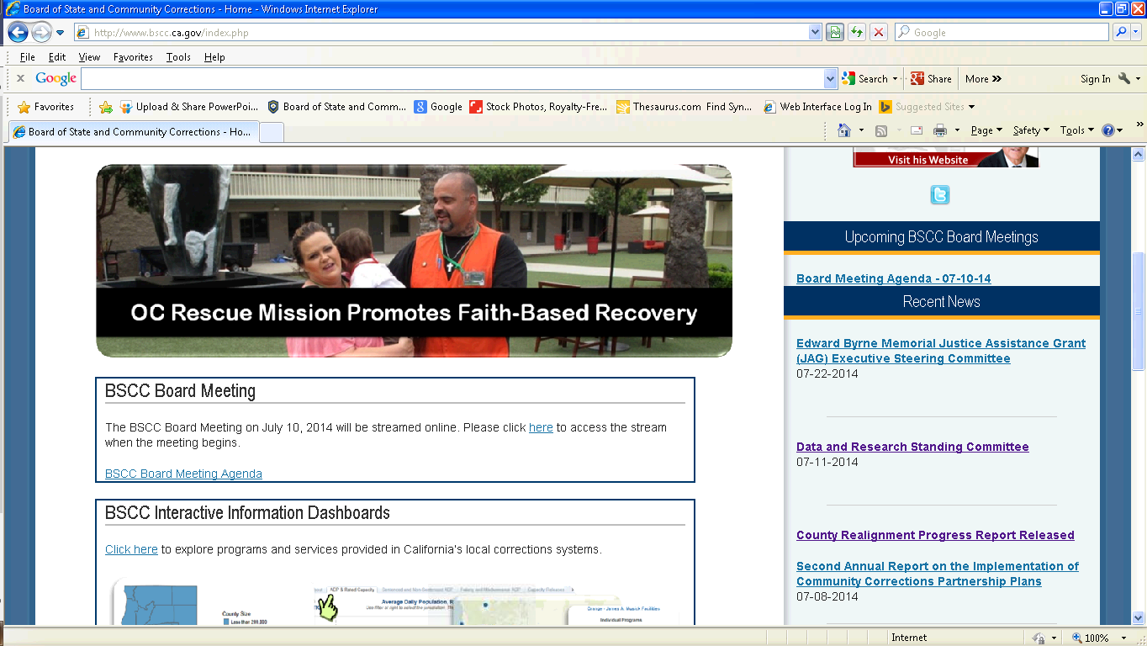

Please add to Recent News Section:

Reducing Racial and Ethnic Disparity Subcommittee Meeting

July 22 & 23, 2014

*\*see language below for webpage and attachment for pdf agenda*

7-22-14 & 7-23-14

Tuesday, July 22, 2014, 9:00 A.M.

Wednesday, July 23, 2014, 9:00 A.M.

Board of State and Community Corrections Conference Room

660 Bercut Drive, Sacramento, CA 95811

AGENDA – PDF

Meeting Called to Order (7.22.14):

1. Welcome and Introductions (Information)
2. Chair Updates (Information)
3. Rater Training (Information)

Meeting Called to Order (7.23.14):

1. Welcome (Information)
2. Discuss 2014-15 R.E.D. Goals and Objectives (Information)
3. Development of funding recommendations for R.E.D. Grant (Discussion)