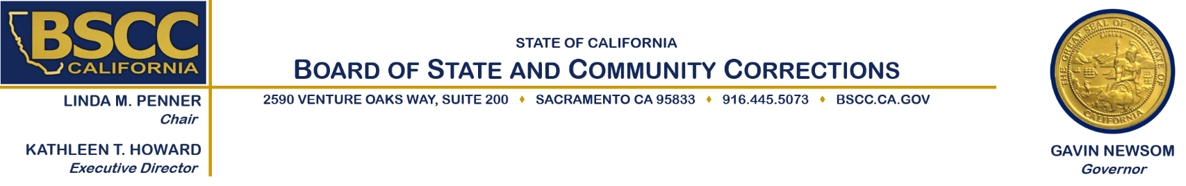

NOTICE OF FUNDING AVAILABILITY
AND
RELEASE OF REQUEST FOR PROPOSALS

DATE: April 13, 2023

TO: Nonprofit Nongovernmental Organizations, and Federally Recognized Indian Tribes.

FROM: Kathleen T. Howard, Executive Director

SUBJECT: AVAILABILITY OF FUNDING FOR THE TITLE II GRANT PROGRAM - TRIBAL

The Board of State and Community Corrections (BSCC) and the State Advisory Committee on Juvenile Justice and Delinquency Prevention (SACJJDP) are announcing the release of the Title II Grant Program Request for Proposals (RFP).

The Juvenile Justice and Delinquency Prevention Act (JJDPA) is the federal statute that establishes the Title II Grant Program. The U.S. Office of Juvenile Justice and Delinquency Prevention (OJJDP) administers the grant, in part, by awarding grants to states to support delinquency prevention and juvenile justice system improvements. The target population for the Title II Grant Program Tribal Request for Proposals (RFP) is Tribal people who are at-risk and/or have been under the jurisdiction of the juvenile justice system and are under the age of 26. The Title II Grant program will fund programs that address Aftercare/Reentry, Alternatives to Detention, Community-Based Programs and Services, Diversion, Job Training, and/or Mentoring, Counseling, and Training Programs.

Applicants for Title II Grant Program awards must be a Federally recognized Indian Tribe, or a nonprofit nongovernmental organization partnering with a Federally recognized Indian Tribe (See RFP for specific eligibility criteria). Indian Tribe grant recipient are required to pass-through a minimum of 70% of grant funding to at least one direct service provider. An Indian Tribe can satisfy the pass-through requirement if they directly provide services to participants. Nonprofit nongovernmental agencies are considered direct service providers.

Total funding for this Title II Grant Program Tribal RFP is $1,050,000 over the course of the grant term, which is October 1, 2023, through September 30, 2026. The maximum amount of funding available per grant is $350,000 annually.

Proposals must be received by the BSCC by 5:00 p.m. on June 9, 2023. A copy of the RFP is available on the BSCC at http://www.bscc.ca.gov/s_titleiigrant

The BSCC staff cannot assist the applicant or its partners with the actual preparation of the proposal. Any technical questions concerning the RFP, the proposal process, or programmatic issues must be submitted by email to: jj_grants@bscc.ca.gov

