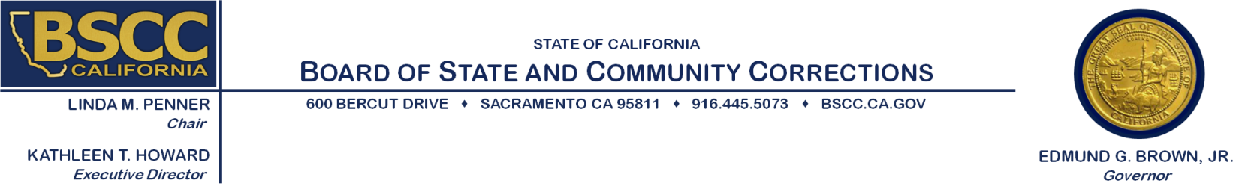

DATE: April 24, 2015

TO: City Managers and County Administrative Officers
Chief Probation Officers of California (CPOC)
Current JABG Project Directors and Financial Officers

FROM: Kathleen T. Howard
Executive Director
Board of State and Community Corrections

SUBJECT: JUVENILE ACCOUNTABILITY BLOCK GRANT (JABG) – NOTICE OF
FUNDING AVAILABILITY (NOFA) AND RELEASE OF REQUEST FOR APPLICATION (RFA) FOR FISCAL YEAR (FY) 2015/16

The Board of State and Community Corrections (BSCC) is pleased to announce the FY 2015/16 federal JABG funding for those jurisdictions that are eligible to receive a direct allocation. It should be noted that in 2013, the Office of Juvenile Justice and Delinquency Prevention discontinued federal funding of the JABG program. The BSCC has continued to fund local jurisdictions that met the FY 2013/14 threshold for receiving a direct allocation for the last several years with a reserve of JABG funding from previous year allocations. The balance of this reserve will fund current JABG recipients for the project period of July 1, 2015 to June 30, 2016. Continued and/or reinstated funding will be dependent upon the outcome of future federal appropriations.
Please see the table below for a list of those jurisdictions that are eligible to apply for a direct allocation. Attached to this letter is the FY 2015/16 application packet. The application packet can also be accessed from the BSCC website at http://www.bscc.ca.gov/.
The FY 2015/16 application will be similar in format to that of last year’s application document. The funding cycle for this program is a 12-month period beginning July 1, 2015 and ending
June 30, 2016.
As in previous years, a qualifying unit of local government may waive its right to a direct subgrant award and request that the funds be awarded to, and expended for its benefit by, a larger or contiguous unit of local government.
California’s State Advisory Committee on Juvenile Justice and Delinquency Prevention (SACJJDP), which oversees the use of federal funds administered by the BSCC, identified three priority areas in its new three-year Strategic Plan (2013-2016) on which California is to focus its efforts. The three priority areas are: Reducing Racial and Ethnic Disparities (R.E.D.); (2) Evidence-Based Practices; and (3) a strategy to support efforts to develop and strengthen services, programs and policies that promote positive outcomes for youth, their families, and communities. The SACJJDP encourages JABG recipients to align the use of their direct allocation with the three priority areas that are identified in the SACJJDP’s Strategic Plan.
Should you have questions regarding this funding notice, please contact the JABG Coordinator, Colleen Stoner, at (916) 324-9385 or by email at colleen.stoner@bscc.ca.gov.

Attachment
(THE 2015/16 DIRECT ALLOCATIONS ARE BASED ON CALIFORNIA’S 2013/14 FEDERAL ALLOCATION)

LOCALITY | DIRECT ALLOCATION | DIRECT ALLOCATION WITH INCREASE | 10% CASH MATCH | TOTAL PROJECT COST
Alameda, County of | $38,492 | $83,681 | $9,298 | $92,979
Contra Costa, County of | $22,347 | $48,582 | $5,398 | $53,980
Fresno, County of | $19,674 | $42,771 | $4,752 | $47,523
Kern, County of | $22,000 | $47,827 | $5,314 | $53,141
Los Angeles, City of | $50,406 | $109,581 | $12,176 | $121,757
Los Angeles, County of | $251,425 | $546,592 | $60,732 | $607,324
Monterey, County of | $10,254 | $22,292 | $2,477 | $24,769
Oakland, City of | $12,774 | $27,770 | $3,086 | $30,856
Orange, County of | $61,461 | $133,615 | $14,846 | $148,461
Riverside, County of | $41,197 | $89,561 | $9,951 | $99,512
Sacramento, County of | $45,854 | $99,686 | $11,076 | $110,762
San Bernardino, County of | $40,405 | $87,839 | $9,760 | $97,599
San Diego, City of | $13,656 | $29,688 | $3,299 | $32,987
San Diego, County of | $66,929 | $145,502 | $16,167 | $161,669
San Francisco, City/County of | $35,987 | $78,235 | $8,693 | $86,928
San Joaquin, County of | $16,808 | $36,540 | $4,060 | $40,600
San Mateo, County of | $18,558 | $40,345 | $4,483 | $44,828
Santa Barbara, County of | $12,701 | $27,612 | $3,068 | $30,680
Santa Clara, County of | $49,715 | $108,079 | $12,009 | $120,088
Sonoma, County of | $15,540 | $33,784 | $3,754 | $37,538
Stanislaus, County of | $11,021 | $23,959 | $2,662 | $26,621
Tulare, County of | $10,679 | $23,216 | $2,580 | $25,796
Ventura, County of | $22,872 | $49,723 | $5,525 | $55,248
TOTALS | $890,755 | $1,936,480 | $215,166 | $2,151,646

