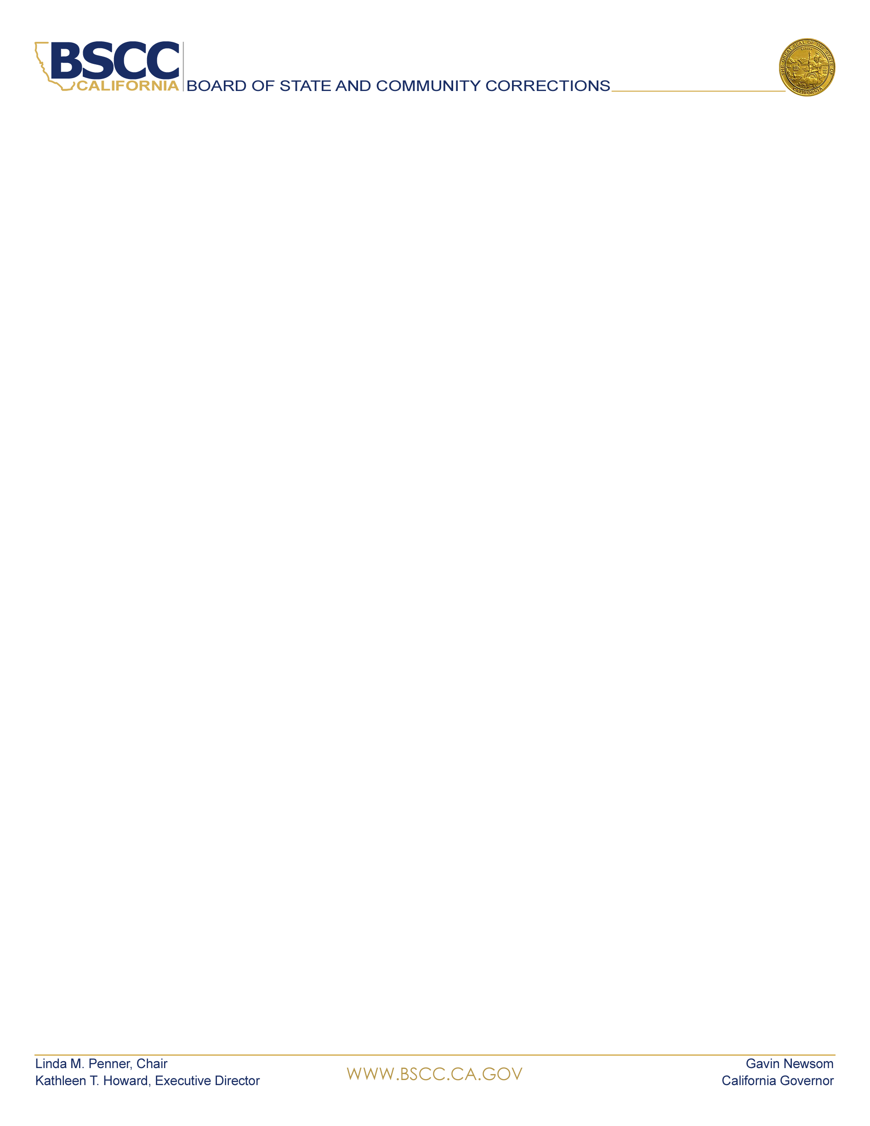  KATHLEEN T. HOWARD  Executive Director, BSCC  BOARD MEMBERS  LINDA M. PENNER  Chair, BSCC  KATHLEEN ALLISON  Secretary, CDCR  GUILLERMO VIERA ROSA  Director, Adult Parole Operations, CDCR  DEAN GROWDON  Sheriff, Lassen County  SHANNON D. DICUS  Sheriff  San Bernardino County  CINDY CHAVEZ  Supervisor  Santa Clara County  KIRK HAYNES  Chief Probation Officer  Fresno County  KELLY M. VERNON  Chief Probation Officer  Kings County  JANET GAARD  Retired Judge  Yolo County  ANDREW MILLS  Chief of Police  City of Palm Springs  SCOTT BUDNICK  Founder  Anti-Recidivism Coalition  Film Producer  MIGUEL GARCIA  State Youth Justice Specialist  Anti-Recidivism Coalition  NORMA CUMPIAN  Associate Director  Anti-Recidivism Coalition  Women’s and Non-Binary Services | BOARD MEETING AGENDA  June 9, 2022 – 10:00 AM  2590 Venture Oaks Way  Sacramento, California, 95833  Board Room  County of Santa Clara  70 West Hedding Street,  1st Floor, Room 157  San Jose, CA 95110  Masking and social distancing are strongly recommended, but not required, for those participating in-person  Remote Public Participants:  To request to speak on an agenda item during the Board meeting, please email publiccomment@bscc.ca.gov  Please state in the subject line on which item you would like to speak  To submit written public comment on an agenda item, please email publiccomment@bscc.ca.gov  Routine items are heard on the consent calendar. All consent items are approved after one motion unless a Board member asks for discussion or separate action on any item. Anyone may ask to be heard on any item on the consent calendar prior to the Board’s vote. Members of the public will be given the opportunity to give public comment during the Board’s discussion of each item. There is a two-minute time limit on public comment unless otherwise directed by the Board Chair.  - Call Meeting to Order  - Information Items  - Chair’s Report  - Executive Director’s Report  - COVID-19 Update  - Legal Update  - Legislative Update  - Update on Survey Regarding Mental Health Screen at Intake in Local Detention Facilities  - Action: Consent Items  - Minutes from the April 7, 2022 Board Meeting: Requesting Approval  - California Violence Intervention and Prevention Program (CalVIP) – Service Contract to Convene Cohort IV Grantees: Requesting Approval  - Action: Discussion Items  - California Violence Intervention and Prevention Grant Program (CalVIP) - Cohort IV Funding Recommendations: Requesting Approval  - California Violence Intervention and Prevention Grant Program - Reallocation of Remaining Cohort IV Funds and Re-Release of Request for Proposals: Requesting Approval  - Extension of the Existing Title II Grant Agreements covering December 1, 2019 to November 30, 2022, and Approval of a new Request for Proposals for January 1, 2023 to March 31, 2026: Requesting Approval  - Reinspection of Los Angeles County Juvenile Hall – Determination of Suitability – (Welf. & Inst. Code, § 209, subd. (a)(4) & (d))  - Barry J. Nidorf Juvenile Hall, Los Angeles County  Requesting Approval  - Local Detention Facilities Inspection Update: Information Only  - Public Comments  Public comment about any agenda items may be heard at this time.  - Adjourn  Next Board Meeting: July 14, 2022  Teleconference and Zoom Participation  Instructions for attendance appear on the last page of this agenda  Instructions for Attending Zoom / Teleconference Board Meeting  Use Zoom to both view and hear the Board meeting. Join by phone for audio only. If you do not have Zoom, download to your device before the meeting.  Via Zoom:  Join from a PC, Mac, iPad, iPhone or Android device:  Please click this URL to join:  June 9, 2022 Board Meeting  Or One tap mobile:  +16699009128,,84057681535# US (San Jose)  +13462487799,,84057681535# US (Houston)  Or join by phone:  Dial(for higher quality, dial a number based on your current location):  US: +1 669 900 9128 or +1 346 248 7799 or +1 253 215 8782 or +1 646 558 8656 or +1 301 715 8592 or +1 312 626 6799  Webinar ID: 840 5768 1535  International numbers available  For additional information about this notice, agenda, to request notice of public meetings, to submit written material regarding an agenda item, or to request special accommodations for persons with disabilities, please contact Adam.Lwin@bscc.ca.gov or call (916) 324-2626.  For general information about the BSCC visit www.bscc.ca.gov, call (916) 445-5073 or write Board of State & Community Corrections, 2590 Venture Oaks Way, Ste 200, Sacramento CA 95833

