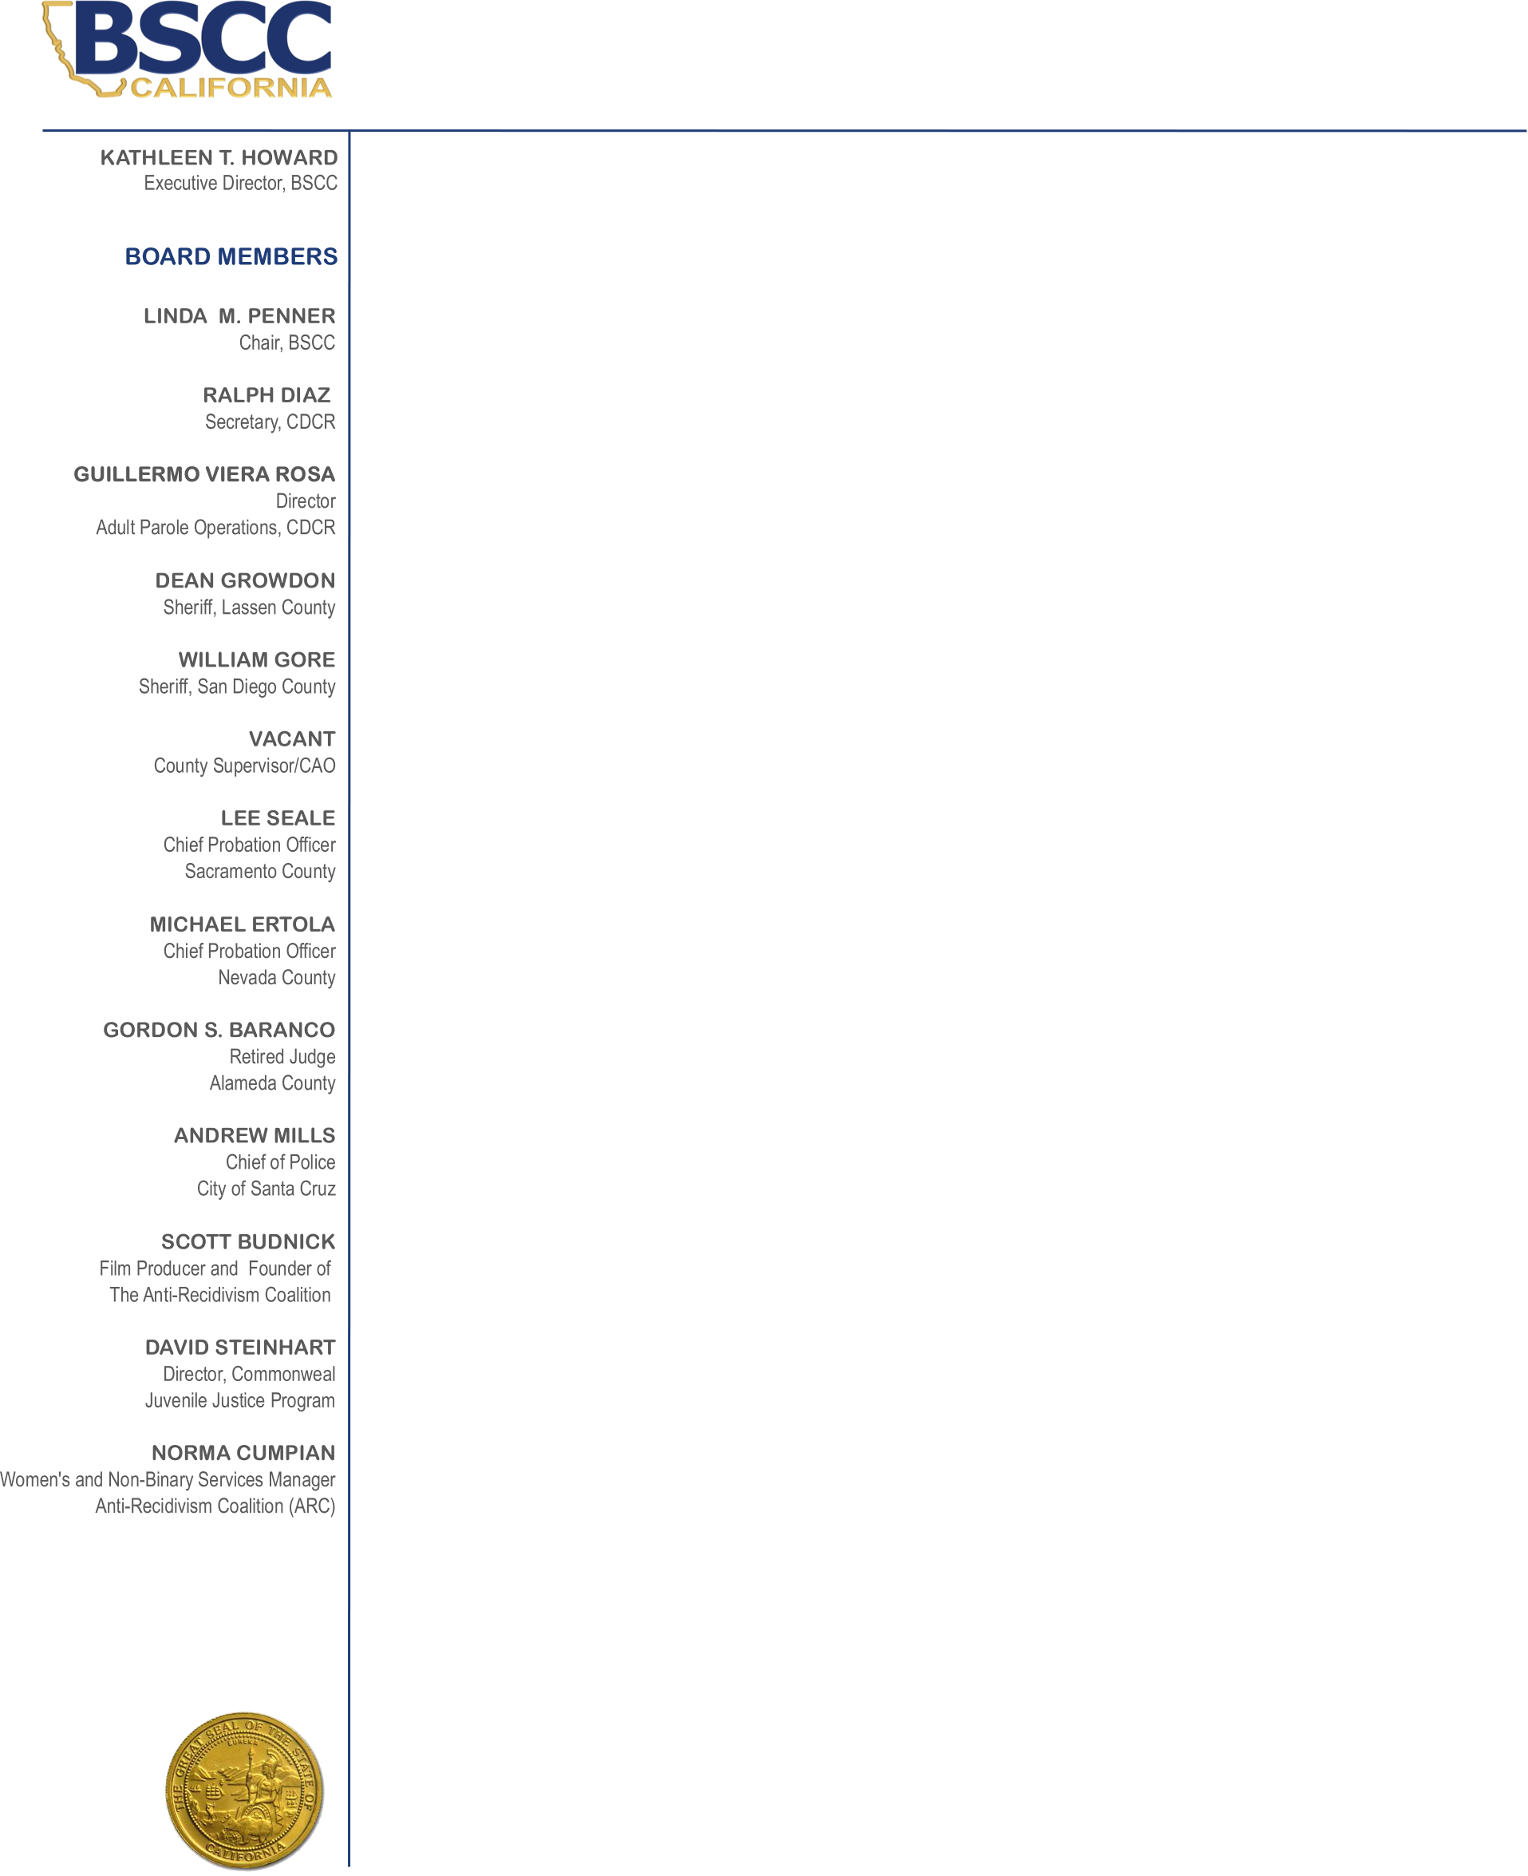
Emergency Board Meeting Agenda

Thursday, July 16, 2020
10:00 AM

TELECONFERENCE & ZOOM PARTICIPATION ONLY
Pursuant to Governor’s Executive Order N-29-20

Instructions for Attending ZOOM/Teleconference Board Meeting appear at the end of this agenda

Routine items are heard on the consent calendar. All consent items are approved after one motion unless a Board member asks for discussion or separate action on any item. Anyone may ask to be heard on any item on the consent calendar prior to the Board’s vote. Members of the public will be given the opportunity to give public comment during the Board’s discussion of each item. There is a two-minute time limit on public comment unless otherwise directed by the Board Chair.

- Call Meeting to Order

- Action: Discussion Items

- Finding of Emergency to waive 10-day notice requirement. (Gov. Code, § 11125.5.)
- Allocation of Coronavirus Emergency Supplemental Funding ($15 million) to the California Department of Corrections and Rehabilitation to provide reentry services and housing to individuals released from state prison due to COVID-19: Requesting Approval

- Public Comments

Public comment about any agenda item or any future agenda items may be heard at this time.

- Adjourn

Next Meeting:

Thursday, August 13, 2020 (Teleconference & Zoom)

Instructions for Attending ZOOM/Teleconference Board Meeting:
Please use this link to download the ZOOM application on to your device prior to the meeting:

Join Zoom Meeting:

https://us02web.zoom.us/j/81122614724?pwd=RWFyOTZ0RzhQR0ZSeWRHRlhCdzBOdz09

Meeting ID: 811 2261 4724
Password: 847417
One tap mobile
+16699009128,,81122614724# US (San Jose)
+12532158782,,81122614724# US (Tacoma)

Dial by your location
+1 669 900 9128 US (San Jose)
+1 253 215 8782 US (Tacoma)
+1 346 248 7799 US (Houston)
+1 312 626 6799 US (Chicago)
+1 646 558 8656 US (New York)
+1 301 715 8592 US (Germantown)
Meeting ID: 811 2261 4724
Find your local number: https://us02web.zoom.us/u/k37JPpgPW

