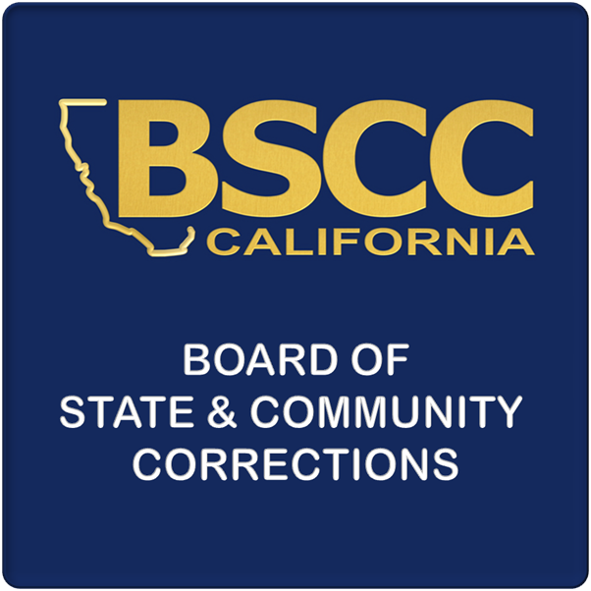
BOARD OF STATE AND JPCF PROGRAM
COMMUNITY CORRECTIONS CAMP ELIGIBILITY FORM

INSTRUCTIONS: Original signature is required. Completely fill out form (print or type) and return to: FSO Report Analyst, 600 Bercut Drive, Sacramento, CA 95811; Questions?
Phone: (916) 323-9704; Email: Camp@bscc.ca.gov; Fax: (916) 322-2461 or (916) 327-3317.

Camp Eligibility Form for Juvenile Probation and Camps Funding (JPCF) Program
effective July 1, 2013; valid until change in camp(s) status requires updating
A. AGENCY INFORMATION
AGENCY NAME | CHIEF PROBATION OFFICER |  | TELEPHONE NUMBER OF CHIEF PROBATION OFFICER
 |  |  | ( )
STREET ADDRESS | CITY |  | STATE | ZIP CODE
MAILING ADDRESS | CITY |  | STATE | ZIP CODE
B. CAMP ELIGIBILITY
Counties will receive an allocation for JPCF through the Enhanced Local Law Enforcement Services Account. The Juvenile Probation portion of this program is administered by the State Controller’s Office. The Camp Funding portion of this program is administered by the Board of State and Community Corrections (BSCC) and is based upon the county’s reported number of occupied camp bed days, not to exceed rated capacity as established by the BSCC.
A camp, for the purpose of allocating funds from subparagraph (C) of paragraph (2) of subdivision (b) of Section 18220 of the Welfare and Institutions Code (WIC), is defined by WIC Section 881:
881.The board of supervisors of any county may, by ordinance, establish juvenile ranches, camps, or forestry camps, within or without the county, to which persons made wards of the court on the ground of fitting the description in Section 602 may be committed. As far as possible, the provisions of this chapter relating to commitments to the probation officer shall apply to commitments to those juvenile facilities, except that where any ward proves to be unfit to remain in any facility, in the opinion of the superintendent or director thereof, the superintendent or director shall make a recommendation to the probation department for consideration for other commitment. Complete operation and authority for the administration shall be vested in the county.
Based on this definition, do you anticipate that your county will be eligible for a camp allocation in this fiscal year? Yes No

Does your county choose to participate in this program? Yes No

Name of Camp(s): | Rated Capacity |  | For BSCC Verification Only
Name of Camp(s): |  |  | Yes | Field Rep Initial
C. JPCF SERVICE CATEGORIES
Please list (or circle) which of the service(s) from the table below (pursuant to WIC §18221) will be provided, fully or in part, from the camp allocation (provide the number of the service(s) as designated in the statute):

Service Categories:
1. Educational advocacy & attendance monitoring |  | 13. Respite care
2. Mental health assessment & counseling |  | 14. Counseling, monitoring, & treatment
3. Home detention |  | 15. Gang intervention
4. Social responsibility training |  | 16. Sex & health education
5. Family mentoring |  | 17. Anger management, violence prevention, & conflict resolution
6. Parent peer support |  | 18. Aftercare services as juveniles transition back into the community & …...reintegrate into their families
7. Life skills counseling
8. Direct provision of, and referral to, prevocational & vocational training |  | 19. Information & referral regarding the availability of community services
9. Family crisis intervention |  | 20. Case management
10. Individual, family, & group counseling |  | 21. Therapeutic day treatment
11. Parenting skills development |  | 22. Transportation related to any of the services described in WIC §18221(b)
12. Drug & alcohol education |  | 23. Emergency & temporary shelter
D. ORIGINAL SIGNATURE OF CHIEF PROBATION OFFICER
Chief Probation Officer (original signature required) |  |  | Date

The Camp Eligibility Form does not expire each fiscal year, but must be updated as changes are made regarding the opening, closing, or change in rated capacity of a camp.

