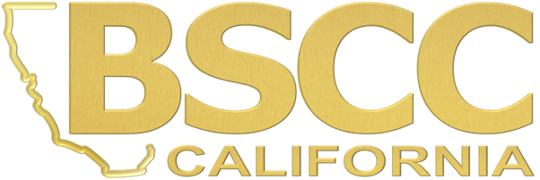

Agenda
Juvenile Justice Standing Committee
To be held at:
Board of State and Community Corrections
2590 Venture Oaks Way, Room 101
Sacramento, CA 95833

Website: www.bscc.ca.gov

Wednesday November 30, 2016
10:00 a.m. – 2:30 p.m.
Meeting Called to Order
Roll Call
- Welcome and Introductions
- Approval of the June 2016 Minutes
- Chair Report
- Review of Relevant 2016 California Legislation
- Title 15 Juvenile Facility Standards Revision: Executive Steering Committee (ESC) update and issues
- Status of Juvenile Detention Profile Survey data objectives and proposal to upgrade; and a discussion of implementation of AB 1998 race/ethnicity data recommendations
- Governor’s Public Safety Initiative - Prospective impact on transfers and facilities
- Continuum of Care (CCR) reform: AB 403 changes and impact on probation placements
- State Advisory Committee on Juvenile Justice & Delinquency Prevention – Status Report
- Next Steps, Next Meeting

PUBLIC COMMENT will be received prior to any action taken by the Committee and at the conclusion of the meeting prior to adjournment.

Please call 916.445-5073 for additional information about this notice, to submit written material regarding an agenda item, or to request special accommodations for persons with disabilities. This agenda and additional information about the Board of State and Community Corrections may be found on our website at www.bscc.ca.gov.

