http://www.bscc.ca.gov/board/announcements/#events-meetings

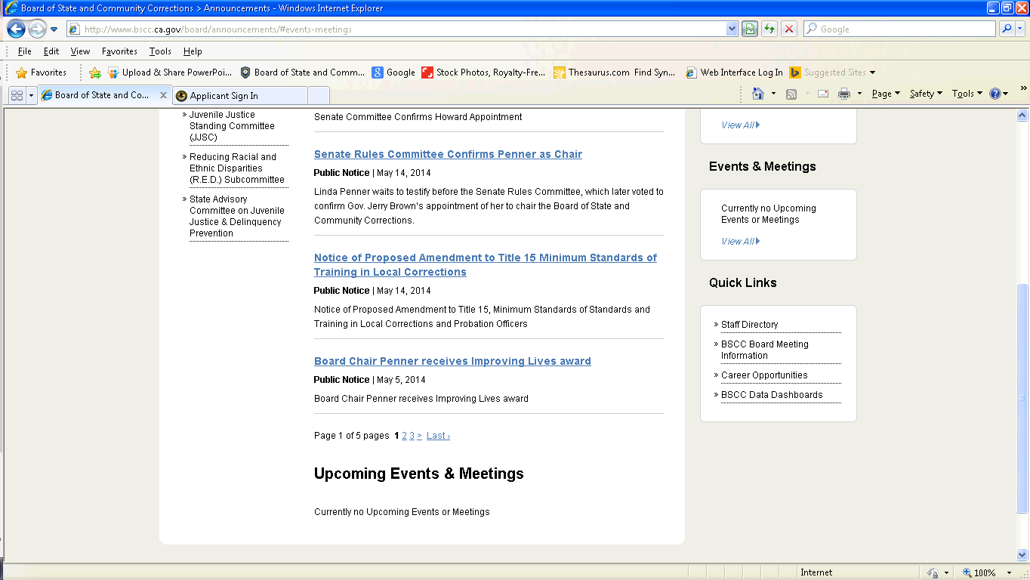

Please add the JAG ESC meeting to the Events & Meeting pages. See attached meeting request for dates/times/purpose/etc