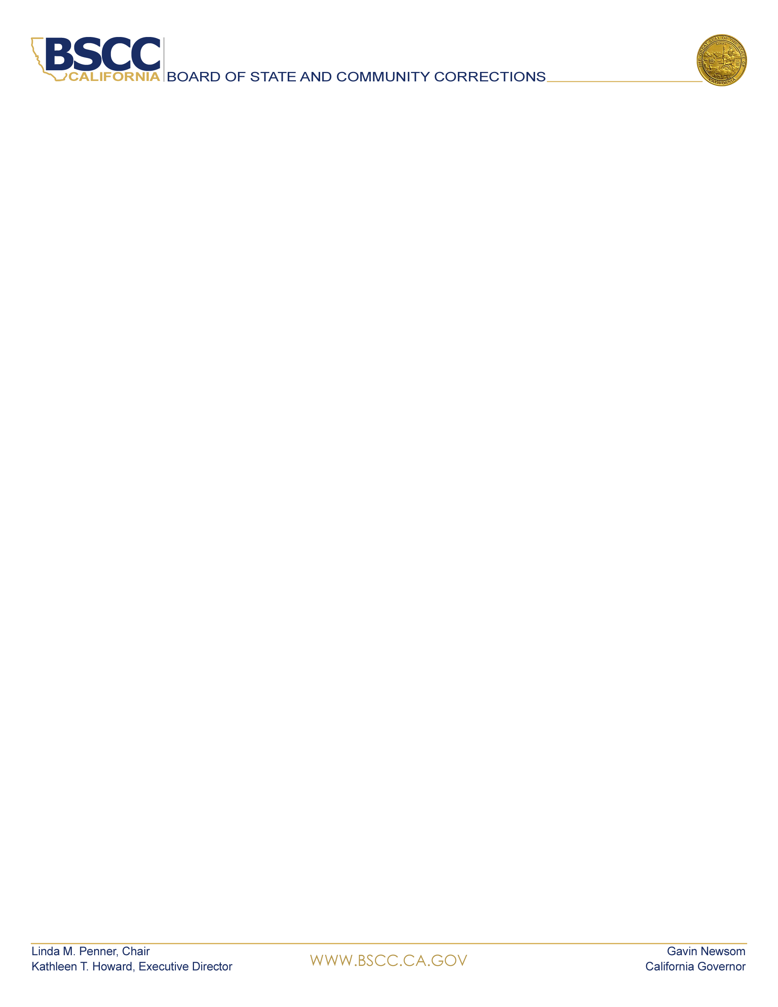  KATHLEEN T. HOWARD  Executive Director, BSCC  BOARD MEMBERS  LINDA M. PENNER  Chair, BSCC  KATHLEEN ALLISON  Secretary, CDCR  GUILLERMO VIERA ROSA  Director, Adult Parole Operations, CDCR  DEAN GROWDON  Sheriff, Lassen County  VACANT  Sheriff  CINDY CHAVEZ  Supervisor  Santa Clara County  KIRK HAYNES  Chief Probation Officer  Fresno County  KELLY M. VERNON  Chief Probation Officer  Kings County  JANET GAARD  Retired Judge  Yolo County  ANDREW MILLS  Chief of Police  City of Palm Springs  SCOTT BUDNICK  Founder, Anti-Recidivism Coalition, Film Producer  DAVID STEINHART  Director, Commonweal  Juvenile Justice Program  NORMA CUMPIAN  Associate Director  Anti-Recidivism Coalition  Women’s and Non-Binary Services | BOARD MEETING AGENDA  February 10, 2022  New Start Time: 9:00 a.m.  Teleconference and Zoom Participation Only  Instructions for attendance appear on the last page of this agenda  To request to speak on an agenda item during the Board meeting, please email publiccomment@bscc.ca.gov  Please state in the subject line on which item you would like to speak  To submit written public comment on an agenda item, please email publiccomment@bscc.ca.gov  Routine items are heard on the consent calendar. All consent items are approved after one motion unless a Board member asks for discussion or separate action on any item. Anyone may ask to be heard on any item on the consent calendar prior to the Board’s vote. Members of the public will be given the opportunity to give public comment during the Board’s discussion of each item. There is a two-minute time limit on public comment unless otherwise directed by the Board Chair.  - Call Meeting to Order  - Information Items  - Chair’s Report  - Executive Director’s Report  - COVID-19 Update  - Legal Update  - Legislative Update  - Action: Consent Items  - Minutes from the November 16, 2021 Board Meeting: Requesting Approval  - Senate Bill 844 (Adult Local Criminal Justice Facilities Construction - Contra Costa) Scope Change: Requesting Approval  - Extension of Public Defense Pilot Program Application Deadline: Requesting Approval  - Edward Byrne Justice Assistance Grant (JAG) No- Cost Six-Month Extension: Requesting Approval  - Action: Discussion Items  - Minimum Standards for Local Juvenile Detention Facilities, Title 15, and Title 24: Launch of the Regulation Revision Process, Solicitation of Community Input and Interest in Executive Steering Committee Membership: Requesting Approval  - Adult Reentry Grant Program, Cohort III Request for Proposal: Requesting Approval  - Proposition 47 Grant Program: Update on Demographic and Recidivism: Information Only  - Proposition 47 Grant Program, Cohort III Request for Proposal: Requesting Approval  - California Violence Intervention and Prevention Program (CalVIP) - Development of Service Contracts for Technical Assistance, Expanded Capacity, and Training for CalVIP Grants: Requesting Approval  - Board of State and Community Corrections 2022 – 2026 Strategic Plan: Requesting Approval  - Local Detention Facilities Inspection Update: Requesting Approval  - Public Comments  Public comment about any agenda items may be heard at this time.  - Adjourn  Next Board Meeting: April 7, 2022  Instructions for Attending Zoom / Teleconference Board Meeting  Use Zoom to both view and hear the Board meeting. Join by phone for audio only. If you do not have Zoom, download to your device before the meeting.  Webinar ID: 878 8503 8751  Join Zoom here: February 10, 2022 Board Meeting  Phone in: 1 (669) 900-9128  One-Tap Mobile: +16699009128, 87885038751#  For additional information about this notice, agenda, to request notice of public meetings, to submit written material regarding an agenda item, or to request special accommodations for persons with disabilities, please contact Adam.Lwin@bscc.ca.gov or call (916) 324-2626.  For general information about the BSCC visit www.bscc.ca.gov, call (916) 445-5073 or write Board of State & Community Corrections, 2590 Venture Oaks Way, Ste 200, Sacramento CA 95833

