FACT SHEET

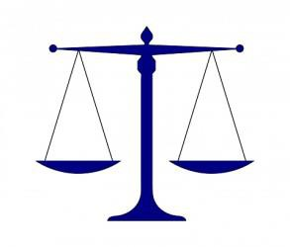
The JJDPA and Court Holding Facilities

Monitoring Authority

The Federal Juvenile Justice and Delinquency Prevention Act (JJDPA) and Welfare and Institutions Code (WIC) §209(f) require the Board of State and Community Corrections (BSCC) to monitor facilities that hold minors in detention for compliance with three core requirements.

Additionally, WIC
§210.2 requires the BSCC to survey law enforcement agencies regarding the processing of minors to ensure compliance with WIC §207.1(d).

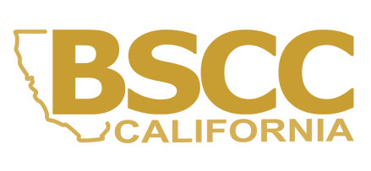
This document may be found under the “Youth in Detention Facilities” at: https://www.bscc.ca.gov/s_fsoservices/

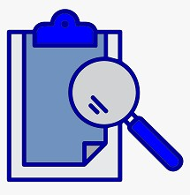
Questions?
Overview

The Federal Juvenile Justice and Delinquency Prevention Act (JJDPA)1 establishes three core protections for care and custody of minors. These protections are commonly referred to as the JJDPA core requirements:

- Deinstitutionalization of Status Offenders
Minors who are charged with only a status offense (WIC
§601) or who are nonoffenders (WIC §300) must not be held in secure detention.
- Separation
Minors held in secure detention must not come into sight or sound contact with adult offenders.
- Jail Removal
Delinquent minors (WIC §602) must not be held in secure detention for more than six (6) hours.
Note: The JJDPA requires that court holding facilities comply with the Separation and Jail Removal core requirements.
Compliance Monitoring Inspections

All court holding facilities identified through the Annual Survey of Court Holding Facilities may be subject to onsite verification.

Court holding facilities that detain or confine
both adults and minors in secure detention will be inspected triennially, or once every three years, per the JJDPA. Each time a minor is detained or confined for OVER six (6) hours, the 2024 Minors in Court Holding Detention Report must be completed and submitted to the BSCC. This will assist the BSCC with data collection and submission requirements.

All court holding facilities will remain subject to various state and local inspections as required.

Contact us at analyst@bscc.ca.gov or (916) 323-8621

¹ Pub. L. No. 93-415 (1974), 34 U.S.C. 5601. For more information on the JJDPA and compliance monitoring, please visit: https://www.ojjdp.gov/compliance/index.html.

