**Juvenile Accountability Block Grant 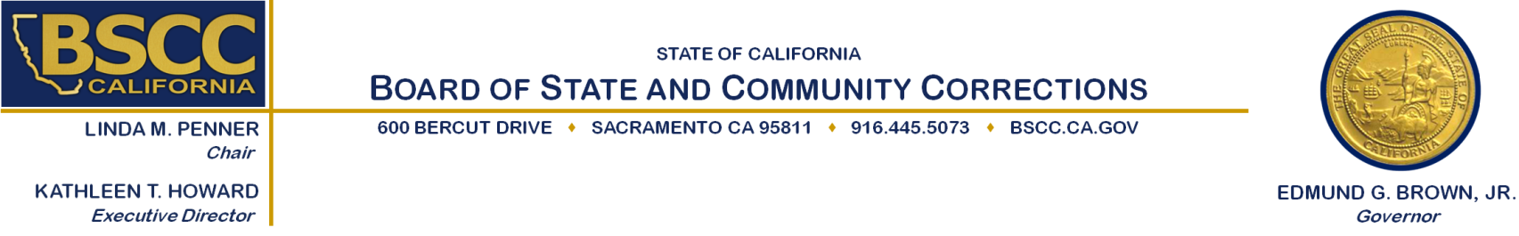Program (JABG)**

**Evidence-Based Practices (EBP) training Project**

**Executive Steering Committee**

**Rater Training**

Sierra Health Foundation

1321 Garden Hwy

Sacramento, CA 95833

Wednesday February 4, 2015

9:30 a.m. to 2:00 p.m.

**Agenda Items Approximate Times**

A. Meeting Called to Order: 9:30 a.m. – 9:45 a.m.

*Co-Chairs Sandra McBrayer and Chief Michelle Brown*

B. Overview of the Rating Process: 9:45 a.m. – 10:00 a.m.

*Colleen Stoner, BSCC Field Representative*

C. Rater Training for the Evaluations and Rating of the 10:00 a.m. – 1:30 p.m.

EBP Training Project Proposals: *Anthony Jackson, BSCC Research Program Specialist*

**-Working Lunch-**

D. Public Comment 1:30 p.m. – 1:45 p.m.

E. Adjourn 2: 00 p.m.



Please contact Colleen Stoner (916) 324-9385 or [colleen.stoner@bscc.ca.gov](mailto:colleen.stoner@bscc.ca.gov) for additional information about this notice, to submit written material regarding an agenda item or to request special accommodations for persons with disabilities. This agenda and additional information about the Board of State and Community Corrections may be found on our website at [www.bscc.ca.gov.](http://www.bscc.ca.gov)