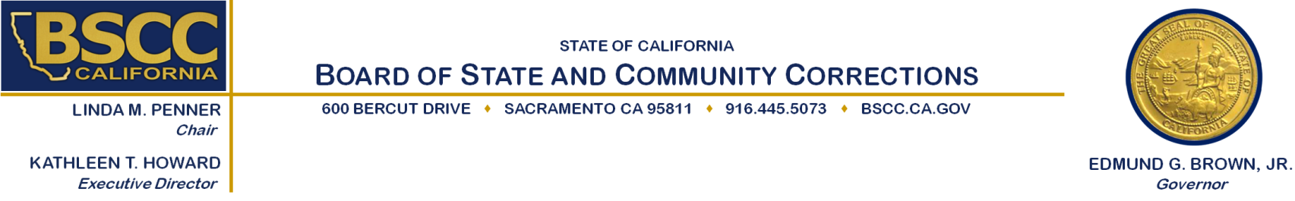**RESIDENTIAL SUBSTANCE ABUSE TREATMENT**

**(RSAT) PROGRAM**

**Executive Steering Committee**

Board of State and Community Corrections

2590 Venture Oaks Way

Sacramento, CA 95833



Tuesday May 19, 2015

10:00 am to 12:30 pm

**Agenda Items Approximate Times**

A. Welcome and Introductions 10:00 am – 10:15 am

B. Rating Review Process 10:15 am – 10:30 am

C. Review of Proposal Scores 10:30 am – 11:45 am

D. Funding Recommendations 11:45 am – 12:15 am

E. Public Comment 12:15 am – 12:30 am

F. Adjourn 12:30 pm

**Note: There will be an opportunity for public comment prior to any action taken by the committee. Agenda items may be taken out of order.**



Please contact Colleen Stoner (916) 324-9385 or [colleen.stoner@bscc.ca.gov](mailto:colleen.stoner@bscc.ca.gov) for additional information about this notice, to submit written material regarding an agenda item or to request special accommodations for persons with disabilities. This agenda and additional information about the Board of State and Community Corrections may be found on our website at [www.bscc.ca.gov.](http://www.bscc.ca.gov)