**Juvenile Accountability Block Grant 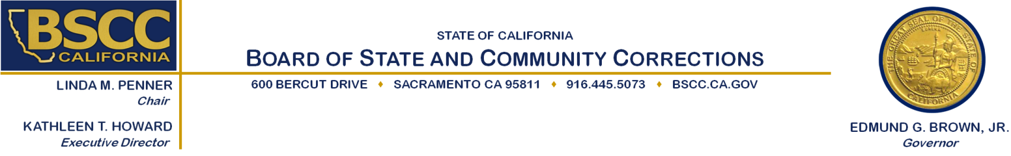Program (JABG)**

**Evidence-Based Practices (EBP) Training Project**

**Executive Steering Committee**

Sierra Health Foundation

Non-Profit Innovation Center

1331 Garden Hwy

Sacramento, CA 95833

Thursday, March 12, 2015

9:00 am to 11:30 am

**Agenda Items Approximate Times**

A. Welcome and Introductions 9:00 am – 9:15 am

B. Rating Review Process 9:15 am – 9:30 am

C. Review of Proposal Scores 9:30 am – 10:45 am

D. Funding Recommendations 10:45 am – 11:15 am

E. Public Comment 11:15 am – 11:30 am

F. Adjourn 11:30 am

**Note: There will be an opportunity for public comment prior to any action taken by the committee. Agenda items may be taken out of order.**

Please contact Colleen Stoner (916) 324-9385 or [colleen.stoner@bscc.ca.gov](mailto:colleen.stoner@bscc.ca.gov) for additional information about this notice, to submit written material regarding an agenda item or to request special accommodations for persons with disabilities. This agenda and additional information about the Board of State and Community Corrections may be found on our website at [www.bscc.ca.gov.](http://www.bscc.ca.gov/)