http://www.bscc.ca.gov/s_boardmeetingschedule,agendas,minutes.php

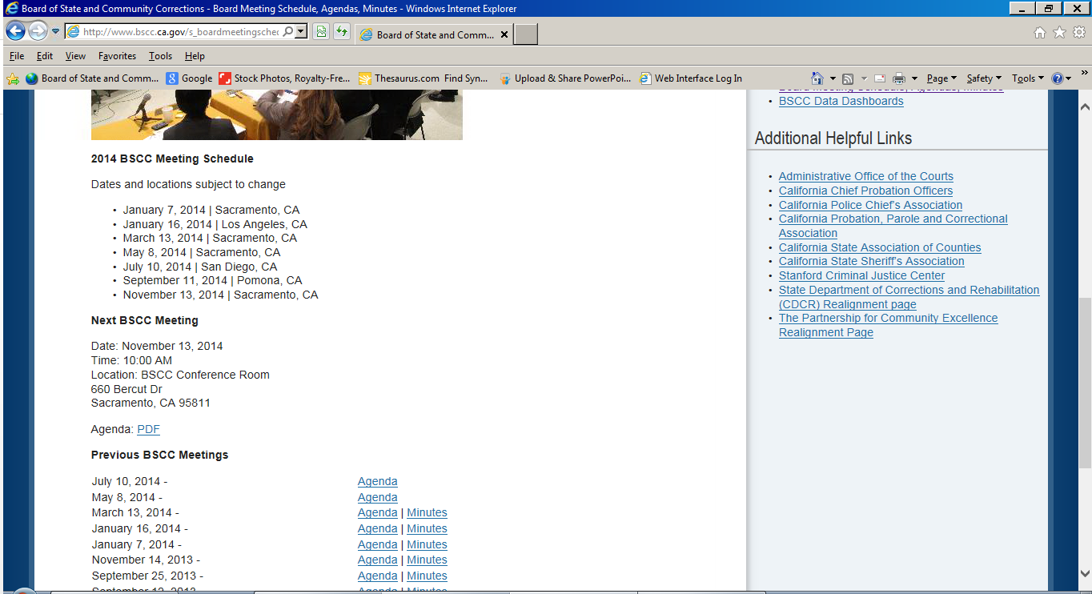

Please change header to:

**2015 BSCC Meeting Schedule**

*Delete current 2014 dates and replace with:*

* February 12, 2015 | Sacramento, CA
* April 9, 2015 | Sacramento, CA
* June 11, 2015 | San Francisco, CA
* September 17, 2015 | Los Angeles, CA
* November 12, 2015 | Sacramento, CA

2015 BSCC Meeting Schedule: PDF

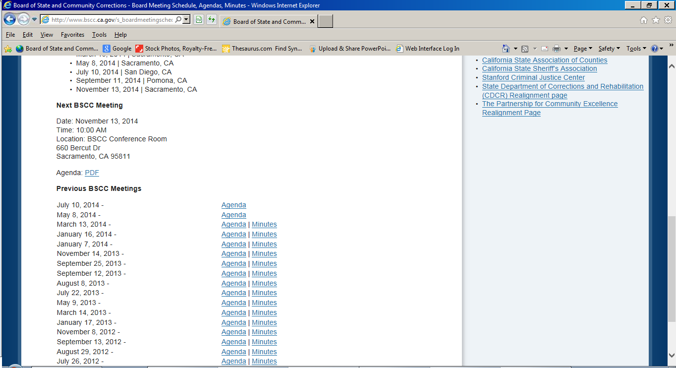

**Next BSCC Meeting**

Date: February 12, 2015

Time: 10:00 AM

Location: Sacramento, CA

Agenda: Agenda will be posted 10 days prior to the meeting date.

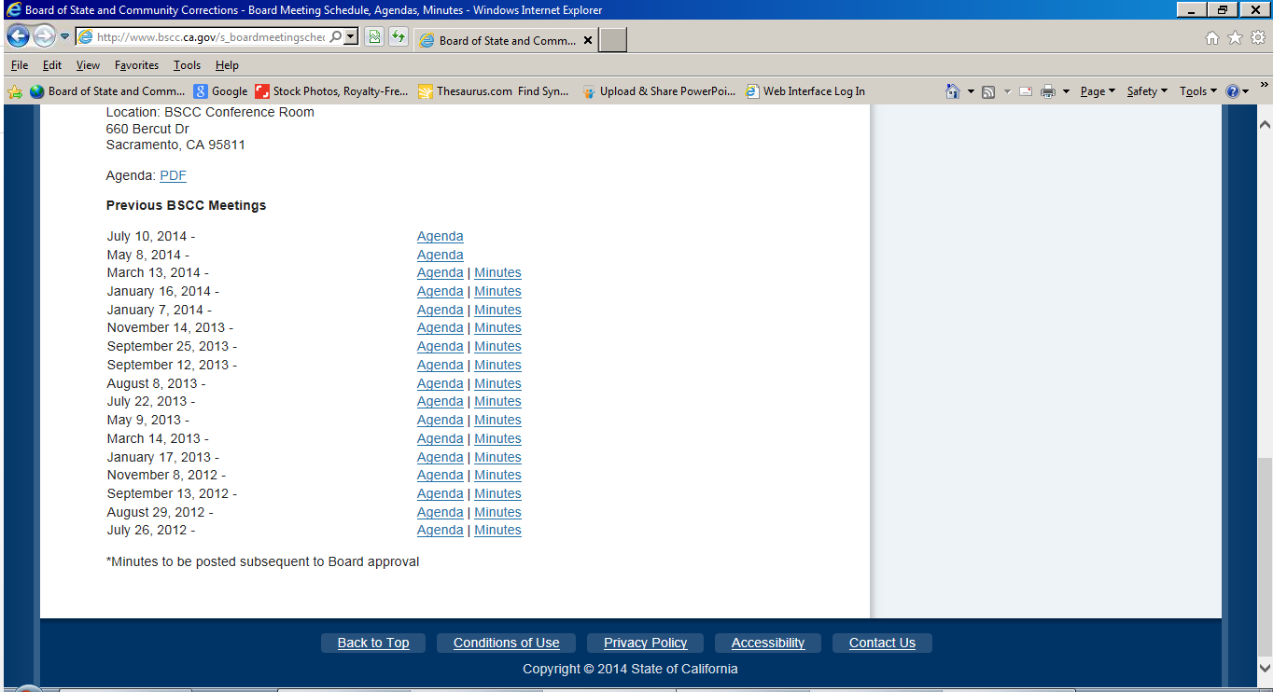

Please insert:

November 13, 2014 - Agenda |

September 11, 2014 - Agenda | Minutes

July 10, 2014 - Agenda | Minutes

May 8, 2014 - Agenda | Minutes

Minutes for May, July & Sept are attached to email request

Agenda for July meeting needs to be replaced with attached version

Agendas for Sept & Nov are attached to email request