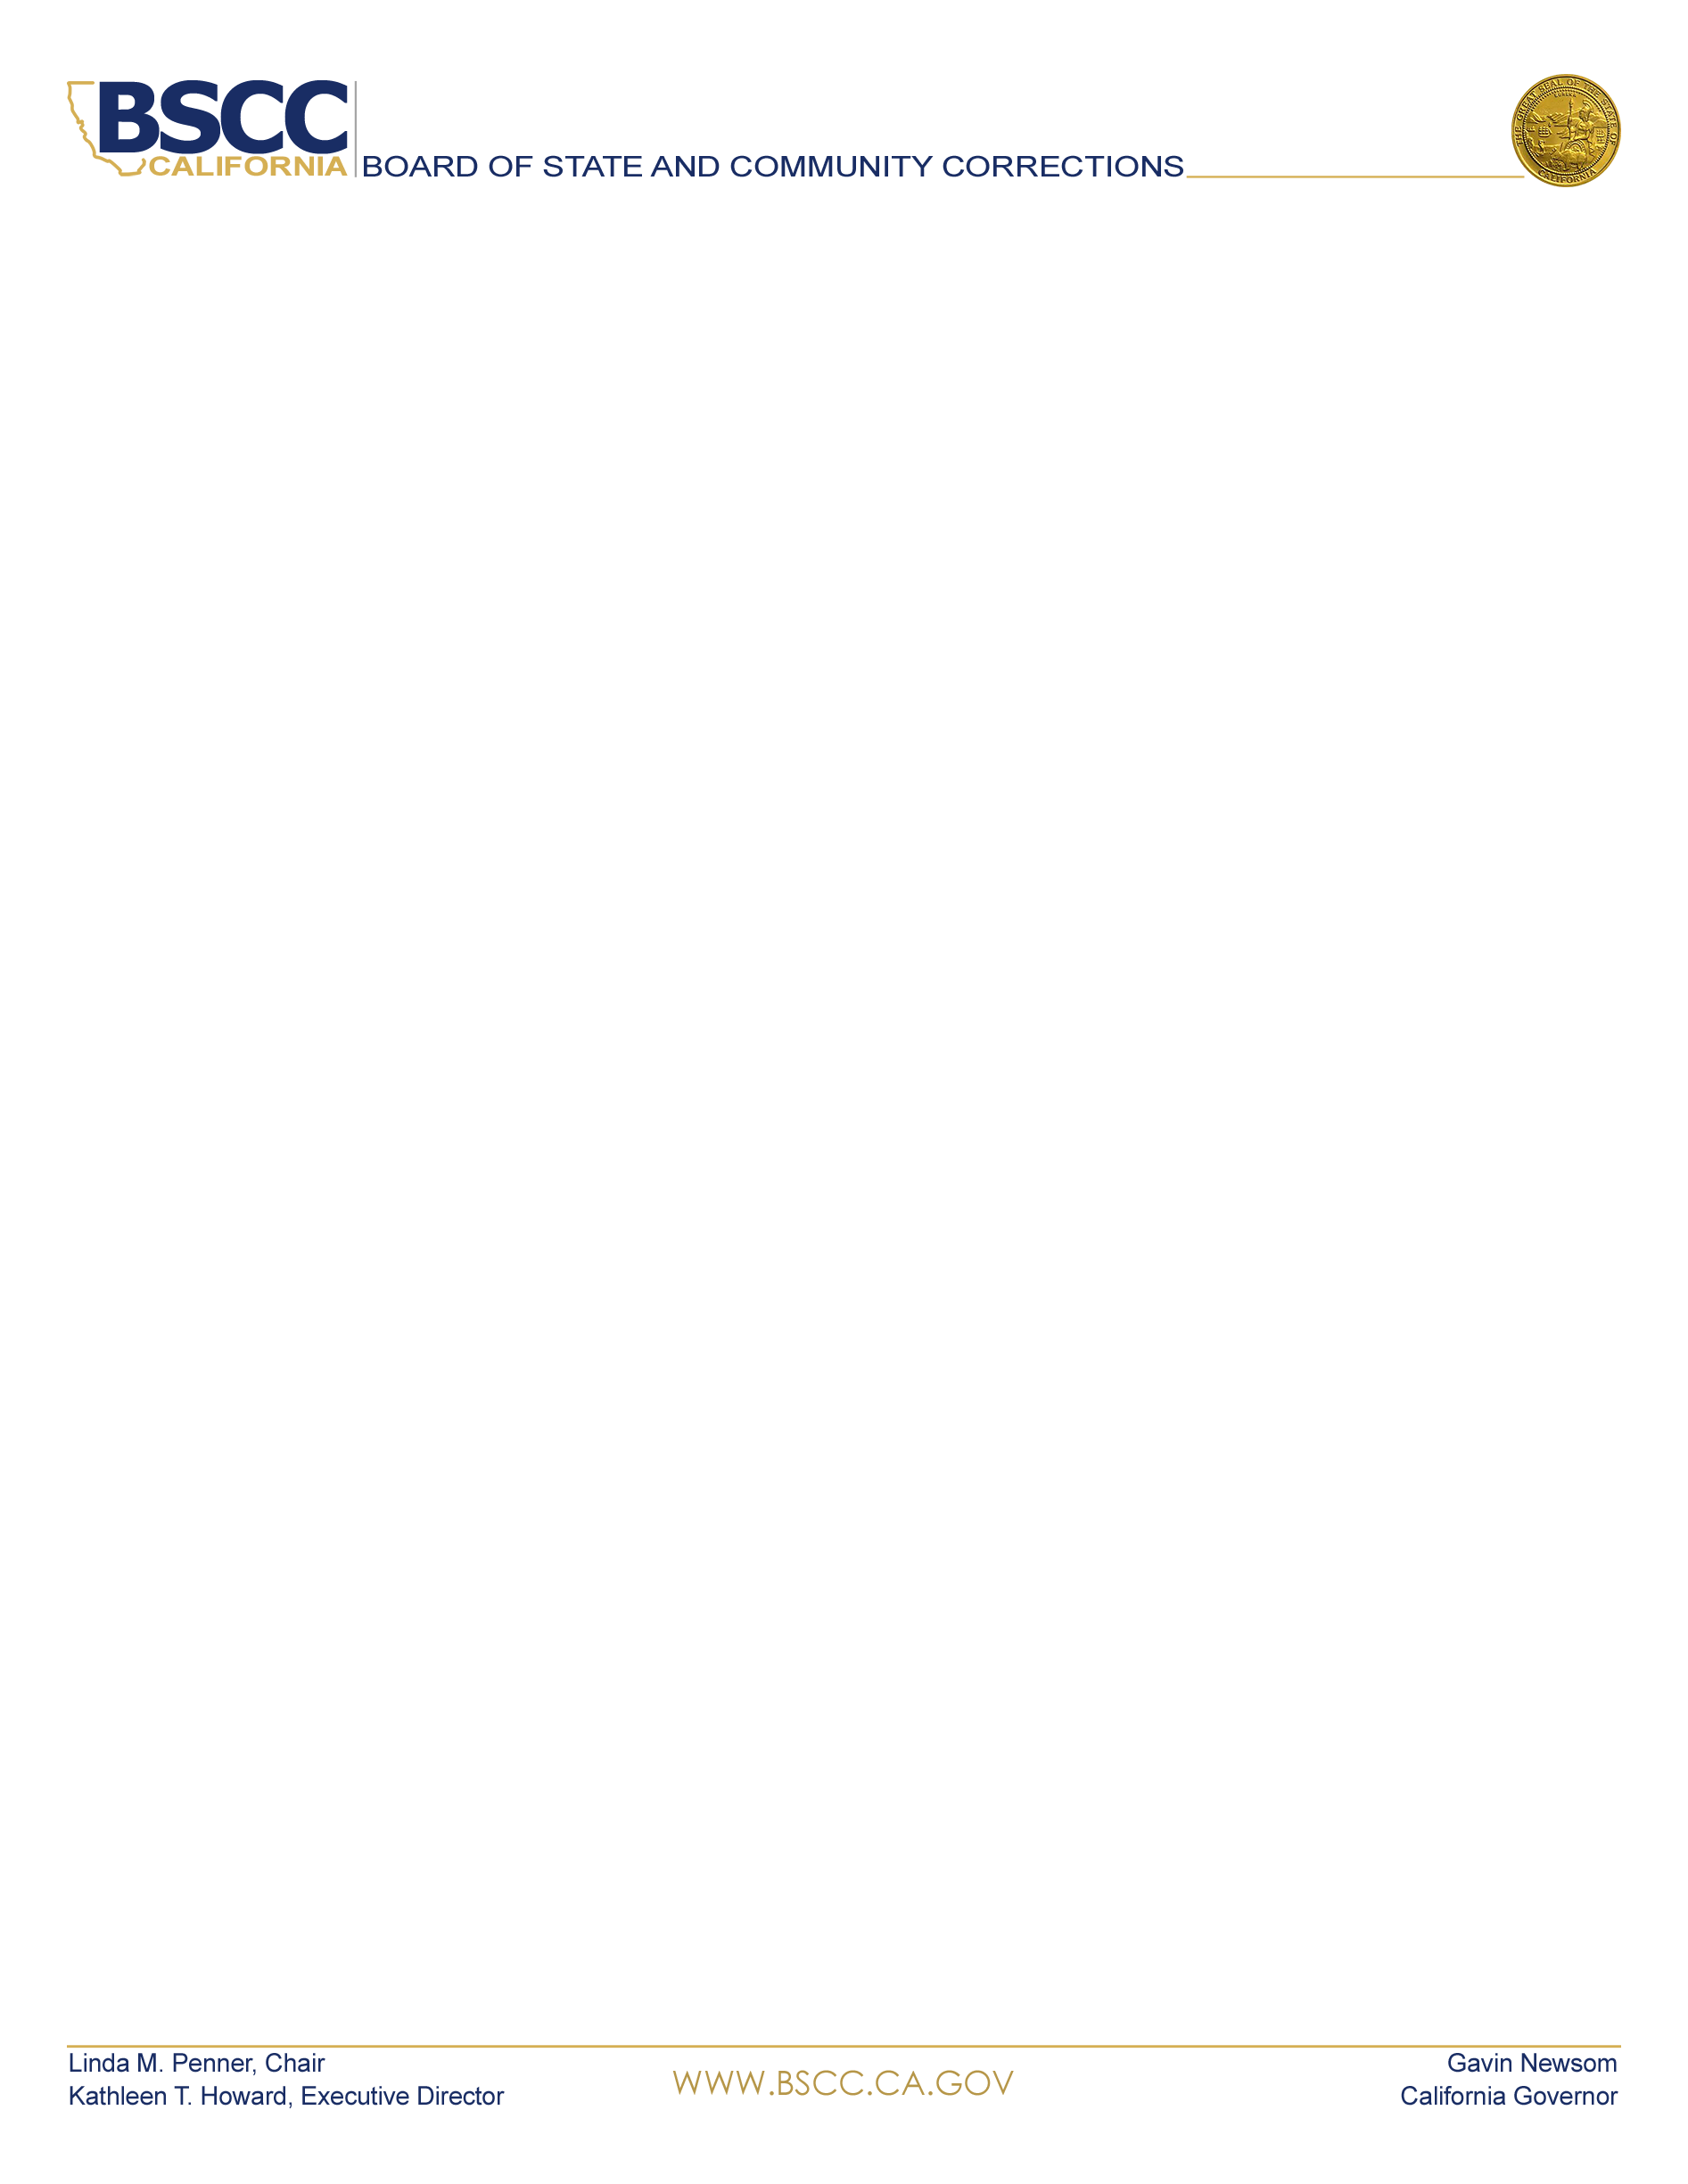  KATHLEEN T. HOWARD  Executive Director, BSCC  BOARD MEMBERS  LINDA M. PENNER  Chair, BSCC  KATHLEEN ALLISON  Secretary, CDCR  GUILLERMO VIERA ROSA  Director, Adult Parole Operations, CDCR  DEAN GROWDON  Sheriff, Lassen County  VACANT  Sheriff  CINDY CHAVEZ  Supervisor  Santa Clara County  KIRK HAYNES  Chief Probation Officer  Fresno County  KELLY M. VERNON  Chief Probation Officer  Kings County  JANET GAARD  Retired Judge  Yolo County  ANDREW MILLS  Chief of Police  City of Palm Springs  SCOTT BUDNICK  Founder  Anti-Recidivism Coalition  Film Producer  MIGUEL GARCIA  State Youth Justice Specialist  Anti-Recidivism Coalition  NORMA CUMPIAN  Associate Director  Anti-Recidivism Coalition  Women’s and Non-Binary Services | BOARD MEETING AGENDA  April 7, 2022  2590 Venture Oaks Way  Sacramento, California, 95833  Palm Springs Police Department  200 S Civic Drive Training Room A  Palm Springs, California, 92262  Those participating in-person  Masking and social distancing is strongly recommended, but not required  Remote Public Participants:  To request to speak on an agenda item during the Board meeting, please email publiccomment@bscc.ca.gov  Please state in the subject line on which item you would like to speak  To submit written public comment on an agenda item, please email publiccomment@bscc.ca.gov  Routine items are heard on the consent calendar. All consent items are approved after one motion unless a Board member asks for discussion or separate action on any item. Anyone may ask to be heard on any item on the consent calendar prior to the Board’s vote. Members of the public will be given the opportunity to give public comment during the Board’s discussion of each item. There is a two-minute time limit on public comment unless otherwise directed by the Board Chair.  - Call Meeting to Order  - Information Items  - Chair’s Report  - Executive Director’s Report  - COVID-19 Update  - Briefing on the San Diego Sheriff’s Department Audit Report:  February 2022  - Legal Update  - Attorney General Opinion No. 18-103 – Grand jury authority under Penal Code section 919, subdivision (b), applies to county jails  - Legislative Update  - Action: Consent Items  - Minutes from the February 10, 2022 Board Meeting: Requesting Approval  - Adult Regulation Revision: Approve Updated Revisions: Requesting Approval  - Tribal Youth Diversion Grant - Cohort I, Six-Month No-Cost Extension: Requesting Approval  - California Violence Intervention and Prevention Grant (CalVIP) Request for Proposals - Service Contract to Strengthen the Data Collection and Management Capacity of Grantees: Requesting Approval  - Action: Discussion Items  - Local Inspection Update: Requesting Approval  - Requested Appearance - Merced County Sheriff: Update on Regulation Section 1027 (staffing) of Title 15 of the California Code of Regulations  - Minimum Standards for Local Juvenile Detention Facilities, Title 15, and Title 24 Begin Regulation Revision Process, Appoint Co-Chairs: Requesting Approval  - Update on Los Angeles Juvenile Halls: Requesting Approval  - Presentation on Tribal Youth Diversion Grant by Sherwood Valley Band of Pomo Indians: Information Only  - Public Comments  Public comment about any agenda items may be heard at this time.  - Adjourn  Next Board Meeting: June 9, 2022  Teleconference and Zoom Participation  Instructions for attendance appear on the last page of this agenda  Instructions for Attending Zoom / Teleconference Board Meeting  Use Zoom to both view and hear the Board meeting. Join by phone for audio only. If you do not have Zoom, download to your device before the meeting.  Via Zoom:  Join from a PC, Mac, iPad, iPhone or Android device:  Please click this URL to join.  April 7, 2022 BSCC Board Meeting  Or One tap mobile:  +16699009128,,88593901904# US (San Jose)  +12532158782,,88593901904# US (Tacoma)  Or join by phone:  Dial(for higher quality, dial a number based on your current location):  US: +1 669 900 9128 or +1 253 215 8782 or +1 346 248 7799 or +1 312 626 6799 or +1 646 558 8656 or +1 301 715 8592  Webinar ID: 885 9390 1904  International numbers available:  For additional information about this notice, agenda, to request notice of public meetings, to submit written material regarding an agenda item, or to request special accommodations for persons with disabilities, please contact Adam.Lwin@bscc.ca.gov or call (916) 324-2626.  For general information about the BSCC visit www.bscc.ca.gov, call (916) 445-5073 or write Board of State & Community Corrections, 2590 Venture Oaks Way, Ste 200, Sacramento CA 95833

