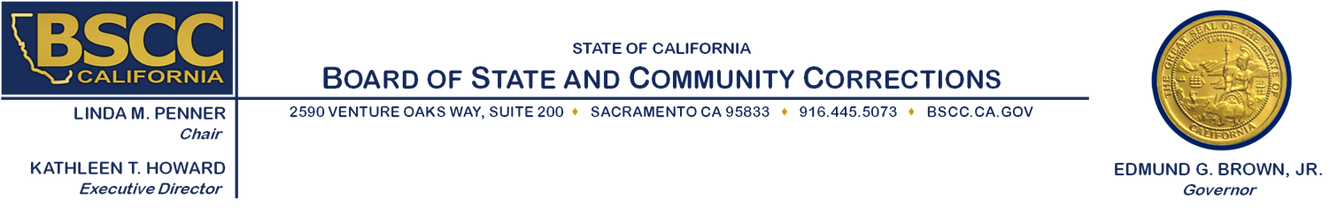

STATE ADVISORY COMMITTEE ON
JUVENILE JUSTICE AND DELINQUENCY PREVENTION

March 15, 2017 Meeting

Issue: Legislation

- SACJJDP Legislative Report
- BSCC Legislative Report

Recommendation / Action Needed: Information only

Resource Person: Various BSCC Staff
For questions contact Nicole Woodman at nicole.woodman@bscc.ca.gov or
(916) 322-1427

