<http://www.bscc.ca.gov/s_bsccescsseekingmembership/>

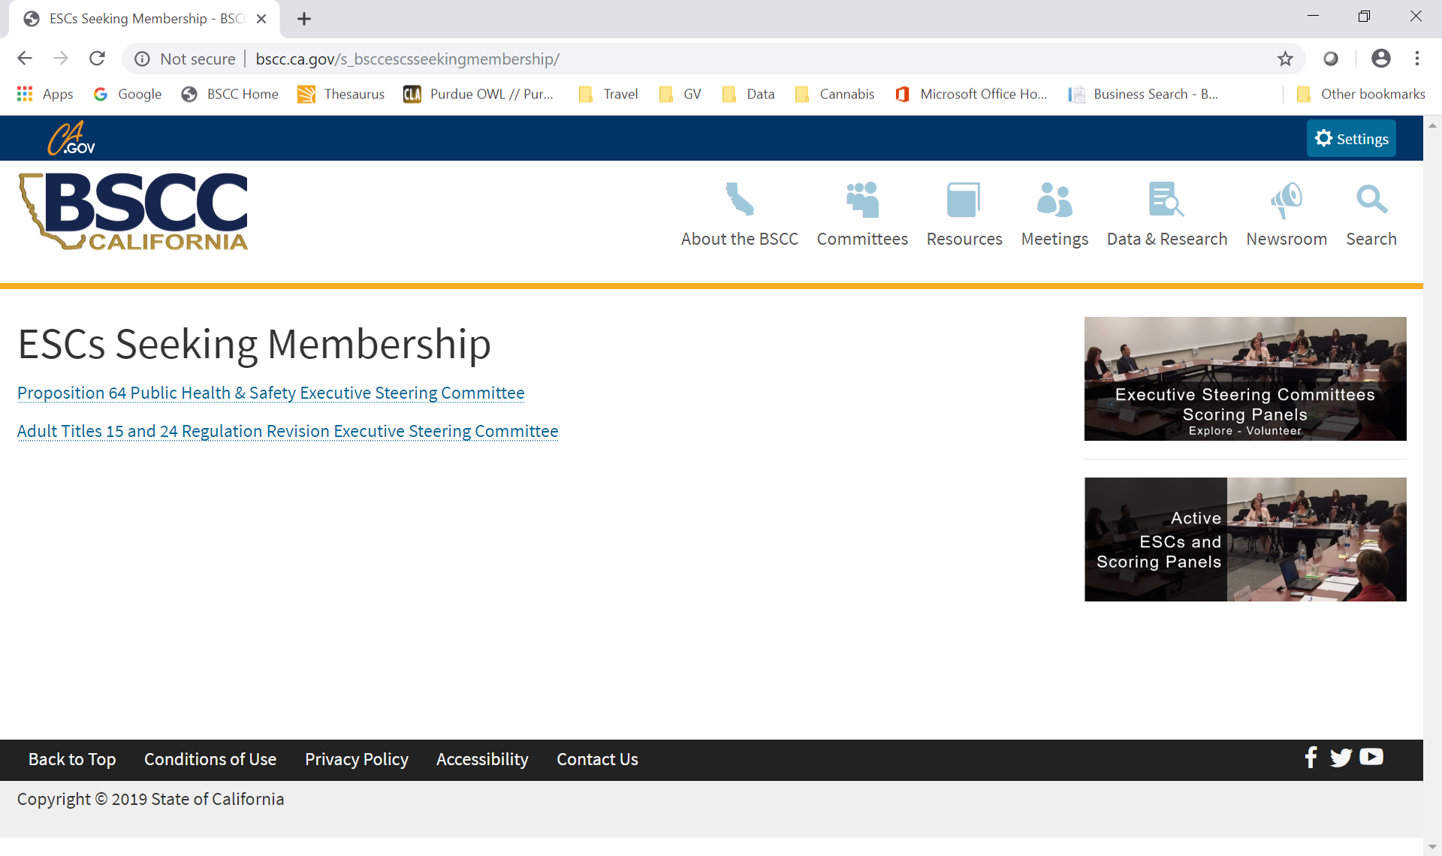

Please delete the Prop 64 link

<http://www.bscc.ca.gov/s_cppgrantfundedprograms/>

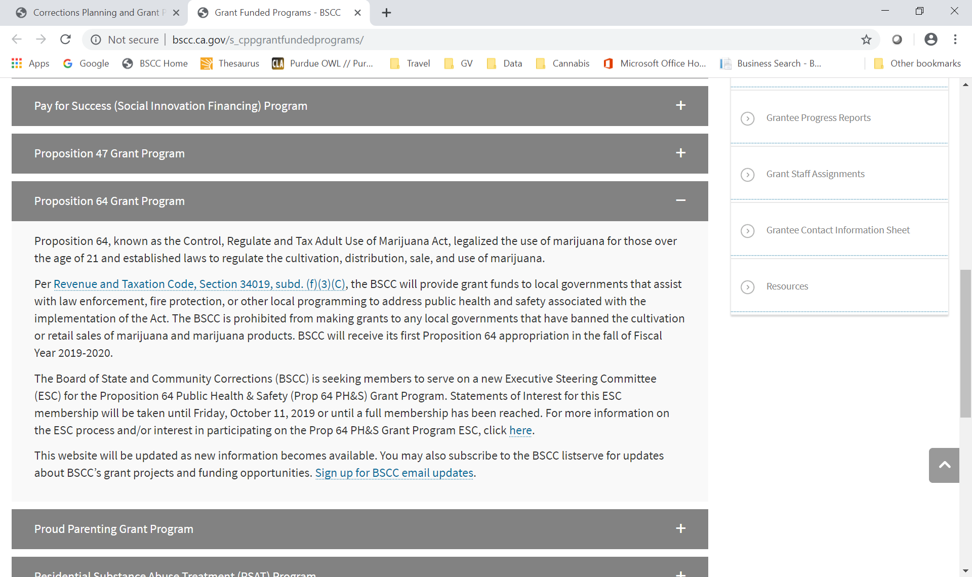

Please delete the paragraph and add info from the next page in its place

The Prop 64 PH&S Executive Steering Committee (ESC) will be meeting on Tuesday, October 22 and Wednesday, October 23, 2019 at the Board of State and Community Corrections in Sacramento, California (Agenda).

**Proposition 64 Public Health & Safety (Prop 64 PH&S) Grant Program**

**Executive Steering Committee Membership Roster**

|  |  |  |  |
| --- | --- | --- | --- |
|  | **Name** | **Title** | **Organization /Agency** |
| **1** | Linda Penner  Chair | BSCC Board Member | Board of State and Community Corrections |
| **2** | Manuel Escandon | Director, Student Intervention & Prevention Department | Office of the Fresno County Superintendent of Schools |
| **3** | Hollie Hall | Consultant, PhD. | Watershed Resource Specialist  Humboldt, Trinity, and Mendocino Counties |
| **4** | Tanja Heitman | Chief Probation Officer | Santa Barbara County |
| **5** | Amy Irani | Director | Environmental Health  Nevada County |
| **6** | Vicki Jones | Environmental Health Director | Merced County Public Health |
| **7** | Jon Lopey | Sheriff | Siskiyou County |
| **8** | Renee Menart | Communication & Policy Analyst | Center on Juvenile and Criminal Justice |
| **9** | Dave Neilson | Retired, Division Chief/Chief | CA Department Alcohol & Drug Programs  CA Department of Mental Health |
| **10** | Sarah Ruby | Deputy Public Defender | Santa Clara County |
| **11** | Michael Salvador | Police Chief | City of Atwater |
| **12** | Sharyn Turner | Registered Nurse | Nevada County Superintendent of Schools |
| **13** | Scott Whitney | Police Chief | City of Oxnard |

<http://www.bscc.ca.gov/m_meetings/>

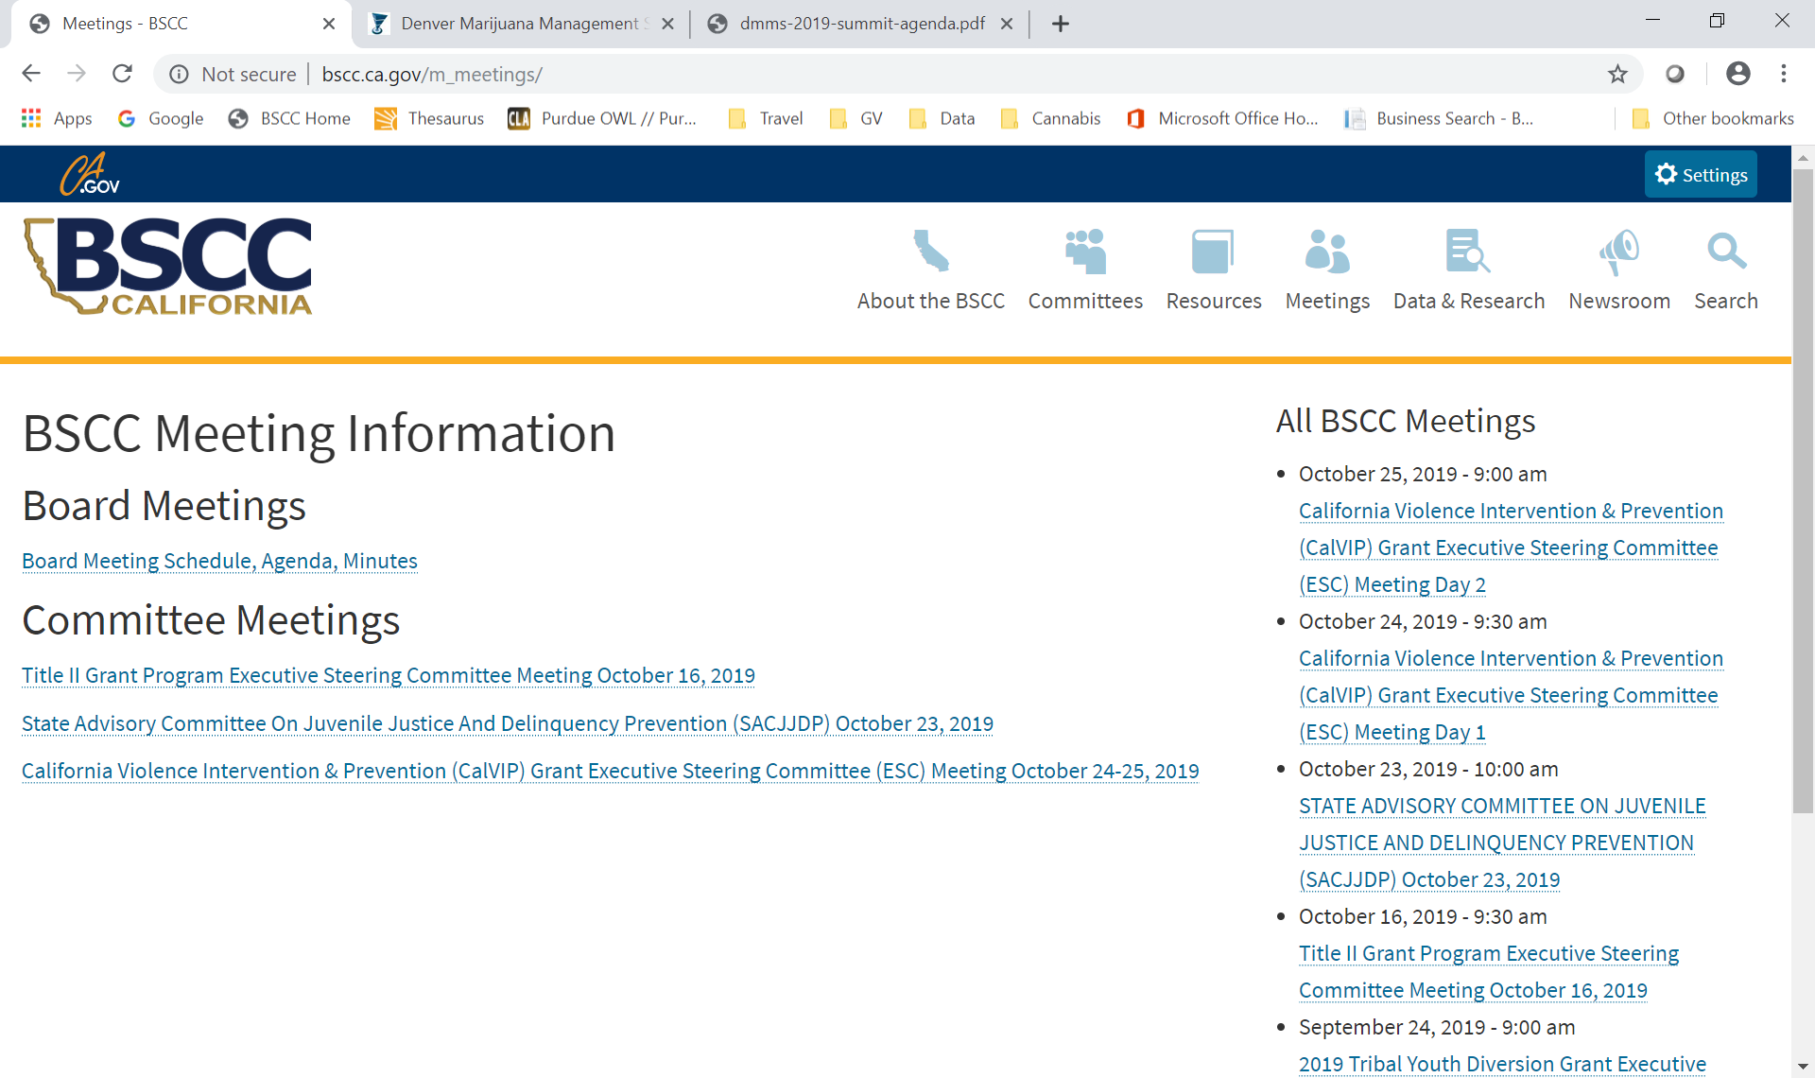

Between Title II & SACJ please insert:

Proposition 64 Public Health and Safety (Prop 64 PH&S) Grant Program Executive Steering Committee (ESC) Meeting October 22-23, 2019

And link to agenda attached to email

Same under All BSCC Meetings