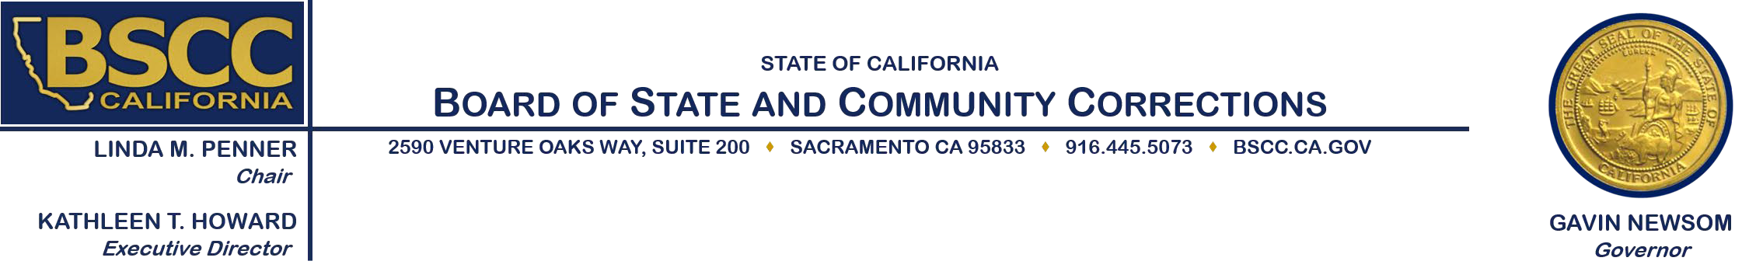

# Adult Reentry Grant Program Cohort III

# Bidders’ Conference Meeting

**Thursday, March 3, 2022 at 1:30 p.m.**

**Public access options for this meeting include:**

* **Join by Zoom**:

o [Bidders Conference ARG Cohort III](https://us02web.zoom.us/j/85181161849?pwd=YTV2YmpTQmZjclQvbVdoZFVjTk5PUT09)

o Meeting ID: 851 8116 1849 | Passcode: 888084

* **Call In**:

o 1-669-900-9128

o Meeting ID: 851 8116 1849 | Passcode: 888084

1. Welcome and Introductions
2. BSCC Overview and Grant Process
   * Executive Steering Committee/Scoring Panel Process
3. Adult Reentry Grant Program Request for Proposal (RFP) Overview
   * Background
   * Eligible Activities
   * Funding Information
   * Use of Effective Programs
   * Housing First
   * Grant Requirements
   * RFP Process
   * Scoring Process
   * Proposal Instructions
   * Review Components of the RFP Application
   * ARG RFP Budget Attachment
   * Questions

***Note:*** *Agenda items may be taken out of order.*

Please contact Field Representative Tanya Thompson at (916) 618-7484 or [tanya.thompson@bscc.ca.gov](mailto:tanya.thompson@bscc.ca.gov) for additional information about this notice, to submit written material regarding an agenda item or to request special accommodations for persons with disabilities. This agenda and additional information about the Board of State and Community Corrections may be found on our website at [www.bscc.ca.gov](http://www.bscc.ca.gov/).