Assembly Bill (AB) 1050

Executive Steering Committee (ESC) Meeting

Wednesday, September 24, 2014

10:00 a.m. to 2:00 p.m.

660 Bercut Drive

Sacramento, CA 95811

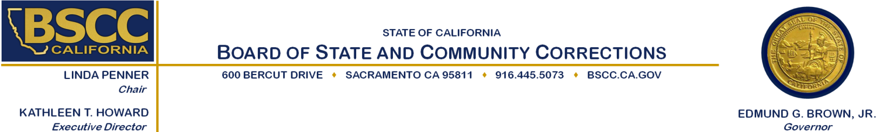

|  |  |
| --- | --- |
| **Agenda Items** | **Approximate Times** |

1. Welcome and Introductions  10:00 am – 10:05 am
2. Approve Minutes from the August 13, 2014 Meeting 10:05 am – 10:10 am
3. Recidivism Definition Development 10:10 am – 12:00 pm

**Working Lunch**

1. Treatment Program Completion Rates Definition Development 12:00 pm – 12:30 pm
2. Other terms deemed relevant… Definition Development12:30 pm – 1:45 pm

* Average length of stay
* Successful completion of probation
* Offender population
* Conviction

1. Next Meeting 1:45 pm – 1:50 pm
2. Public Comment 1:50 pm – 2:00 pm
3. Adjourn  2:00 pm

**Note:** There will be an opportunity for public comment prior to any action taken by the committee. Agenda items may be taken out of order.

**Meeting Contact Information:**

**Please contact Ricardo Goodridge at (916) 341-5160 or** [Ricardo.Goodridge@bscc.ca.gov](mailto:Ricardo.Goodridge@bscc.ca.gov) **for additional information about this notice, to submit written material regarding an agenda item or to request special accommodations for persons with disabilities. This agenda and additional information about the Board of State and Community Corrections may be found on our website at** [www.bscc.ca.gov](http://www.bscc.ca.gov).