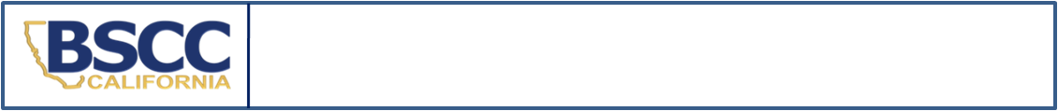
California Board of State and Community Corrections
2021 Federal Youth Detention Report

- When a youth is held in a secure juvenile detention facility solely for a federal detention hold (e.g., illegal entry), administrators are required to report the name of that individual and their length of stay to the Board of State and Community Corrections (BSCC).
- Please submit this form to the BSCC by the 10th of the month if any youth were held for the federal government and released during the preceding month. Submit the report after the youth has been released.
- A separate form must be completed for each youth detained for the federal government.
SECTION A.
Name of facility: FORMTEXT FORMTEXT | County: FORMTEXT FORMTEXT
Type of facility (please check one):
Juvenile Hall Special Purpose Juvenile Hall Camp
SECTION B.
Youth’s Name: FORMTEXT FORMTEXT | Gender: M F | County ID#: FORMTEXT FORMTEXT
Intake Date (m/d/yy): FORMTEXT FORMTEXT | Intake Time (Please indicate if time is AM or PM): FORMTEXT FORMTEXT
Court-Ordered Release Date: FORMTEXT FORMTEXT
(If youth also had criminal charges)
Date ICE Notified of scheduled release date: FORMTEXT FORMTEXT
Actual Release Date (m/d/yy): FORMTEXT FORMTEXT | Release Time (Please indicate if time is AM or PM): FORMTEXT FORMTEXT
SECTION C.
Reason and length of stay for detention:
Federal Government Hold Pursuant to Contract? YES NO
1. Youth was held solely for illegal entry or as a material witness and subsequently deported.
Less than 24 hours | More than 24 hours - FORMTEXT FORMTEXT days detained.
2. Youth was held for illegal entry AND had criminal charges pending or was committed on criminal charges. Count ONLY the time from court ordered release date until youth is released to ICE.
Less than 24 hours | More than 24 hours - FORMTEXT FORMTEXT days detained.
SECTION D.
Name and Title of Reporting Person:  FORMTEXT FORMTEXT |  |  | Phone: FORMTEXT FORMTEXT | Date:
 |  |  | E-Mail: FORMTEXT FORMTEXT
Name and Title of Facility Manager:  FORMTEXT FORMTEXT |  |  | Phone: FORMTEXT FORMTEXT | Date: FORMTEXT FORMTEXT
 |  |  | E-Mail: FORMTEXT FORMTEXT
Submit completed form: |  | This form may be downloaded at https://www.bscc.ca.gov/s_fsoservices/
email: | analyst@bscc.ca.gov
fax: | (916) 322-2461
mail: | Board of State and Community Corrections
 | ATTN: FSO Report Analyst
 | 2590 Venture Oaks Way, Suite 200
 | Sacramento, CA 95833 | Questions? Contact Tameka Shedwin at  analyst@bscc.ca.gov or (916) 323-9704

Do not include youth who have a federal detention hold and are charged according to WIC §602; the JJDPA Act of 2002 requires the BSCC to monitor only those youth held solely for a federal detention hold for illegal entry.

