Leadership
Candidate Orientation Booklet
Probation Officer Examination for Local Corrections

January 2008
BOARD OF STATE AND
COMMUNITY CORRECTIONS
Standards and Training for Corrections Division
600 Bercut Drive, Sacramento, CA 95811
916.445.5073 PHONE
916.322.5036 FAX
bscc.ca.gov
Excellence
Support

In preparing and updating the Probation Officer Examination, the Board of State and Community Corrections has taken into account the following documents concerning selection testing:

- The Standards for Educational and Psychological Testing (American Educational Research Association, American Psychological Association, National Council on Measurement in Education, Joint Committee, 1999).
- The Principles for the Validation and Use of Personnel Selection Procedures (Society for Industrial and Organizational Psychology, Inc., 2003).
- The Uniform Guidelines on Employee Selection Procedures (U.S. Equal Employment Opportunity Commission, et al, 1978).

Candidate Orientation Booklet

Probation Officer Examination

Overview
The Candidate Orientation Booklet is designed to serve four functions:

- To provide background information about the development and validation of the Probation Officer Examination;
- To familiarize candidates with the examination format;
- To preview the contents of the Probation Officer Examination; and
- To provide sample problems (with answers) to help candidates prepare for the examination.

Description of the Probation Officer Job
The Probation Officer (PO) investigates and analyzes cases, writes reports and makes recommendations to the courts, enforces orders of the courts, and supervises probationers who are under the jurisdiction of the courts and/or county probation departments. A further role may be to provide services and/or behavioral controls that would aid in the correction of the probationer's behavior and aid them whereby they may make successful adjustments in the community. The major tasks and responsibilities of the PO are summarized below.

Probation Officer Work Activities

- Monitoring and Enforcing Compliance - Monitoring probationers’ adherence to the terms of probation, detecting violations, and enforcing compliance. Reviewing relevant probation conditions, such as employment, residence, treatment, payments, etc. Contacting probationers with appropriate frequency, including home or school visits, drug tests, etc. Conducting regular and thorough discussions with parents, relatives, school officials, etc., to check on probationers' conduct and compliance. Setting goals for probationers' treatment or conduct, and monitoring progress. Being alert to signs of problems, anticipating and preventing such problems when possible.
- Investigating - Gathering and learning all relevant case and background information. Obtaining and reviewing appropriate department records, probation files, District Attorney's files, rap sheets, Juvenile Hall logs, police reports, chronological records, etc. Gaining a working knowledge of information in all probationers' files and living situation, including the nature of offenses, prior criminal records, family living situation, and evidence of quality of environment.
- Analyzing and Making Recommendations – Synthesizing and evaluating all relevant information in reaching decisions and recommendations. Making appropriate decisions and recommendations regarding detention, placement, sentencing, payments, terms and conditions of probation, degree of monitoring and supervision required, and release/revocation. Giving appropriate weight and consideration to all relevant factors in reaching conclusions.
- Report Writing and Documentation – Writing reports (e.g., detention, fitness, pre-sentence, disposition), correspondence and other documents/reports related to intake, progress, detention/release, etc., that are clear complete, accurate and concise. Adhering to legal and departmental guidelines regarding all paperwork and documentation requirements. Keeping appropriate and accurate records of field and other work activities.
- Handling Emergencies – Working effectively and taking appropriate actions in emergency or crisis situations (e.g., injuries, escapes, fires, physical fights or attacks upon staff). Using sound judgment and following proper procedures in using physical force or restraints, enlisting and providing appropriate assistance; and rendering appropriate first aid. This includes demonstrated performance in job simulation exercises and drills. Note: the focus of this work activity is on judgment and following procedures. Physical ability is not included here (it is to be described later in a separate work activity.
- Interacting/Communicating with Probationers – Clearly conveying the terms of probation to probationers, including their rights, responsibilities, the nature of probation violations, and the consequences for committing violations. Gaining probationers' cooperation and respect through professionalism, answering questions, providing support and counseling, and offering guidance as appropriate regarding meeting the conditions of probation (e.g., school attendance, urinalysis testing, employment, housing, transportation, treatment, payment schedules, etc.).
- Interacting/Communicating with Non-Probationers – Appropriately and effectively working with affected parties such as parents/guardians, victims, witnesses, employers, teachers, etc. Interviewing family, school officials, etc., regarding probationers' history, character, and conduct. Providing all necessary information to affected parties regarding court or hearing dates and relevant legal procedures, in a timely and effective manner. Providing warnings to others of potential problems, threats, or dangers. Counseling and assisting victims and family members as appropriate.
- Working with Probation Staff and Other Agencies – Working effectively and professionally with co-workers and with external departments, agencies, and institutions. Informing police of law violations by probationers and assisting in their investigations. Keeping law enforcement, other probation officers, and other correctional and governmental agencies informed when necessary. Referring probationers to medical, mental health, social service, and educational institutions, as needed.
- Working with the Justice System – Filing accurate, complete, and timely legal reports, affidavits, warrant requests, petitions, memoranda, etc., with the courts. Adhering to filing and court appearance procedures and deadlines. Demonstrating professionalism and effectiveness in providing testimony, participating in detention hearings, recommending sentencing, and in all other interactions with judges, the District Attorney's office, and defense attorneys. Maintaining cooperative relationships with attorneys, judges, and court staff. Maintaining current knowledge of case law and sentencing precedents.
- Performing Physically Demanding Work – Working with physical skill sufficient to handle emergency situations such as medical emergencies, defending one self, and pursuing, disarming, subduing and restraining probationers. This includes demonstrated performance in job simulation exercises and drills.

Development of the Probation Officer Examination
The Probation Officer Examination was developed as a result of a three-year statewide analysis of the PO position. The analysis was undertaken pursuant to state legislation mandating the development of selection standards for the PO job.

Examination development began with a review of job descriptions and related documentation, site visits, and interviews with PO incumbents and their supervisors. The test researchers developed a job analysis questionnaire from these documents and interviews. The questionnaire was administered to PO incumbents and supervisors from agencies throughout California. Questionnaire results were used to determine the nature of the PO job and to develop a clear and complete description of the abilities and attributes necessary for successful job performance.

A large pool of test items* was developed to measure important abilities and attributes identified in the job analysis as important to job success. These test items were administered to a large sample of Probation Officers working in local detention facilities around the state. Supervisors of these same officers rated various aspects of each officer’s job performance. The Probation Officer Examination represents a combination of test items found to predict job performance.

*A Word About Terms: Test items are also called test problems and questions. There are two ways to present test items to test takers: Items can be written as questions (e.g. “How many dimes are there in a dollar?”) followed by several answer choices; or as statements (e.g., “Indicate to what extent you agree with the following statement using the accompanying scale: “California is a great place to live.”) This information booklet contains references to test items, questions, and problems.

Examination Format
The Probation Officer Examination consists of multiple-choice problems. There are two ways to take the examination: paper and pencil or electronic. Each agency determines which method they use.

For the paper and pencil format, the test is contained in a single test booklet and an accompanying answer sheet. You will answer all examination problems on the answer sheet, not in the test booklet. Typically, testing will be done in a group setting.

For the electronic version, you will be prompted through the test steps on the computer and record your answers as prompted.

Total testing time for either the paper and pencil or electronic format will be approximately 2 hours. Most applicants have adequate time to complete all test items.

Preparing for the Probation Officer Examination
A brief description of the abilities and attributes measured in each section of the examination is given below, followed by examples of the types of items you will find in each section.

- Following Written Directions – Apply a set of rules to determine the correct action or solution for a problem.
- Problem Solving: Evaluate a set of facts and draw logical conclusions. Following the fact set, a set of conclusions is presented, each of which is to be evaluated and concluded to be true, false, or indeterminable based solely upon the corresponding set of facts.
- Reading Comprehension - Read a passage and answer questions that may require identifying facts and details, interpreting information, or drawing conclusions.
- Writing Clarity - Recognize and use clear writing, avoiding writing problems that result in ambiguous or erroneous communication.
- Writing Detail - Evaluate written information and determine whether it provides a useful, detailed description of people or events.
- Accuracy with Forms and Coded Information - Part A: Check the accuracy of information coded in report forms compared to a written summary; and Part B: Compare coded information to a brief list of information and determine whether the coded information matches any of the items on the list.
- Work Attitudes - This section of the examination contains various test items designed to measure attitudes about work-related situations and behavior, reflecting attributes such as conscientiousness, confidence, handling work pressure, getting along with others, and integrity/trustworthiness. Please note: This section of the test should not be confused with a psychological examination that gauges the extent of your mental health. The Probation Officer Examination is not a measure of your mental well-being and should not be construed as such.
The instructions and sample questions that appear in the examination for each section are presented on the following pages.

1. Following Written Directions

Directions:
In this section, several sets of rules and procedures are presented. Each set is followed by several short problems that are to be solved by applying the rules. For each problem, mark the letter (A, B, C, or D) on your answer sheet corresponding to the correct action or solution. An example is provided below.

Sample Item:

Rules for Assigning Cases to Facilities:
The four facilities are: (A) Main, (B) West, (C) North, and (D) East. Listed below are the rules for assigning cases to facilities:

- Main facility is for adult males who require maximum security.
- West facility is for adult males who require minimum security.
- North facility is for juveniles (ages 18 and under).
- East facility is for adult females of all security levels.

 |  | Problem |  | Main |  | West |  | North | East
S1. | Adult male, minimum security |  | A |  | B |  | C |  |  | D
S2. | 14-year-old youth |  | A |  | B |  | C |  |  | D

Sample Answer Sheet

A B C D E
S1. ○  ○ ○ ○
A B C D E
S2. ○ ○ ○ ○ ○
In the first example (S1), option B (West) is marked as the correct answer. For the second example (S2), you would mark option C.

This section will contain 3 sets of rules and procedures with a total of 22 problems to be solved. Most candidates finish this section of the test within about 15 minutes.

2. Problem Solving

Directions:
In this section, a set of facts is presented followed by a set of conclusions. From the facts, you can tell that some of the conclusions are definitely true and some are definitely false. If you decide a conclusion is definitely TRUE, mark A on your answer sheet. If it is definitely FALSE, mark B on your answer sheet. If the facts do not give enough information to tell whether a conclusion is definitely true or definitely false, mark C on your answer sheet. An example is provided below.

Sample Item:

Facts:
Mr. Jackson works for Facility A.
Ms. Gaynor is a part-time employee.
All Facility A employees work full-time.
Facility B has some part time employees.

Conclusions:
 |  | True | False | Uncertain
S1. | Ms. Gaynor works for Facility A. | A | B | C
S2. | Ms. Gaynor works for Facility B. | A | B | C
S3. | Mr. Jackson works full time. | A | B | C

Sample Answer Sheet

A B C D E
S1. ○  ○ ○ ○
A B C D E
S2. ○ ○  ○ ○
A B C D E
S3.  ○ ○ ○ ○
The first conclusion has been marked B (False) because Ms. Gaynor works part time and all Facility A employees work full time. The second conclusion has been marked C (uncertain) because there is no information given in the facts to know definitely where Ms. Gaynor works. Because Ms. Gaynor works part-time, it is possible that she works for Facility B. It is also possible that she works for another facility. The third conclusion has been marked A (true) because Mr. Jackson works for Facility A and all Facility A employees work full-time.

This section will contain 3 sets of facts with a total of 12 problems to be solved. Most candidates finish this section of the test within about 10 minutes.

3. Reading Comprehension

Directions:
In this section, several passages are presented. Each passage is followed by several questions. Select the best answer to each question based on the information in the passage, marking the circle (A, B, C, or D) on your answer sheet. An example is provided below.

Sample Item:

First aid is to be given in order of priority. Problems with breathing, circulation, and bleeding are the highest priority. Injuries to the neck and spine should be identified and treated before injuries to the extremities. For example, in treating fractures, injuries to the neck and spine are always treated first; then the head and rib cage; and finally, the arms and legs. Open chest wounds, open abdominal wounds, shock, and serious burns should all be cared for before fractures are treated.

S1. According to the passage, which of the following injuries should receive the lowest priority for treatment?

Sample Answer Sheet

A B C D E
S1. ○ ○ ○  ○
- An airway blockage.
- Heavy bleeding from a cut on the arm.
- Broken ribs.
- A broken ankle.

For this example, the correct answer is D because, according to the passage, fractures are lower priority than breathing problems or bleeding, and fractures in the extremities are the lowest priority.

This section will contain three passages with a total of 17 questions. Most candidates finish this section of the test within about 15 minutes.

4. Writing Clarity

Directions:
Look at the sample item below. A sentence is presented with some of the words underlined. Four alternative words or phrases are listed to replace the underlined words. Select the word or phrase from the list that results in the most clearly written sentence. Mark your answer (A, B, C, or D) on the answer sheet.

Sample Item:

S1. If, in the event that the weapon is found, it should be analyzed.

Sample Answer Sheet

A B C D E
S1. ○  ○ ○ ○

- If, in the event that
- If
- Now
- Since if

The correct answer is option B because it provides the most clearly stated sentence, so B is marked on the sample answer sheet.

This section will contain a total of 13 questions. Most candidates finish this section of the test within about 10 minutes.

5. Writing Detail

Directions:
In this section, pairs of statements are presented which describe the same event or procedure. For each pair of sentences, determine which one provides the most useful, detailed information in describing the event or procedure. Mark your answer (A or B) on the answer sheet. An example is provided below.

Sample Item:

- A customer at the ATM machine on 12th and Euclid was robbed at gunpoint today by a masked man. In addition to being robbed of $250, Julie Montrose, 20, was beaten with a gun. She is in fair condition.

- A young woman was robbed at 8:00 this morning at the new ATM station on Euclid Avenue. Her face was badly bruised and she received a concussion as a result of the beating she received by the gunman.

The correct answer is option A because it provides more useful and detailed information about the incident, such as the location, the people involved, and what happened. You would mark A on your answer sheet for this problem.

Sample Answer Sheet

A B C D E
S1.  ○ ○ ○ ○

This section will contain a total of 16 questions. Most candidates finish this section of the test within about 10 minutes.
6. Accuracy with Forms and Coded Information

Part A - Directions:
Look at the sample item below. A short paragraph is presented followed by a corresponding report form. Parts of the report form are numbered that are to be checked for accuracy. For each numbered part, mark A on your answer sheet if the form is correctly filled in, or mark B if the form is not correctly filled in.

Sample Item:

On March 14th a check of the 635 cases for the week showed that all cases were processed on time. Of these cases, 86 were pre-trial cases. Of the 86 pre-trial cases, 79 were transported to Superior court, and 7 were transported to the medical facility.
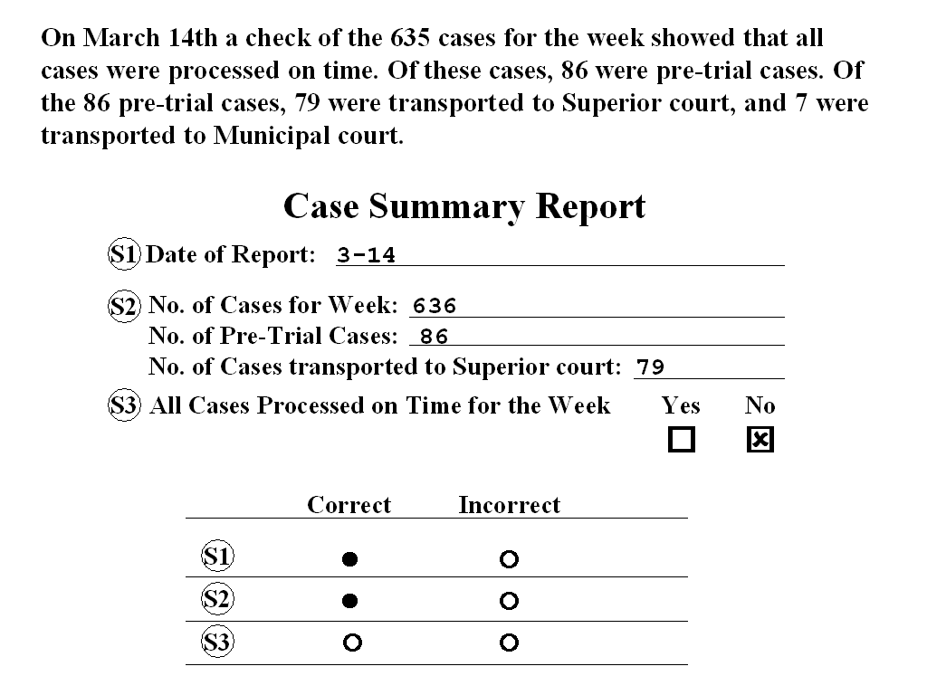

For the first sample item (S1), option A is marked because the date was filled in correctly.

Sample Answer Sheet

A B C D E
S1.  ○ ○ ○ ○
A B C D E
S2. ○  ○ ○ ○
A B C D E
S3. ○ ○ ○ ○ ○

For the second sample item (S2), option B is marked because the number of cases processed for the week was NOT filled in correctly.

For the third sample item (S3), you would mark B because all cases were processed on time.

You do not have to check every line on the form. Check only those items that have circled numbers next to them.

This section will contain 2 sets of passages and report forms with a total of 10 items to be checked. Most candidates finish this section of the test within about 5 minutes.

7. Accuracy with Forms and Coded Information (continued)

Part B - Directions:
Look at the sample items below. In the first sample (S1), you will see a code number presented, 792. Compare that code number to the four code numbers in the same row and see if any of the numbers match 792. If you see an option in the row that matches, mark the letter (A, B, C, or D) of that option on your answer sheet. If no match is found, mark E on your answer sheet.

Sample Items:

Sample Answer Sheet

A B C D E
S1. ○  ○ ○ ○
A B C D E
S2. ○ ○ ○ ○ 
A B C D E
S3.  ○ ○ ○ ○
 | Code Number | A | B | C | D | E
S1. | 792 | 795 | 792 | 790 | 192 | No Match
S2. | 6696 | 6669 | 9696 | 6966 | 6999 | No Match
S3. | 117! | 117! | 1171 | 1!71 | !171 | No Match

The match for S1 is option B, so you would mark B on your answer sheet. There is no match for S2, so you would mark E on your answer sheet. The match for S3 is option A, so you would mark A on your answer sheet.

This section will contain 11 codes to be checked for matches. Most candidates finish this section of the test within about 3 minutes.
8. Work Attitude Survey

Directions:
This section contains a variety of multiple-choice test items. Read each statement carefully and decide the extent to which you agree with the statement. Respond to each item truthfully. Some of the items may describe things that you have never experienced. In this situation, or if you are uncertain about a response, choose the one that most closely describes you or your views. Do not spend too much time on any one item; respond to each item as best as you can and move on to the next one.

Sample Items:
For each item below, you should mark the letter A to E on the answer sheet corresponding to your choice of response.

S1. In a crisis situation, you are willing to lead others.
- Strongly Disagree
- Disagree
- In Between
- Agree
- Strongly Agree

S2. You enjoy working with people who are different from you.
- Strongly Disagree
- Disagree
- In Between
- Agree
- Strongly Agree

S3. You work well in situations that require you to "think on your feet."
- Strongly Disagree
- Disagree
- In Between
- Agree
- Strongly Agree

S4. It is hard for you to remain even-tempered when others are being rude or obnoxious.
- Strongly Disagree
- Disagree
- In Between
- Agree
- Strongly Agree

This section will contain 125 questions. Most candidates finish this section of the test within about 30 minutes.

Your Score
Good performance on one section of the examination may offset relatively poor performance on another portion of the test. You do not pass or fail individual sections of the examination. What counts is your total score —you pass or fail the entire test only.

A Final Word About Testing
Below are several suggestions about taking the Probation Officer Examination. If you thoroughly review the information in this booklet and follow the suggestions, you will be at your best when you take the examination.

In general, you should work quickly, but not so fast as to become careless. The time limit has been set to allow you plenty of time. If you have a question during testing, raise your hand and a proctor will assist you.

Always read all possible choices before marking your answer. If you don't know the answer to a problem it is usually best to skip it and go on to the others. If you finish before time is called, you can go back to any problems you may have skipped.

If you are not sure of the answer to a problem, eliminate the answers you know are wrong and then mark the choice that is your best guess. You will not be penalized for guessing. Your score is simply the number of problems you answer correctly so you should not leave any problems unanswered even if you are only guessing.

You should get a good night's sleep the night before the examination. Some people find that eating a snack or light meal an hour or two before testing is good preparation.

