
September 13, 2024
Organized Retail Theft Vertical Prosecution Grant Program
Third Quarter Status Update (April to June 2024)

About the Grant Program
The Organized Retail Theft (ORT) Vertical Prosecution Grant Program supports district attorneys in addressing increased levels of retail theft property crimes by using a vertical prosecution model. Vertical prosecution means a prosecutor is assigned to an ORT case from beginning to end (e.g., initial hearing/arraignment to sentencing). Under this model, victims, witnesses, and law enforcement officials have a single point of contact. In September 2023, a total amount of $24,868,293 in grant funds was awarded to 13 District Attorney’s Offices. The grant service period began on October 1, 2023. Detailed information about the grantees and their funding is available on the grant webpage.

In August 2024, grantees submitted their third Quarterly Progress Report to the BSCC reporting on grant activities that occurred between April 1, 2024, and June 30, 2024. This document summarizes the progress report information submitted by all 13 grantees.

Project Implementation
During the first nine (9) months of a grant service period grantees are generally focused on project implementation activities necessary for an effective project start. The figure below summarizes the grantees’ status updates for four (4) project implementation activities during Quarter 3 (Q3).

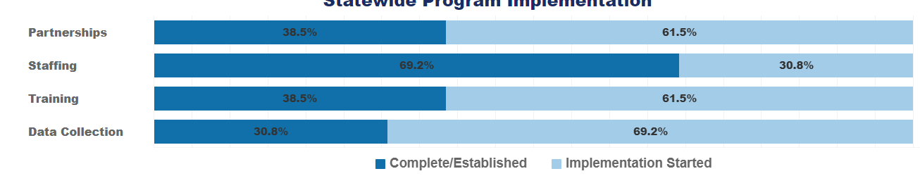
Figure 1. Project implementation status for Q3.
Partnerships: Developing formal relationships with entities to support project goals.
- 38 percent of grantees (n = 5) have established collaborative partnerships with major retailers and work directly with local police and other agencies who focus on ORT-related incidents.
- 62 percent of grantees (n = 8) have started developing partnerships to support their project’s goals.
  - Grantees have established relationships with retailers (e.g., department, cosmetic, and convenience stores), neighboring county District Attorney’s Offices, and local law enforcement agencies to aid with identifying ORT cases, collecting evidence, and filing cases.
  - Regular meetings are held with partner law enforcement agencies and retailers to provide a platform to discuss ORT trends, store systems, efforts to decrease ORT, and share successful strategies other retailers have made to deter and prevent retail crime.

Staffing: Hiring or retaining staff for the essential positions of the projects.
- 69 percent of grantees (n = 9) completed staffing, hiring the necessary Deputy District Attorneys, District Attorney Investigators, and other staff for their project.
- 31 percent of grantees (n = 4) have started recruitment, hiring and/or retaining of essential staff such as Deputy District Attorneys, District Attorney Investigators, and analysts.
  - Several positions are anticipated to be filled in Quarter 4, once lengthy background investigations have concluded.
  - Some grantees state they are unable to fill full-time positions yet, resulting in reassigning staff part-time to the VP unit who must also maintain their current caseloads.
  - The recruitment process is still ongoing for a couple of grantees.

Training: Providing training to staff or external collaborators to support project goals.
- 38 percent of grantees (n = 5) have completed their internally mandated organized retail crime training. They also hosted regional meetings to discuss filling guidelines, provide case examples, and teach retailers and law enforcement agencies about the type of important information to include in investigation reports.
- 62 percent of grantees (n = 8) have started implementing the training provided to support their projects.
  - Grantees have conducted training(s) with retail partners to their bolster documentation to aid in prosecutions.
  - Grantees have conducted internal training(s) for new hires and ongoing training(s) for current staff.
  - External training sessions were attended across the state. Some grantees attended the National Retail Federation PROTECT conference in June 2024 for training and networking. One grantee is preparing a training bulletin related to ORT for First Responders which is expected to be completed by next quarter (Q4).

Data Collection: Systematic, ongoing data collection for progress reports and evaluation.
- 31 percent of grantees (n = 4) have completed their data collection systems and procedures. Evaluation staff will continue to monitor incoming data and produce reports documenting case trends.
- 69 percent of grantees (n = 9) started implementing data collection and evaluation processes for their projects.
  - Grantees have submitted evaluation plans.
  - Some grantees continued working with data and IT teams to refine case file tagging to ensure data is being appropriately categorized, modify current case management databases to meet data collection requirements, and provide reliable, accurate data. Others have obtained new reporting software to assist in extracting required metrics.

About the Collection of Theft-related and ORT Case Metrics
The Quarterly Progress Report collects metrics for theft-related property crimes and organized retail theft crimes. For both types of crimes, grantees may use the BSCC definition or a department specific definition. The BSCC definitions are:
- Theft-related property crimes include any crimes described in Chapter 5 of Title 13 of Part 1 of the Penal Code (PC, commencing with Section 484). In addition, theft-related property crimes include violations of PC Sections 211-215 (robbery, train robbery, and carjacking), 459 (burglary), and 459.5 (shoplifting). Theft-related property crime also includes ORT (PC Section 490.4). Seventy-seven (77) percent of the grantees (n = 10) report using the BSCC definition.
- A case involving organized retail theft crimes can include multiple charges but at least one of the charges must be for PC Section 490.4 and a coparticipant does not have to be charged. ORT cases fall within the BSCC definition of theft-related property crimes and therefore counts of ORT cases using this definition are a subset of theft-related property crime cases. Seventy-seven (77) percent of the grantees (n = 10) report using the BSCC definition.

The metrics collected quarterly for both theft-related property crimes and organized retail theft crimes are listed below. Metrics for each are collected in total and then broken down to show the percent of which occurred used a vertical prosecution model. The data reported are for the county and are not attributed to a specific funding source. The metrics include:
- number of cases filed,
- number of charges within those cases,
- count of unique people within those cases,
- number of charges for which a conviction was obtained, and
- number of people associated with those convictions.

Theft-related property crimes are broad in nature and include a subset of organized retail theft crimes. All organized retail theft crimes are theft-related but not all theft-related crimes are considered organized retail theft. Prosecuting attorneys have the discretion to make a variety of important decisions at different stages of a case including whether to file charges, the types and number of different charges (counts) to include (which depend on the evidence available at the time of filing or anticipated to be available at the time of trial), whether to negotiate a plea bargain, and whether to take a case to trial. Factors that influence prosecutorial discretion include the availability and strength of evidence, the interests of the victim, the cost and complexity of the prosecution, and interests of justice. Given the discretionary nature of these prosecutorial decisions, we anticipate fewer discreet “organized retail theft” (i.e., Penal Code Section 490.4) convictions due to factors such as the higher burden of evidence required, the complexities involved in prosecuting organized crime, and the potential considerations of plea bargaining or prioritizing cases based on resource allocation and the broader interests of justice.

The metrics were also collected for the year prior to grant funding and are referred to as the baseline metrics. As these baseline metrics span a full year, once four quarters of metrics are available for the grant period, it will be possible to evaluate trends pre-grant funding and for the first year of grant funding. These trends may be influenced by both grant funding and any other state or local prosecution efforts. It is anticipated that these trends will be available in January 2025.

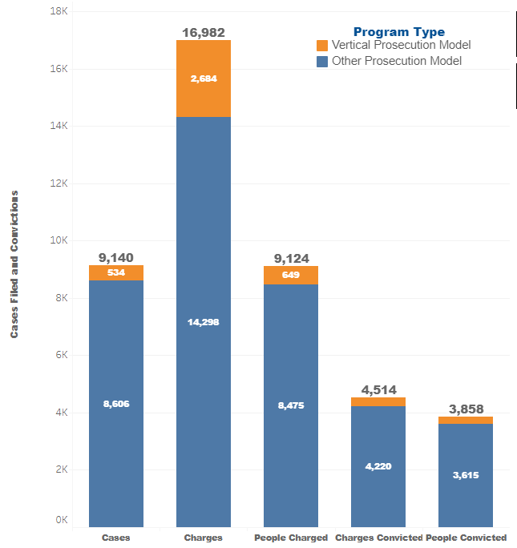
Metrics for Theft-related Property Crimes
For theft-related property crimes, between April 1, 2024 and June 30, 2024 (Q3), grantees reported:
- 9,140 cases were filed, of which 6 percent (n = 534) used a vertical prosecution (VP) model. The cases included:
  - 16,982 charges (counts), of which 16 percent (n = 2,684) used a VP model.
  - 9,124 people were charged, of which 7 percent (n = 649) were charged using a VP model.
  - Convictions were obtained for 4,514 charges (counts), of which 7 percent (n = 294) were prosecuted using a VP model
  - 3,858 unique people were represented across these convictions, for which 6 percent (n = 243) a VP model was used.
Figure 2. Theft-related property crime metrics for Q3.
Cumulatively, for theft-related property crimes, between Quarters 1 and 3 (October 1, 2023 and June 30, 2024), grantees reported:
- 25,514 cases were filed, of which 8 percent (n = 2,134) used a VP model. Summarily, the cases included:
  - 49,379 charges (counts), of which 19 percent (n = 9,555) used a VP model.
  - 25,397 people were charged, of which 9 percent (n = 2,230) were charged using a VP model.
  - Convictions were obtained for 12,524 charges (counts), of which 8 percent (n = 1,002) were prosecuted using a VP model.
  - 10,176 unique people were represented across these convictions, for which 8 percent (n = 786) a VP model was used.

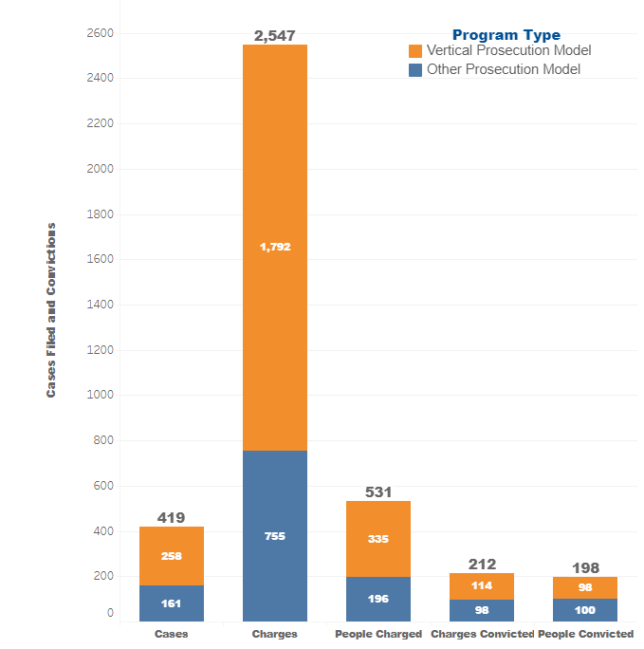
Metrics for Organized Retail Theft Crimes
For organized retail theft crimes, between April 1, 2024 and June 30, 2024 (Q3), grantees reported:
- 419 cases were filed, of which 62 percent (n = 258) used a VP model. The cases included:
  - 2,547 charges (counts), of which 70 percent (n = 1,792) used a VP model.
  - 531 people were charged, of which 63 percent (n = 335) used a VP model.
  - Convictions were obtained for 212 charges (counts), of which 54 percent (n = 114) were prosecuted using a VP model.
  - 198 unique people were represented across these convictions, of which 49 percent (n = 98) used a VP model.
Figure 3. Organized retail theft crime metrics for Q3.

Cumulatively, for organized retail theft crimes, between Quarters 1 and 3 (October 1, 2023 and June 30, 2024), grantees reported:
- 1,325 cases were filed, of which 43 percent (n = 564) used a VP model. Summarily, the cases included:
- 7,572 charges (counts), of which 63 percent (n = 4,794) used a VP model.
- 1,643 people were charged, of which 42 percent (n = 696) used a VP model.
  - Convictions were obtained for 598 charges (counts), of which 39 percent (n = 235) used a VP model.
  - 467 unique people were represented across these convictions, of which 35 percent (n = 165) used a VP model.

Sentence Type for People Who Received an ORT Conviction
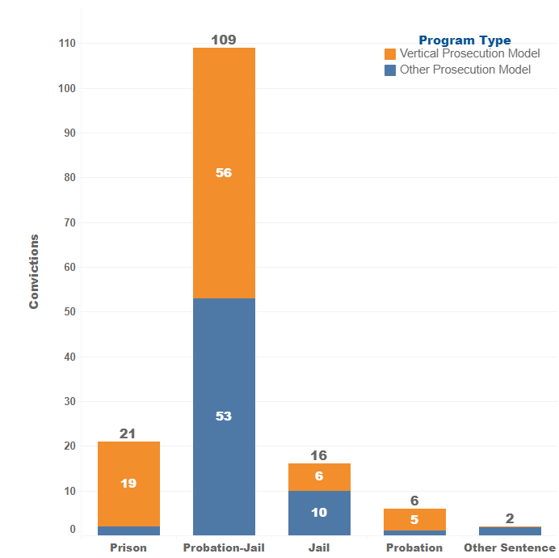
For organized retail theft crimes, of the 198 people who were convicted of at least one ORT charge (count) between April 1, 2024 and June 30, 2024 (Q3), grantees reported:
- 11 percent (n = 21) were sentenced to prison, 90 percent (n = 19) of which were obtained using the VP model.
- 55 percent (n = 109) were sentenced to probation with jail, 51 percent (n = 56) of which were obtained using the VP model.
- 8 percent (n = 16) were sentenced to jail, 38 percent (n = 6) of which were obtained using the VP model.
- 3 percent (n = 6) were sentenced to probation, 83 percent (n = 5) of which were obtained using the VP model.
- 1 percent (n = 2) received an unspecified sentence, none (n = 0) of which were obtained through the VP model.
Figure 4. Sentence type for people with ORT convictions in Q3.

Cumulatively, of the 467 people who were convicted of at least one ORT charge (count) between October 1, 2023 and June 30, 2024:
  - 16 percent (n = 74) were sentenced to prison, 47 percent (n = 35) of which were obtained using the VP model.
  - 59 percent (n = 275) were sentenced to probation with jail, 32 percent (n = 88) of which were obtained using the VP model.
  - 7 percent (n = 32) were sentenced to jail, 38 percent (n = 12) of which were obtained using the VP model.
  - 4 percent (n = 19) were sentenced to probation, 74 percent (n = 14) of which were obtained using the VP model.
  - 1 percent (n = 10) received an unspecified sentence, 30 percent (n = 3) of which were obtained using the VP model.

Offense Type for People Who Received an ORT Conviction
For organized retail theft crimes, of the 198 people who were convicted on at least one ORT charge (count) between April 1, 2024 and June 30, 2024 (Q3), grantee reported:
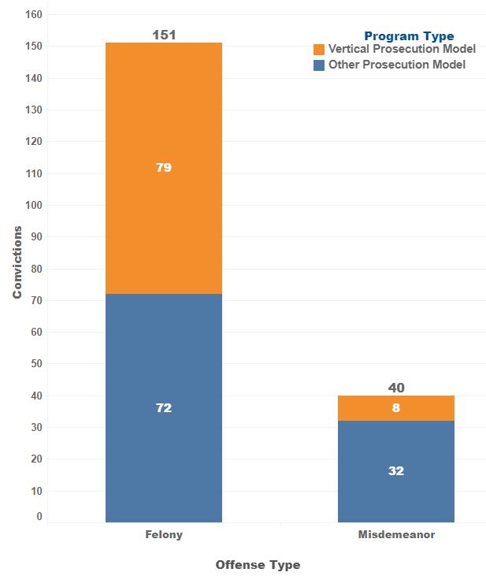
- 79 percent (n = 151) were convicted of a felony; 52 percent (n = 79) of which were obtained using the VP model.
- 21 percent (n = 40) were convicted of a misdemeanor, 20 percent (n = 8) of which were obtained using the VP model.

Cumulatively, of the 4676 people who were convicted of at least one ORT charge (count) between October 1, 2023 and June 30, 2024:
        - 75 percent (n = 348) were convicted of a felony; 39 percent (n = 134) of which were obtained using the VP model.
        - 22 percent (n = 105) were convicted of a misdemeanor, 19 percent (n = 20) of which were obtained using the VP model.

Figure 5. Offense type for people with ORT convictions in Q3.

Summary
In the first nine months of the 39-month grant service period, most grantees made substantial progress in project implementation activities including building partnerships, hiring and training of staff, and developing and implementing data collection procedures.
For Quarters 1, 2 and 3, 25,514 theft-related property crimes cases were filed, 2,134 of which were filed using the vertical prosecution model. These cases included a total of 49,379 charges (counts), 9,555 of which were filed using the vertical prosecution model. Overall, 25,397 people were charged, 2,230 of which were charged using the vertical prosecution model. Convictions were obtained for a total of 12,524 charges, 1,002 of which were obtained using the vertical prosecution model. Of the 10,176 unique people represented across these convictions, 786 were convicted using the vertical prosecution model.
For Quarters 1, 2 and 3, 1,325 organized retail theft cases were filed, 564 of which were filed using the vertical prosecution model. These cases included a total of 7,572 charges (counts), 4,794 of which were filed using the vertical prosecution model. Overall, 1,643 people were charged, 696 of which were charged using the vertical prosecution model. Convictions were obtained for a total of 598 charges, 235 of which were obtained using the vertical prosecution model. Of the 467 unique people represented across these convictions, 165 were convicted using the vertical prosecution model.
As these figures are representative of only the first nine months of the grant program, cases using the vertical prosecution model are anticipated to increase in the coming quarters. The next Quarterly Progress Report is due from grantees on November 15, 2024. Following BSCC’s review and subsequent analysis of the reports, updates regarding grantees’ progress and reported metrics will be made available on the grant webpage.

https://www.bscc.ca.gov/organized-retail-theft-vertical-prosecution-grant-program/
For reference, the reporting template is available at https://www.bscc.ca.gov/wp-content/uploads/2024/04/ORT-Vertical-Prosecution-QPR_Final-April-Release.docx. The data reporting guide with detailed reporting instructions and definitions is available at https://www.bscc.ca.gov/wp-content/uploads/2024/04/ORT-Vertical-Prosecution-Grantee-Data-Reporting-Guide_Final-April-Update.pdf.
Three grantees indicated using county-specific definitions. Differences compared to the BSCC definition are: One excludes PC Section 215 (carjacking); one specifies including PC Section 484 (petty theft) and 487 (grand theft), and the third includes PC Section 182 (criminal conspiracy).
Three grantees indicated using a county-specific definition. Differences compared to BSCC definition include the addition of: crimes committed alone and does not require proof beyond a reasonable doubt of intent to sell, exchange, or return the merchandise; an offender with repeated offenses and intent to sell stolen merchandise and encompass PC 211 (a theft using force), PC 490.4 (ORT can be prosecuted as a felony or misdemeanor) , PC 487 (grand theft over $950), PC 487(e) charges.
Conviction by Offense Type and Sentencing may occur in a later quarter than the current reporting period.
Conviction by Offense Type and Sentencing may occur in a later quarter than the current reporting period.
If a person received more than one conviction, grantees were instructed to classify the conviction type as a single instance of the highest level of conviction. If one person was convicted of a misdemeanor charge and a felony charge, they would be reported in the felony conviction category once.
https://www.bscc.ca.gov/organized-retail-theft-vertical-prosecution-grant-program/

