June 20, 2024

**Organized Retail Theft Vertical Prosecution Grant Program**

**Second Quarter Status Update (January to March 2024)**

**About the Grant Program**

The Organized Retail Theft (ORT) Vertical Prosecution Grant Program supports district attorneys in addressing increased levels of retail theft property crimes by using a vertical prosecution model. Vertical prosecution means a prosecutor is assigned to an ORT case from beginning to end (e.g., initial hearing/arraignment to sentencing). Under this model, victims, witnesses, and law enforcement officials have a single point of contact. In September 2023, a total amount of $24,868,293 in grant funds was awarded to 13 District Attorney’s Offices. The grant service period began on October 1, 2023. Detailed information about the grantees and their funding is available on the [grant webpage](https://www.bscc.ca.gov/organized-retail-theft-vertical-prosecution-grant-program/).[1]

In May 2024, grantees submitted their second Quarterly Progress Report to the BSCC reporting on grant activities that occurred between January 1, 2024, and March 31, 2024. This document summarizes the progress report information submitted by all 13 grantees.

**Project Implementation**

During the first six (6) months of a grant service period grantees are generally focused on project implementation activities necessary for an effective project start. The figure below summarizes the grantees’ status updates for four (4) project implementation activities during Quarter 2 (Q2).

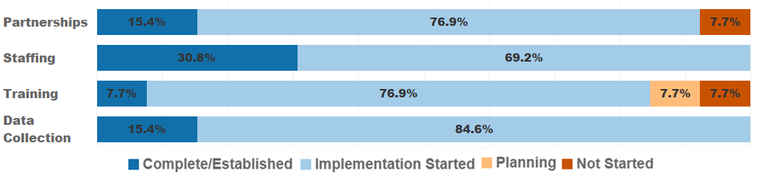

Figure 1. Project implementation status for Q2.

*Partnerships: Developing formal relationships with entities to support project goals.*

* 77 percent of grantees (*n* = 10) have started developing partnerships to support their project’s goals.
  + Grantees have established relationships with retailers (e.g., department, cosmetic, and convenience stores), neighboring county District Attorney’s Offices, and local law enforcement agencies to aid with identifying ORT cases, collecting evidence, and filing cases.
  + Regular meetings are held with partner law enforcement agencies and retailers to provide a platform to discuss ORT trends, store systems, efforts to decrease ORT, and share successful strategies other retailers have made to deter and prevent retail crime.
* 15 percent of grantees (*n* = 2) have established collaborative partnerships with major retailers and work directly with local police and other agencies who focus on ORT-related incidents.
* 8 percent of grantees (*n* = 1) have not yet begun establishing partnerships as staff are still being hired.

*Staffing: Hiring or retaining staff for the essential positions of the projects.*

* 69 percent of grantees (*n* = 9) have started recruitment, hiring and/or retaining of essential staff such as Deputy District Attorneys, District Attorney Investigators, and analysts.
  + Several positions are anticipated to be filled in Quarter 3, once lengthy background investigations have concluded.
  + Some grantees state they are unable to fill full-time positions yet, resulting in reassigning staff part-time to the VP unit who must also maintain their current caseloads.
  + The recruitment process is still ongoing for several grantees.
* 31 percent of grantees (*n* = 4) completed staffing, hiring the necessary Deputy District Attorneys, District Attorney Investigators, and other staff for their project.

*Training: Providing training to staff or external collaborators to support project goals.*

* 77 percent of grantees (*n =* 10) have started implementing the training provided to support their projects.
  + Grantees have conducted training(s) with retail partners to their bolster documentation to aid in prosecutions.
  + Grantees have conducted internal training(s) for new hires and ongoing training(s) for current staff.
  + External training sessions were attended across the state. Sessions were held with other counties, law enforcement, the California Highway Patrol (CHP) Regional ORT Task Force and the San Diego Organized Retail Crimes Association (SDORCA), regarding investigation techniques, use of diversion, retailer relations, legal procedures, report-writing, criminal prosecution procedures and court testimony.
* 8 percent of grantees (*n* = 1) are planning to host training(s) for law enforcement and retail partners regarding case documentation to enable successful prosecutions.
* 8 percent of grantees (*n* = 1) have completed their internally mandated organized retail crime training. They also host regional meetings to discuss filling guidelines, give case examples, and teach retailers and law enforcement agencies the type of information needed to be included in investigative reports.
* 8 percent of grantees (*n* = 1) have not started training as staff have yet to be hired.

*Data Collection: Systematic, ongoing data collection for progress reports and evaluation.*

* 85 percent of grantees (*n =* 11) started implementing data collection and evaluation processes for their projects.
  + Grantees are working with internal staff and evaluators to submit evaluation plans and progress reports.
  + Some grantees continued working with data and IT teams to refine case file tagging to ensure data is being appropriately categorized, modify current case management databases to meet data collection requirements, and provide reliable, accurate data. Others have obtained new reporting software to assist in extracting required metrics.
* 15 percent of grantees (*n =* 2) have completed their data collection systems and procedures. Evaluation staff will continue to monitor incoming data and produce reports documenting case trends.

**About the Collection of Theft-related and ORT Case Metrics**

The Quarterly Progress Report collects metrics for theft-related property crimes and organized retail theft crimes.[2] For both types of crimes, grantees may use the BSCC definition or a department specific definition. The BSCC definitions are:

* **Theft-related property crimes** include any crimes described in Chapter 5 of Title 13 of Part 1 of the Penal Code (PC, commencing with Section 484). In addition, theft-related property crimes include violations of PC Sections 211-215 (robbery, train robbery, and carjacking), 459 (burglary), and 459.5 (shoplifting). Theft-related property crime also includes ORT (PC Section 490.4). Seventy-seven (77) percent of the grantees (*n* = 10) report using the BSCC definition.[3]
* A case involving **organized retail theft crimes** can include multiple charges but at least one of the charges must be for PC Section 490.4 and a coparticipant does not have to be charged. ORT cases fall within the BSCC definition of theft-related property crimes and therefore counts of ORT cases using this definition are a subset of theft-related property crime cases. Ninety-two (92) percent of the grantees (*n* = 12) report using the BSCC definition.[4]

The metrics collected quarterly for both theft-related property crimes and organized retail theft crimes are listed below. Metrics for each are collected in total and then broken down to show the percent of which occurred used a vertical prosecution model. The data reported are for the county and are not attributed to a specific funding source. The metrics include:

* number of cases filed,
* number of charges within those cases,
* count of unique people within those cases,
* number of charges for which a conviction was obtained, and
* number of people associated with those convictions.

Theft-related property crimes are broad in nature and include a subset of organized retail theft crimes. All organized retail theft crimes are theft-related but not all theft-related crimes are considered organized retail theft. Prosecuting attorneys have the discretion to make a variety of important decisions at different stages of a case including whether to file charges, the types and number of different charges (counts) to include (which depend on the evidence available at the time of filing or anticipated to be available at the time of trial), whether to negotiate a plea bargain, and whether to take a case to trial. Factors that influence prosecutorial discretion include the availability and strength of evidence, the interests of the victim, the cost and complexity of the prosecution, and interests of justice. Given the discretionary nature of these prosecutorial decisions, we anticipate fewer discreet “organized retail theft” (i.e., Penal Code Section 490.4) convictions due to factors such as the higher burden of evidence required, the complexities involved in prosecuting organized crime, and the potential considerations of plea bargaining or prioritizing cases based on resource allocation and the broader interests of justice.

The metrics were also collected for the year prior to grant funding and are referred to as the baseline metrics. As these baseline metrics span a full year, once four quarters of metrics are available for the grant period, it will be possible to evaluate trends pre-grant funding and for the first year of grant funding. These trends may be influenced by both grant funding and any other state or local prosecution efforts. It is anticipated that these trends will be available in January 2025.

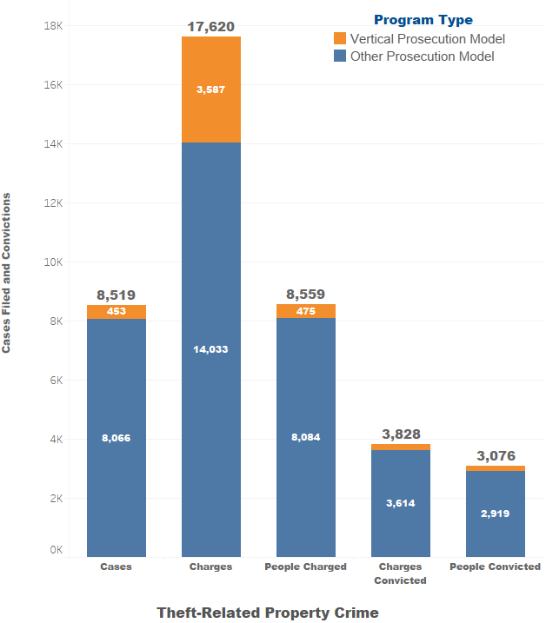**Metrics for Theft-related Property Crimes**

For theft-related property crimes, between January 1, 2024 and March 31, 2024 (Q2), grantees reported:

* 8,519 cases were filed, of which 5 percent (*n* = 453) used a vertical prosecution (VP) model. The cases included:
  + 17,620 charges (counts), of which 20 percent (*n* = 3,587) used a VP model.
  + 8,559 people were charged, of which 6 percent (*n* = 475) were charged using a VP model.
  + Convictions were obtained for 3,828 charges (counts), of which 6 percent (*n* = 214) were prosecuted using a VP model
  + 3,076 unique people were represented across these convictions, for which 5 percent (*n* = 157) a VP model was used.

Figure 2. Theft-related property crime metrics for Q2.

Cumulatively, for theft-related property crimes, between Quarters 1 and 2 (October 1, 2023 and March 31, 2024), grantees reported:

* 16,374 cases were filed, of which 10 percent (*n* = 1,600) used a VP model. Summarily, the cases included:
  + 32,397 charges (counts), of which 21 percent (*n* = 6,871) used a VP model.
  + 16,273 people were charged, of which 10 percent (*n* = 1,581) were charged using a VP model.
  + Convictions were obtained for 8,010 charges (counts), of which 9 percent (*n* = 708) were prosecuted using a VP model.
  + 6,318 unique people were represented across these convictions, for which 9 percent (*n* = 543) a VP model was used.

**Metrics for Organized Retail Theft Crimes**

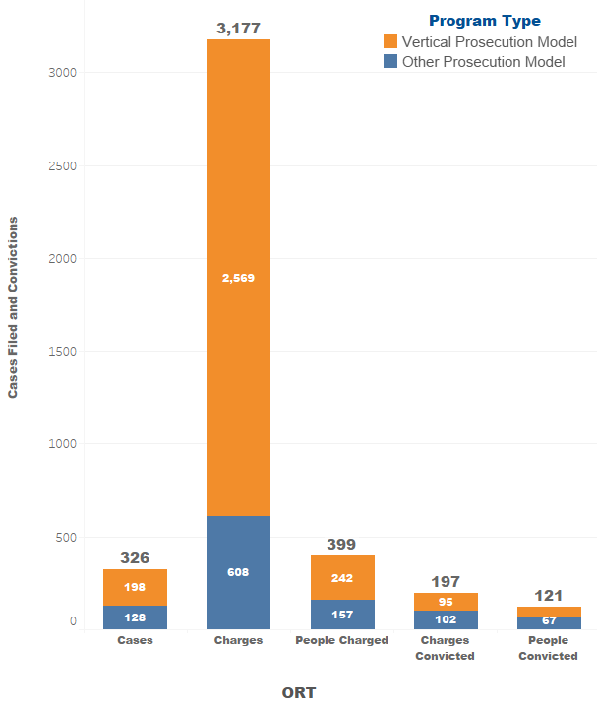For organized retail theft crimes, between January 1, 2024 and March 31, 2024 (Q2), grantees reported:

* 326 cases were filed, of which 61 percent (*n* = 198) used a VP model. The cases included:
  + 3,177 charges (counts), of which 81 percent (*n* = 2,569) used a VP model.
  + 399 people were charged, of which 61 percent (*n* = 242) used a VP model.
  + Convictions were obtained for 197 charges (counts), of which 48 percent (*n* = 95) were prosecuted using a VP model.
  + 121 unique people were represented across these convictions, of which 45 percent (*n* = 54) used a VP model.

Cumulatively, for organized retail theft crimes, between Quarters 1 and 2 (October 1, 2023 and March 31, 2024), grantees reported:

Figure 3. Organized retail theft crime metrics for Q2.

* 906 cases were filed, of which 34 percent (*n* = 306) used a VP model. Summarily, the cases included:
* 5,025 charges (counts), of which 60 percent (*n* = 3,002) used a VP model.
* 1,112 people were charged, of which 32 percent (*n* = 361) used a VP model.
  + Convictions were obtained for 386 charges (counts), of which 31 percent (*n* = 121) used a VP model.
  + 269 unique people were represented across these convictions, of which 25 percent (*n* = 67) used a VP model.

**Sentence Type for People Who Received an ORT Conviction**

For organized retail theft crimes, of the 121 people who were convicted of at least one ORT charge (count) between January 1, 2024 and March 31, 2024 (Q2), grantees reported:

* 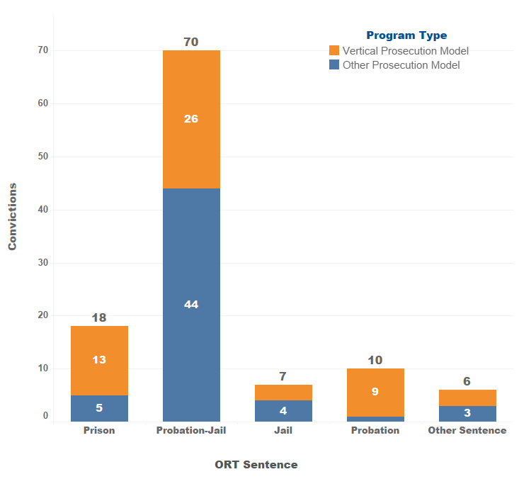15 percent (*n* = 18) were sentenced to prison, 72 percent (*n* = 13) of which were obtained using the VP model.
* 58 percent (*n* = 70) were sentenced to probation with jail, 37 percent (*n* = 26) of which were obtained using the VP model.
* 6 percent (*n* = 7) were sentenced to jail, 43 percent (*n* = 3) of which were obtained using the VP model.
* 8 percent (*n* = 10) were sentenced to probation, 90 percent (*n =* 9) of which were obtained using the VP model.
* 5 percent (*n* = 6) received an unspecified sentence, 50 percent (*n =* 3) of which were obtained through the VP model.

Cumulatively, of the 269 people who were convicted on at least one ORT charge (count) between October 1, 2023 and March 31, 2024:

Figure 4. Sentence type for people with ORT convictions in Q2.

* + 20 percent (*n* = 53) were sentenced to prison, 30 percent (*n* = 16) of which were obtained using the VP model.
  + 62 percent (*n* = 166) were sentenced to probation with jail, 19 percent (*n* = 32) of which were obtained using the VP model.
  + 6 percent (*n* = 16) were sentenced to jail, 38 percent (*n* = 6) of which were obtained using the VP model.
  + 5 percent (*n* = 13) were sentenced to probation, 69 percent (*n =* 9) of which were obtained using the VP model.
  + 3 percent (*n* = 8) received an unspecified sentence, 38 percent (*n =* 3) of which were obtained using the VP model.

**Offense Type for People Who Received an ORT Conviction**

For organized retail theft crimes, of the 121 people who were convicted on at least one ORT charge (count), 114[5] received an ORT Conviction during the between January 1, 2024 and March 31, 2024 (Q2)[6]:

* 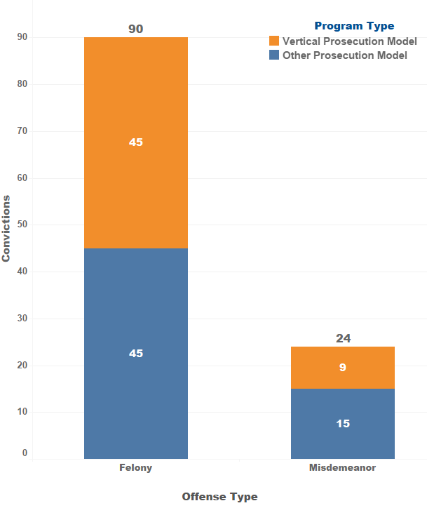79 percent (*n* = 90) were convicted of a felony; 50 percent (*n* = 45) of which were obtained using the VP model.
* 21 percent (*n* = 24) were convicted of a misdemeanor, 38 percent (*n* = 9) of which were obtained using the VP model.

Cumulatively, of the 262 people who were convicted on at least one ORT charge (count) between October 1, 2023 and March 31, 2024:

* + - * + 75 percent (*n* = 197) were convicted of a felony; 28 percent (*n* = 55) of which were obtained using the VP model.
        + 25 percent (*n* = 65) were convicted of a misdemeanor, 18 percent (*n* = 12) of which were obtained using the VP model.

Figure 5. Offense type for people with ORT convictions in Q2.

**Summary of Q1 and Q2**

In the first six months of the 39-month grant service period, most grantees made substantial progress in project implementation activities including building partnerships, hiring and training of staff, and developing and implementing data collection procedures.

For Quarters 1 and 2, 16,374 theft-related property crimes cases were filed, 1,600 of which were filed using the vertical prosecution model. These cases included a total of 32,397 charges (counts), 6,871 of which were filed using the vertical prosecution model. Overall, 16,273 people were charged, 1,581 of which were charged using the vertical prosecution model. Convictions were obtained for a total of 8,010 charges, 708 of which were obtained using the vertical prosecution model. Of the 6,318 unique people represented across these convictions, 543 were convicted using the vertical prosecution model.

For Quarters 1 and 2, 906 organized retail theft cases were filed, 306 of which were filed using the vertical prosecution model. These cases included a total of 5,025 charges (counts), 3,002 of which were filed using the vertical prosecution model. Overall, 1,112 people were charged, 361 of which were charged using the vertical prosecution model. Convictions were obtained for a total of 386 charges, 121 of which were obtained using the vertical prosecution model. Of the 269 unique people represented across these convictions, 67 were convicted using the vertical prosecution model.

As these figures are representative of only the first six months of the grant program, cases using the vertical prosecution model are anticipated to increase in the coming quarters. The next Quarterly Progress Report is due from grantees on August 15, 2024. Following BSCC’s review and subsequent analysis of the reports, updates regarding grantees’ progress and reported metrics will be made available on the [grant webpage](https://www.bscc.ca.gov/organized-retail-theft-vertical-prosecution-grant-program/).[7]

1. <https://www.bscc.ca.gov/organized-retail-theft-vertical-prosecution-grant-program/>
2. For reference, the reporting template is available at <https://www.bscc.ca.gov/wp-content/uploads/2024/04/ORT-Vertical-Prosecution-QPR_Final-April-Release.docx>. The data reporting guide with detailed reporting instructions and definitions is available at <https://www.bscc.ca.gov/wp-content/uploads/2024/04/ORT-Vertical-Prosecution-Grantee-Data-Reporting-Guide_Final-April-Update.pdf>.
3. Three grantees indicated using county-specific definitions. Differences compared to the BSCC definition are: One excludes PC Section 215 (carjacking); one specifies including PC Section 484 (petty theft) and 487 (grand theft), and the third includes PC Section 182 (criminal conspiracy).
4. One grantee indicated using a county-specific definition. Their definition is slightly expanded to include crimes committed alone and does not require proof beyond a reasonable doubt of intent to sell, exchange, or return the merchandise.
5. Conviction by Offense Type and Sentencing may occur in a later quarter than the current reporting period.
6. If a person received more than one conviction, grantees were instructed to classify the conviction type as a single instance of the highest level of conviction. If one person was convicted of a misdemeanor charge and a felony charge, they would be reported in the felony conviction category once.
7. https://www.bscc.ca.gov/organized-retail-theft-vertical-prosecution-grant-program/