**Organized Retail Theft**

**Vertical Prosecution Grant Program**

First Quarter Status Update (October to December 2023)

**About the Grant Program**

The Organized Retail Theft (ORT) Vertical Prosecution Grant Program supports district attorneys in addressing increased levels of retail theft property crimes by using a vertical prosecution model. Vertical prosecution means a prosecutor is assigned to an ORT case from beginning to end (e.g., initial hearing/arraignment to sentencing). Under this model, victims, witnesses, and law enforcement officials have a single point of contact. In September 2023, a total amount of $24,868,293 in grant funds was awarded to 13 District Attorney’s Offices. The grant service period began on October 1, 2023. Detailed information about the grantees and their funding is available on the [grant webpage](https://www.bscc.ca.gov/organized-retail-theft-vertical-prosecution-grant-program/).[1]

In March 2023, grantees submitted their first Quarterly Progress Report to the BSCC reporting on grant activities that occurred between October 1, 2023 and December 31, 2023. This document summarizes the progress report information submitted by all 13 grantees.

**Project Implementation**

During the first few months of a grant service period grantees are generally focused on project implementation activities necessary for an effective project start. The figure below summarizes the grantees status updates for four (4) project implementation activities.

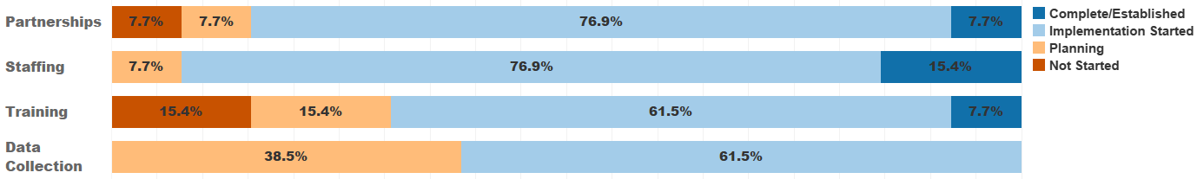

Figure 1. Project implementation status.

*Partnerships: Developing formal relationships with entities to support project goals.*

* 77 percent of grantees (*n* = 10) have started developing partnerships to support their project’s goals.
  + Grantees have established relationships with retailers (e.g., department, cosmetic, and convenience stores), neighboring county District Attorney’s Offices, and local law enforcement agencies to aid with identifying ORT cases, collecting evidence, and filing cases.
  + Regular meetings are held with partners to provide a platform to discuss ORT trends, store systems, and share information.
* 15 percent of grantees (*n* = 2) have yet to begin establishing partnerships as staff are still being hired.
* 8 percent of grantees (*n* = 1) have established collaborative partnerships with major retailers and other stakeholders to target fencing operations.

*Staffing: Hiring or retaining staff for the essential positions of the projects.*

* 77 percent of grantees (*n* = 10) have started hiring or retaining essential staff through recruitment and hiring of Deputy District Attorneys, Deputy District Investigators and analysts.
  + Lengthy background investigations, unit restructuring, staff reassignment and turnover challenges have delayed completion of staffing.
  + Some grantees reported that when vertical prosecutors are in court, their incoming cases must be reviewed by fellow attorneys to adequately respond to in-custody cases in a timely manner. Additional funding will be sought to supplement team staffing levels to accommodate the caseload.
* 15 percent of grantees (*n* = 2) completed staffing, hiring the necessary Deputy District Attorneys, District Attorney Investigators, and other staff for their project.

*Training: Providing training to staff or external collaborators to support project goals.*

* 62 percent of grantees (*n =* 8) have started implementing the training provided to support their projects. Grantees have conducted internal trainings and attended external training sessions with other counties, law enforcement, the California Highway Patrol (CHP) Regional ORT Task Force and the San Diego Organized Retail Crimes Association (SDORCA), regarding investigation techniques, use of diversion, retailer relations, legal procedures, report-writing, criminal prosecution procedures and court testimony.
* 15 percent of grantees (*n* = 2) are planning to host trainings for law enforcement and retail partners regarding case documentation to enable successful prosecutions. Grantees are evaluating available training opportunities that will benefit future staff.
* 15 percent or grantees (*n* = 2) have not started training as staff have yet to be hired.

*Data Collection: Systematic, ongoing data collection for progress reports and evaluation.*

* 62 percent of grantees (*n =* 8) started implementing data collection and evaluation process for their projects, working with internal staff and evaluators to streamline data collection for reporting requirements, develop their evaluation plans, and summarize their progress towards the projects’ goals and objectives.
* 38 percent of grantees (*n =* 5) were planning the next steps for their data collection and evaluation efforts.
  + Some grantees began working with data and IT teams to modify case management databases, reporting criteria, and tracking abilities to meet data collection requirements and provide reliable, accurate data.
  + Challenges with identifying and contracting with evaluators have caused delays in starting collaborative efforts and documenting local evaluation plans.

**About the Collection of Theft-related and ORT Case Metrics**

The Quarterly Progress Report collects metrics for theft-related property crimes and organized retail theft crimes.[2] For both types of crimes, grantees may use the BSCC definition or a department specific definition. The BSCC definitions are:

* **Theft-related property crimes** include any crimes described in Chapter 5 of Title 13 of Part 1 of the Penal Code (PC, commencing with Section 484). In addition, theft-related property crimes include violations of PC sections 211-215 (robbery, train robbery, and carjacking), 459 (burglary), and 459.5 (shoplifting). Theft-related property crime does include ORT (PC section 490.4). Seventy-seven (77) percent of the grantees (*n* = 10) report using the BSCC definition.[3]
* A case involving **organized retail theft crimes** can include multiple charges but at least one of the charges must be for PC section 490.4 and a coparticipant does not have to be charged. ORT cases do fall within the BSCC definition of theft-related property crimes and counts of ORT cases using this definition are therefore a subset of theft-related property crime cases. Ninety-two (92) percent of the grantees (*n* = 12) report using the BSCC definition. [4]

The metrics collected quarterly for both theft-related property crimes and organized retail theft crimes are listed below. Each is collected by the use of a vertical prosecution model and any other prosecution model. The data reported are for the county and are not attributed to a specific funding source.

* number of cases filed,
* number of charges within those cases,
* count of unique people within those cases,
* number of charges for which a conviction was obtained, and
* number of people associated with those convictions.

Theft-related property crimes are broad in nature and include a subset of organized retail theft crimes. All organized retail theft crimes are theft-related but not all theft-related crimes are considered organized retail theft. Prosecuting attorneys have the discretion to make a variety of important decisions at different stages of a case including whether to file charges, the types and number of different charges (counts) to include, which depend on the evidence available at the time of filing (or anticipated to be available at the time of trial), whether to negotiate a plea bargain, and whether to take a case to trial. Factors that influence prosecutorial discretion include the availability and strength of evidence, the interests of the victim, the cost and complexity of the prosecution, and interests of justice. Given the discretionary nature of these prosecutorial decisions, we anticipate fewer discreet “organized retail theft” (i.e., Penal Code section 490.4) convictions due to factors such as the higher burden of evidence required, the complexities involved in prosecuting organized crime, and the potential considerations of plea bargaining or prioritizing cases based on resource allocation and the broader interests of justice.

The metrics were also collected for the year prior to grant funding and are referred to as the baseline metrics. As these baseline metrics span a full year, once four quarters of metrics are available for the grant period, it will be possible to evaluate trends pre-grant funding and for the first year of grant funding. These trends may be influenced by both grant funding and any other state or local prosecution efforts. It is anticipated that these trends will be available in January 2025.

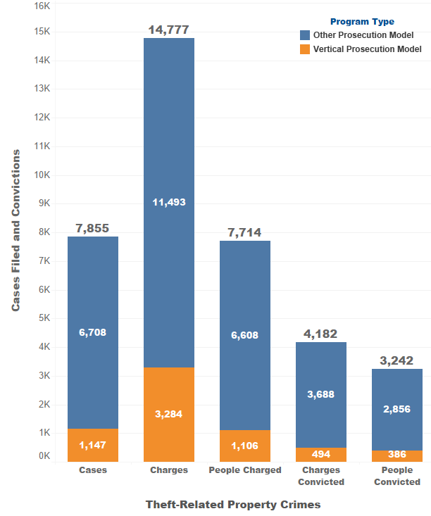

**Metrics for Theft-related Property Crimes**

For theft-related property crimes, between October 1, 2023 and December 31, 2023, grantees reported:

* 7,855 cases were filed, 15 percent (*n* = 1,147) with a vertical prosecution (VP) model. The cases included:
  + 14,777 charges (counts), 22 percent (*n* = 3,284) with a VP model.
  + 7,714 people charged, 14 percent (*n* = 1,106) with a VP model.
* Convictions were obtained for 4,182 charges (counts), 12 percent (*n* = 494) were prosecuted with a VP model.
* 3,242 unique people were represented across these convictions, 12 percent (*n* = 386) with a VP model.

Figure 2. Theft-related property crime metrics.

**Metrics for Organized Retail Theft Crimes**

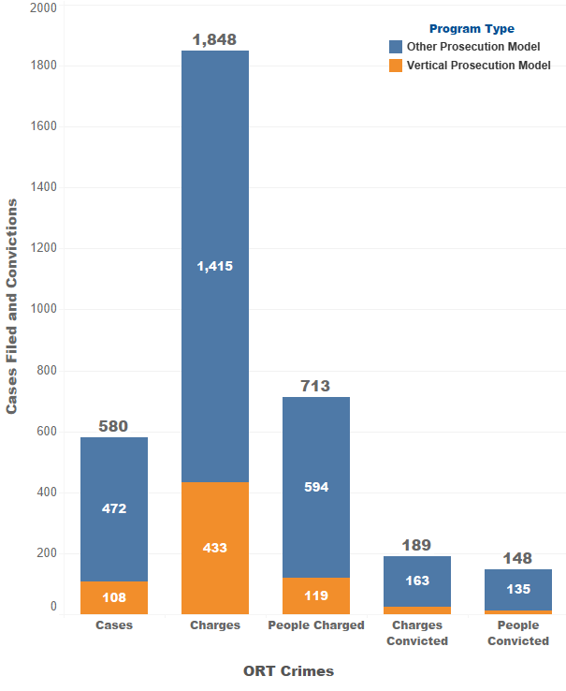For organized retail theft crimes, between October 1, 2023 and December 31, 2023, grantees reported:

* 580 cases were filed, 19 percent (*n* = 108) with a VP model. The cases included:
  + 1,848 charges (counts), 23 percent (*n* = 433) with a VP model.
  + 713 people were charged, 17 percent (*n* = 119) with a VP model.
* Convictions were obtained for 189 charges (counts), 14 percent (*n* = 26) were prosecuted with a VP model.
* 148 unique people were represented across these convictions, 9 percent (*n* = 13) with a VP model.

Figure 3. Organized retail theft crime metrics.

**Sentence Type for People Who Received an ORT Conviction**

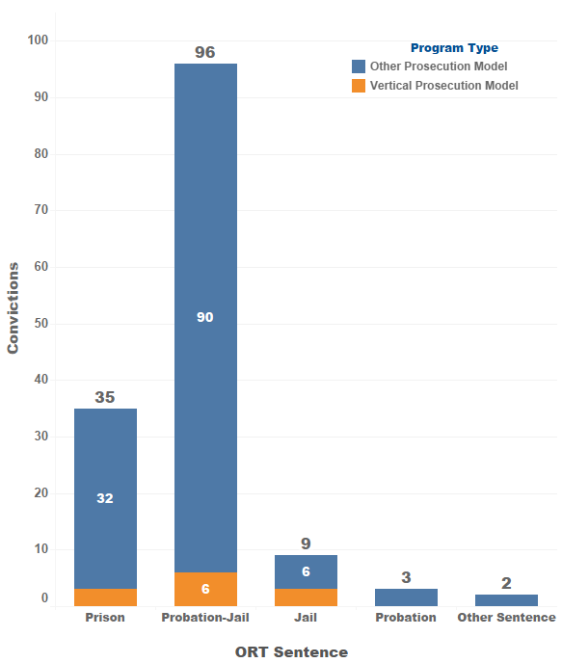Of the 148 people who were convicted on at least one ORT charge (count):

* 24 percent (*n* = 35) were sentenced to prison, 9 percent (*n* = 3) were obtained with the VP model.
* 66 percent (*n* = 96) were sentenced to probation with jail, 6 percent (*n* = 6) were obtained with the VP model.
* 6 percent (*n* = 9) were sentenced to jail, 33 percent (*n* = 3) were obtained with the VP model.
* 2 percent (*n* = 3) were sentenced to probation, all utilizing an alternative prosecution model.
* 1 percent (*n* = 2) received an unspecified sentence utilizing an alternative prosecution model.

Figure 4. Sentence type for people with ORT convictions.

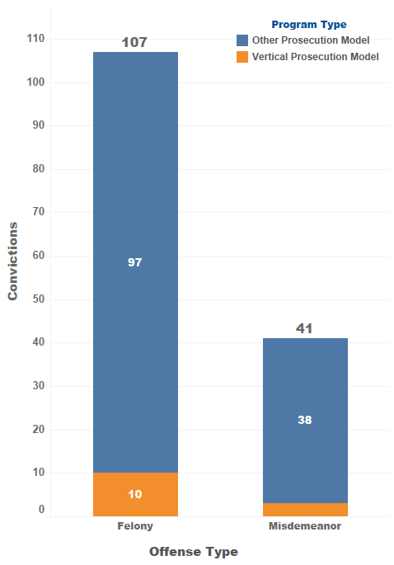**Offense Type for People Who Received an ORT Conviction**

Of the 148 people who were convicted on at least one ORT charge (count):[5]

* 72 percent (*n* = 107) were convicted of a felony; 9 percent (*n* = 10) with the VP model.
* 28 percent (*n* = 41) were convicted of a misdemeanor, 7 percent (*n* = 3) with the VP model.

Figure 5. Offense type for people with ORT convictions.

**Summary**

In the first three months of the 39-month grant service period, most grantees made substantial progress in project implementation activities including building partnerships; hiring and training of staff; and developing and implementing data collection procedures. Across the 13 grantees, 1,147 theft-related property crimes cases were filed using the vertical prosecution model. These cases included a total of 3,284 charges (counts) across 1,106 people. Convictions were obtained for 494 charges using the vertical prosecution model across 386 people. For organized retail theft crimes, 108 cases were filed using the vertical prosecution model. These cases included a total of 433 charges (counts) across 119 people. Convictions were obtained for 26 charges using the vertical prosecution model across 13 people. As these figures are representative of the first three months of the grant program, cases using the vertical prosecution model are anticipated to increase in the coming quarters. The next Quarterly Progress Report is due from grantees on May 15, 2024. Following BSCC’s review and subsequent analysis of the reports, updates regarding grantees’ progress and reported metrics will be made available on the [grant webpage](https://www.bscc.ca.gov/organized-retail-theft-vertical-prosecution-grant-program/).[6]

1. https://www.bscc.ca.gov/organized-retail-theft-vertical-prosecution-grant-program/
2. For reference, the reporting template is available at <https://www.bscc.ca.gov/wp-content/uploads/2024/03/ORT-Vertical-Prosecution-QPR_Final.-March2024.docx>. The data reporting guide with detailed reporting instructions and definitions is available at <https://www.bscc.ca.gov/wp-content/uploads/2024/03/ORT-Vertical-Prosecution-Grantee-Data-Reporting-Guide_Final-March-2024.pdf>.
3. Three grantees indicated using county-specific definitions. Differences compared to the BSSC definition are: One excludes PC section 215 (carjacking); one specifies including PC section 484 (petty theft) and 487 (grand theft), and the third includes PC section 182 (criminal conspiracy).
4. One grantee indicated using a county-specific definition. Their definition is slightly expanded to include crimes committed alone and does not require proof beyond a reasonable doubt of intent to sell, exchange, or return the merchandise.
5. If a person received more than one conviction, grantees were instructed to classify the conviction type as a single instance of the highest level of conviction. If one person was convicted of a misdemeanor charge and a felony charge, they would be reported in the felony conviction category once.
6. https://www.bscc.ca.gov/organized-retail-theft-vertical-prosecution-grant-program/