June 18, 2024

**Organized Retail Theft Prevention Grant Program**

**Second Quarter Status Update (January to March 2024)**

**About the Grant Program**

The Organized Retail Theft (ORT) Prevention Grant Program supports local law enforcement agencies in preventing and responding to organized retail theft, motor vehicle or motor vehicle accessory theft, or cargo theft. In September 2023, a total amount of $242,250,000 in grant funds was awarded to 38 grantees (31 city police departments and 7 county sheriff’s offices).[1] The grant service period began on October 1, 2023. Detailed information about the grantees and their funding is available on the [grant webpage](https://www.bscc.ca.gov/organized-retail-theft-grant-program/).[2]

In May 2024, grantees submitted their second Quarterly Progress Report to the BSCC reporting on grant activities that occurred between January 1, 2024, and March 31, 2024. This document summarizes the progress report information submitted by all 38 grantees.

**Project Implementation**

During the first six (6) months of a grant service period, grantees are generally focused on project implementation activities necessary for an effective project start. The figure below summarizes the grantees status updates for five (5) project implementation activities.

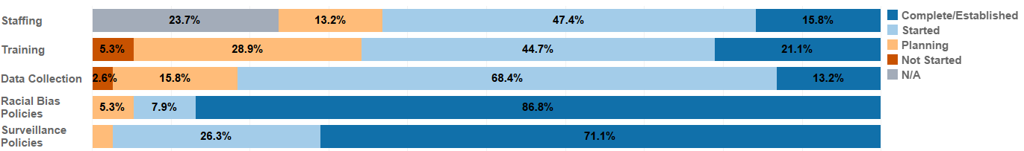

Figure 1. Project implementation status for Q2.

*Staffing: Hiring staff for the essential positions of the projects.*

* 47 percent of grantees (*n* = 18) began recruitment, interviewing and making tentative offers for positions within their departments. Once backgrounds and other personnel steps are completed, these staff will be assigned to grant-related tasks.
* 16 percent of grantees (*n* = 6) completed their planned hiring activities, including hiring analyst(s), detective(s), and staffing out task forces.
* 13 percent of grantees (*n* = 5) were in the planning stage on staffing activities. Job specifications were being developed or modified for sworn personnel, crime analysts and police aides. While some staff may have recently been hired, grantees are still developing plans to formally assign staff to grant-related activities once equipment is procured and put into operation.
* 24 percent of grantees (*n* = 9) are not hiring additional staff.

*Training: Providing training to staff to support project goals*.

* 45 percent of grantees (*n* = 17) began training staff to use new technology and equipment (e.g., drones, automated license plate readers, real time information center activities, etc.).
* 29 percent of grantees (*n* = 11) were in the planning stage of training activities. As new staff and equipment come on board, training needs are being identified, grantees are exploring available training options and coordinating with partners.
* 21 percent of grantees (*n* = 8) completed their planned training activities but continue to seek new opportunities.
* 5 percent of grantees (*n* = 2) have not started training. No personnel were assigned training due to the technology/equipment procurement process being in progress and staff vacancies had not yet been filled.

*Data Collection: Systematic, ongoing data collection for the progress reports and local evaluation.*

* 68 percent of grantees (*n* = 26) began implementation, with staff continuing to refine data collection procedures for internal and external reporting requirements as well as working with external evaluators to finalize evaluation standards and procedures and submit their local evaluation plans.
* 16 percent of grantees (*n* = 6) were in the planning stage for data collection.
  + Grantees report continual work on evaluating and establishing the best data resources and core areas to measure program effectiveness.
  + Some developed requests for proposals to procure evaluators who will be responsible for data collection, evaluation, reporting, and quality assurance.
* 13 percent of grantees (*n* = 5) have established their data collection systems. Contracts with external evaluators are finalized and oversight personnel, including crime analysts, are in place to monitor trends and share progress with patrol staff.
* 3 percent of grantees (*n* = 1) have not started because equipment and technology set to record incidents have not yet been installed and therefore cannot yet be monitored for trends.

*Racial Bias Policies: Policies or training to limit racial bias in the facilitation of project activities.*

* 87 percent of grantees (*n* = 33) already had established policies and/or training to limit racial bias.
  + These were included within existingpolicies and procedures and are followed by all department members and all partner agencies.
  + Training was provided for new hires; subsequent mandatory training sessions held as needed.
* 8 percent of grantees (*n =* 3) started establishing new policies and/or training to limit racial bias.
* 5 percent of grantees (*n* = 2) were in the planning stage with departments examining the potential need to update policies and training as new technologies were procured and implemented, as well as notifying staff of current departmental policies.

*Surveillance Policies: Policies or training to govern the use of surveillance technologies.*

* 71 percent of grantees (*n* = 27) already had established policies and training to govern the use of surveillance technologies.
  + These were included within existingpolicy and procedure manuals and are followed by all department members and all partner agencies.
  + Training was provided for recent hires and subsequent as-needed training sessions were held in support of the policies.
  + Policies and training were in accordance with privacy laws, focusing on automated license plate readers, closed-circuit television use, facial recognition, unmanned aerial systems (drones), public safety video surveillance systems, surveillance and undercover equipment, and guidance for the capture, storage, and use of digital data.
* 26 percent of grantees (*n* = 10) started establishing these policies and/or training. New policies are being developed by internal staff and discussions were held to examine the potential need to update policies and training as new technologies were put into operation. Once established, training will be held for all staff.
* 3 percent of grantees (*n* = 1) were in the planning stage. The grantee and their partners are reviewing a draft MOU that reflects data sharing, security and compliance.

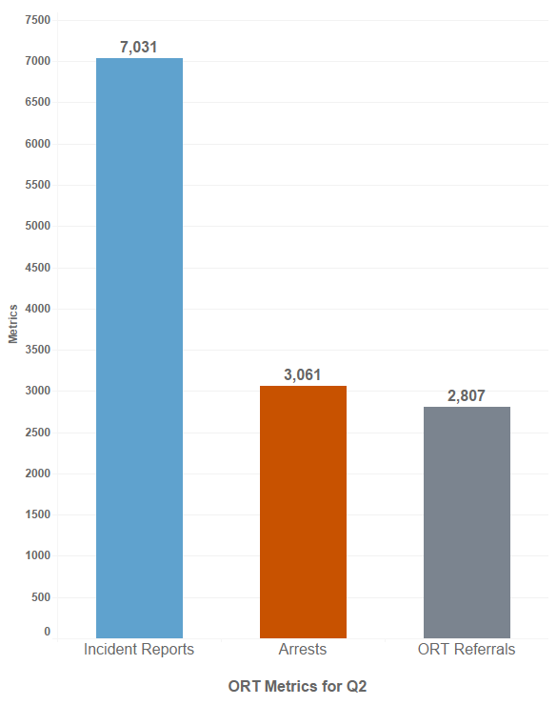

**Organized Retail Theft Metrics**

For organized retail theft, between January 1, 2024, and March 31, 2024, grantees reported:

* 7,031 ORT incidents.[3]
* 3,061 arrests related to ORT.
* 2,807 referrals to the District Attorney’s Offices for ORT prosecution.[4]
* Cumulatively, across Quarters 1 and 2:
  + 12,840 ORT incidents occurred.
  + 5,365 arrests related to ORT were made.
  + 4,520 referrals were made to the District Attorney’s Offices for ORT prosecution.4

Of the 3,061 arrests made related to ORT during Q2:

* 50 percent (*n* = 1,518) were attributed to three grantees – the Los Angeles County Sheriff’s Department (*n* = 594), the Daly City Police Department[5] (*n* = 468), and the San Francisco Police Department (*n* = 456).

Figure 2. Organized Retail Theft Prevention Metrics for Q2.

* 30 percent (*n* = 926) were attributed to the work of the San Jose Police Department (*n* = 330), the Sacramento County Sheriff’s Office (*n* = 243), the Fresno Police Department (*n* = 196), and the Bakersfield Police Department (*n* = 157).

**About the Collection of Incident, Arrest and Referral Metrics**

The relationship between arrests by law enforcement and referrals to the District Attorney’s Offices (DAs) for prosecution is complex. Once an arrest is made, law enforcement must conduct an investigation *prior to* referring a case for prosecution. The investigation, which includes the collection of evidence, witness interviews, victim statements, etc., takes a significant amount of time. For this reason, arrests are not always equal to or greater than the number of referrals for prosecution. Arrests made in one quarter may not be referred for prosecution until subsequent quarters. Similarly, an incident may occur in one quarter which prompts an investigation during the same quarter and, given the time to investigate, an arrest may not be made until a subsequent reporting period. Finally, not all incidents involve an arrest and not all arrests result in a referral for prosecution. An arrest may not lead to a referral for prosecution due to insufficient evidence or a variety of other factors at the local level.

Incident and arrest metrics are totals for the grantee (and any partner agencies). Incidents are known occurrences that are reported from a variety of sources, including from the public to dispatch, officer incident reports, etc. Arrests can be made by any officer on any assignment and therefore difficult to directly attribute to the ORT Prevention Grant Program. The number of referrals to DAs is collected by funding source (ORT Prevention Grant funds and other funding sources). For this document, the total of all referrals to District Attorney’s Offices for ORT prosecution was used to be consistent with the reporting of incident and arrest metrics.

The incident, arrest, and referral metrics were also collected for the year prior to grant funding and are referred to as the baseline metrics. As these baseline metrics span a full year, once four quarters of metrics are available for the grant period, it will be possible to evaluate trends in incidents, arrests, and referrals pre-grant funding and for the first year of grant funding. These trends may be influenced by both grant funding and any other state or local efforts to address ORT. It is anticipated that these trends will be available in January 2025.

**Motor Vehicle and Motor Vehicle Accessory Theft Metrics**

For motor vehicle and motor vehicle accessory theft (MVT/MVAT), between January 1, 2024, and March 31, 2024, grantees reported:

* 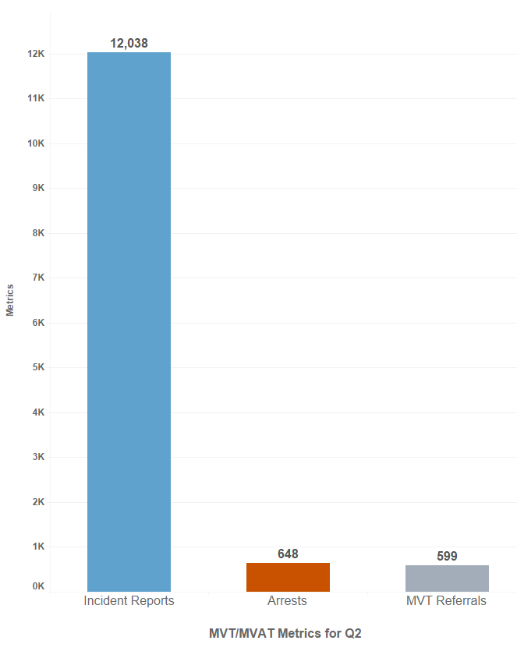12,038 MVT/MVAT incidents.
* 648 arrests related to MVT/MVAT.
* 599 referrals to the District Attorney’s Offices for MVT/MVAT prosecution.6
* Cumulatively, across Quarters 1 and 2:
* 17,614 MVT/MVAT incidents occurred.
* 1,389 arrests related to MVT/MVAT were made.
* 1,266 referrals were made to the District Attorney’s Offices for MVT/MVAT prosecution.[6]

Of the 648 arrests made related to MVT/MVAT:

* 53 percent (*n* = 343) were from the efforts of three grantees – the Fresno Police Department[7] (*n* = 164), the Bakersfield Police Department (*n* = 108), and the San Mateo County Sheriff’s Office (*n* = 71).
* 16 percent (*n* = 102) were attributed to the work of the Modesto Police Department (*n* = 35), the Salinas Police Department (*n* = 35), and the Daly City Police Department (*n* = 32).

Figure 3. Motor Vehicle and Motor Vehicle Accessory Theft Metrics for Q2.

**Cargo Theft Metrics**

For cargo theft, between January 1, 2024, and March 31, 2024, grantees reported:

* 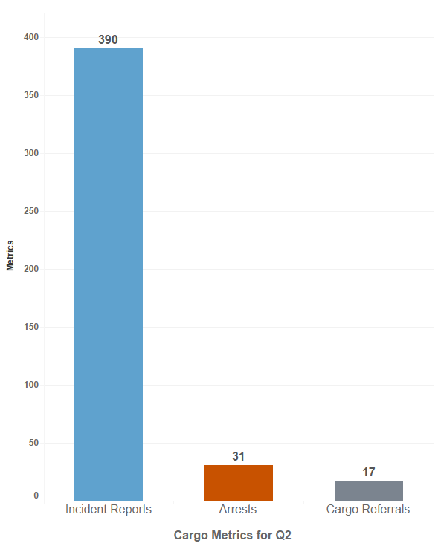390 cargo theft incidents.
* 31 arrests were made related to cargo theft.
* 17 referrals to the District Attorney’s Offices for prosecution.[8]
* Cumulatively, across Quarters 1 and 2:
  + 479 cargo incidents occurred.
  + 34 arrests related to cargo theft were made.
  + 26 referrals to the District Attorney’s Offices for cargo theft prosecution.8

Of the 31 arrests made related to cargo theft:

* 97 percent (*n =* 30) were from the efforts of three grantees – the Los Angeles Police Department (*n =* 14), the San Mateo County Sheriff’s Office (*n =* 10), and the Los Angeles County Sheriff’s Department (*n =* 6).
* 3 percent (*n =* 1) were from the efforts of the Anaheim Police Department.

Figure 4. Cargo Theft Metrics for Q2.

**Summary**

In the first six months of the 39-month grant service period, most grantees made substantial progress in project implementation activities including the hiring and training of staff; developing and implementing data collection procedures; and have or are establishing policies to limit racial bias in project activities and to govern the use of surveillance technologies. Across the 38 grantees, a total of **6,788 arrests** occurred related to ORT, MVT/MVAT, and cargo theft with **5,812 referrals** to District Attorney’s Offices for prosecution. The next Quarterly Progress Report is due from grantees on August 15, 2024. Following BSCC’s review and subsequent analysis of the reports, updates regarding grantees’ progress and reported metrics will be made available on the [grant webpage](https://www.bscc.ca.gov/organized-retail-theft-grant-program/).[9]

1. Three grantees are multi-agency partnerships: one police department with two partners, one police department with three partners, and a sheriff’s office with 13 partners.
2. https://www.bscc.ca.gov/organized-retail-theft-grant-program/
3. Incidents refer to known events or occurrences, including dispatch incident reports, officer incident reports, etc. The count includes incidents reported across all partners of the grant funded project.
4. Los Angeles Police Department referrals are excluded as the data is not available at this time.
5. Daly City Police Department is in a multi-agency partnership grant with San Bruno Police Department and San Mateo Police Department.
6. Los Angeles Police Department referrals are excluded as the data is not available at this time.
7. Fresno Police Department is in a multi-agency partnership grant with Clovis Police Department, Fresno County Probation Department, and Fresno County District Attorney's Office.
8. Los Angeles Police Department referrals are excluded as the data is not available at this time.
9. https://www.bscc.ca.gov/organized-retail-theft-grant-program/