March 26, 2024

**Organized Retail Theft Prevention Grant Program**

**First Quarter Status Update (October to December 2023)**

**About the Grant Program**

The Organized Retail Theft (ORT) Prevention Grant Program supports local law enforcement agencies in preventing and responding to organized retail theft, motor vehicle or motor vehicle accessory theft, or cargo theft. In September 2023, a total amount of $242,250,000 in grant funds was awarded to 38 grantees (31 city police departments and 7 county sheriff’s offices).[1] The grant service period began on October 1, 2023. Detailed information about the grantees and their funding is available on the [grant webpage](https://www.bscc.ca.gov/organized-retail-theft-grant-program/).[2]

In March 2023, grantees submitted their first Quarterly Progress Report to the BSCC reporting on grant activities that occurred between October 1, 2023 and December 31, 2023. This document summarizes the progress report information submitted by 37 grantees.[3]

**Project Implementation**

During the first few months of a grant service period grantees are generally focused on project implementation activities necessary for an effective project start. The figure below summarizes the grantees status updates for five (5) project implementation activities.

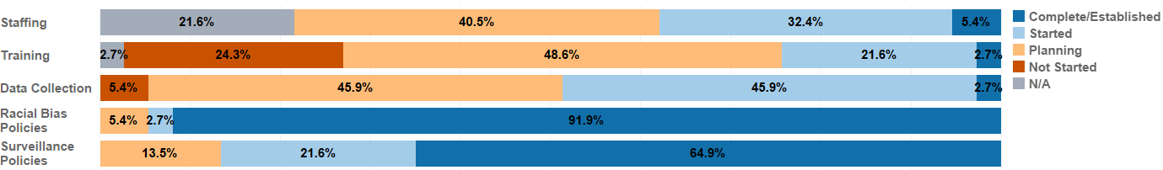

Figure 1. Project implementation status.

*Staffing: Hiring staff for the essential positions of the projects.*

* 41 percent of grantees (*n* = 15) were in the planning stage on staffing activities. Job specifications were being developed or modified for sworn personnel, crime analysts and detectives. Recruitment and advertisements for vacant positions are planned through June 2024.
* 32 percent of grantees (*n* = 12) began recruitment and hiring. However, background clearance takes a significant amount of time and some applicants have withdrawn from the process, causing delays in filling vacancies. Additionally, discussions of county-level budget cuts have impacted hiring.
* 22 percent of grantees (*n* = 8) are not hiring additional staff.

*Training: Providing training to staff to support project goals*.

* 49 percent of grantees (*n* = 18) were in the planning stage on training activities. As staff come on board, training needs are being identified and grantees are exploring available training options.
* 22 percent of grantees (*n* = 8) began training staff on the use of new technology and equipment (e.g., drones, automated license plate readers, etc.).
* 24 percent of grantees (*n* = 9) have not started training. No personnel were assigned training due to the technology/equipment procurement process being in progress and staff vacancies had not yet been filled.

*Data Collection: Systematic, ongoing data collection for the progress reports and local evaluation.*

* 46 percent of grantees (*n* = 17) were in the planning stage for data collection.
  + Grantees report working with external vendors, internal crime analysts and information technology staff to develop data collection tools and establish reporting parameters to ensure accurate data reporting.
  + Some developed requests for proposals to procure evaluators who will be responsible for data collection, evaluation, reporting, and quality assurance.
* 46 percent of grantees (*n* = 17) began implementation, with staff continuing to refine data collection procedures for internal and external reporting requirements as well as working with recently hired evaluators to develop local evaluation plans and evaluation standards and procedures.
* 5 percent of grantees (*n* = 2) have not started because of contractual and staffing challenges. Although, these grantees submitted the first progress report.

*Racial Bias Policies: Policies or training to limit racial bias in the facilitation of project activities.*

* 92 percent of grantees (*n* = 34) have established policies and/or training to limit racial bias.
  + For these grantees, policies were already established and were followed by all department members and all subgrantee agencies.
  + Training was provided for new hires; subsequent mandatory training sessions held as needed.
* 3 percent of grantees (n = 1) started establishing policies and/or training to limit racial bias.
* 5 percent of grantees (*n* = 2) were in the planning stage with departments examining the potential need to update policies and training as new technologies were procured and implemented.

*Surveillance Policies: Policies or training to govern the use of surveillance technologies.*

* 65 percent of grantees (*n* = 24) have established policies and training to govern the use of surveillance technologies.
  + These were already included within their existingpolicy and procedure manuals and are followed by all department members and all subgrantee agencies.
  + Training was provided for recent hires and subsequent as-needed training sessions were held in support of the policies.
  + Policies and training were in accordance with privacy laws, focusing on automated license plate readers, closed-circuit television use, facial recognition, unmanned aerial systems (drones), public safety video surveillance systems, surveillance and undercover equipment, and guidance for the capture, storage, and use of digital data.
* 22 percent of grantees (*n* = 8) started establishing these policies and/or training. New policies are being developed by internal staff and discussions were held to examine the potential need to update policies and training as new technologies were put into operation. Once established, training will be held for all staff.
* 14 percent of grantees (*n* = 5) were in the planning stage. Establishing commissions or work groups to develop policies and procedures for surveillance technologies were being planned for future quarters.

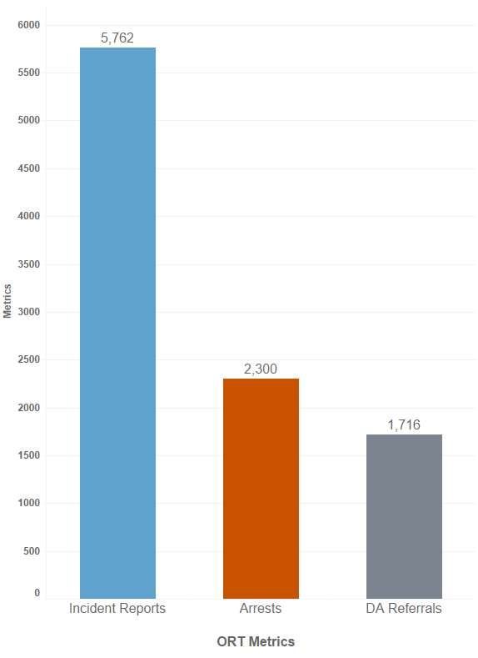

**Organized Retail Theft Metrics**

For organized retail theft, between October 1, 2023 and December 31, 2023, grantees reported:

* 5,762 ORT incidents.[4]
* 2,300 arrests related to ORT.
* 1,716 referrals to the District Attorney’s Offices for prosecution.

Of the 2,300 arrests made related to ORT:

* 48 percent (*n* = 1,102) were from the efforts of three grantees – Los Angeles County Sherriff’s Department (*n* = 448), San Francisco Police Department (*n* = 343), and the Sacramento County Sheriff’s Department (*n* = 311).
* 28 percent (*n* = 642) were attributed to the work of the Daly City Police Department[5] (*n* = 290), Modesto Police Department (*n* = 220), and the Bakersfield Police Department (*n* = 132).

Figure 2. Organized Retail Theft Prevention Metrics

**About the Collection of Incident, Arrest and Referral Metrics**

The relationship between arrests by law enforcement and referrals to the District Attorney’s Offices (DAs) for prosecution is complex. Once an arrest is made, law enforcement must conduct an investigation *prior to* referring a case for prosecution. The investigation, which includes the collection of evidence, witness interviews, victim statements, etc., takes a significant amount of time. For this reason, arrests are not always equal to or greater than the number of referrals for prosecution. Arrests made in one quarter may not be referred for prosecution until subsequent quarters. Similarly, an incident may occur in one quarter which prompts an investigation during the same quarter and, given the time to investigate, an arrest may not be made until a subsequent reporting period. Finally, not all incidents involve an arrest and not all arrests result in a referral for prosecution. An arrest may not lead to a referral for prosecution due to insufficient evidence or a variety of other factors at the local level.

Incident and arrest metrics are totals for the grantee (and any partner agencies). Incidents are known occurrences that are reported from a variety of sources, including from the public to dispatch, officer incident reports, etc. Arrests can be made by any officer on any assignment and therefore difficult to directly attribute to the ORT Prevention Grant Program. The number of referrals to DAs is collected by funding source (ORT Prevention Grant Fund and other funding sources). For this document, the total of all referrals to DAs was used to be consistent with the reporting of incident and arrest metrics.

The incident, arrest, and referral metrics were also collected for the year prior to grant funding and are referred to as the baseline metrics. As these baseline metrics span a full year, once four quarters of metrics are available for the grant period, it will be possible to evaluate trends in incidents, arrests, and referrals pre-grant funding and for the first year of grant funding. These trends may be influenced by both grant funding and any other state or local efforts to address ORT. It is anticipated that these trends will be available in January 2025.

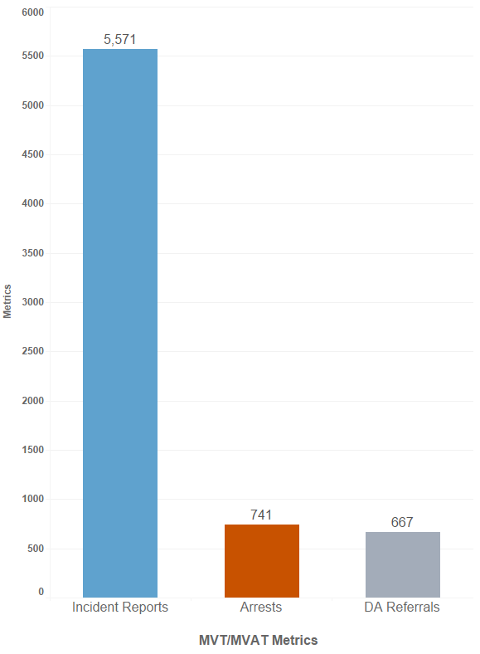**Motor Vehicle and Motor Vehicle Accessory Theft Metrics**

For motor vehicle and motor vehicle accessory theft (MVT/MVAT), between October 1, 2023 and December 31, 2023, grantees reported:

* 5,571 MVT/MVAT incidents.
* 741 arrests related to MVT/MVAT.
* 667 referrals to the District Attorney’s Offices for prosecution.

Of the 741 arrests made related to MVT/MVAT:

* 57 percent (*n* = 424) were from the efforts of three grantees – Fresno Police Department[6] (*n* = 224), Bakersfield Police Department (*n* = 110), and the Daly City Police Department (*n* = 90).
* 19 percent (*n* = 138) were attributed to the work of the National City Police Department (*n* = 51), Modesto Police Department (*n* = 50), and the Orange County Sheriff’s Department (*n* = 37).

Figure 3. Motor Vehicle and Motor Vehicle Accessory Theft Metrics

**Cargo Theft Metrics**

For cargo theft, between October 1, 2023 and December 31, 2023, grantees reported:

* 84 cargo theft incidents.
* 3 arrests related to cargo theft. These three arrests were reported by the Los Angeles County Sheriff’s Department.
* 9 referrals to the District Attorney’s Offices for prosecution.

**Summary**

In the first three months of the 39-month grant service period, most grantees made substantial progress in project implementation activities including the hiring and training of staff; developing and implementing data collection procedures; and have or are establishing policies to limit racial bias in project activities and polices to govern the use of surveillance technologies. Across the 37 grantees, a total of 3,044 arrests occurred related to ORT, MVT/MVAT, and cargo theft with 2,392 referrals to District Attorney’s Offices for prosecution. The next Quarterly Progress Report is due from grantees on May 15, 2024. Following BSCC’s review and subsequent analysis of the reports, updates regarding grantees’ progress and reported metrics will be made available on the [grant webpage](https://www.bscc.ca.gov/organized-retail-theft-grant-program/).[7]

1. Three grantees are multi-agency partnerships: one police department with two partners, one police department with three partners, and a sheriff’s office with 13 partners.
2. https://www.bscc.ca.gov/organized-retail-theft-grant-program/
3. Los Angeles Police Department was unable to submit the first progress report as scheduled due to data systems challenges that were still being resolved as of the release of this document.
4. Incidents refer to known events or occurrences, including dispatch incident reports, officer incident reports, etc. The count includes incidents reported across all partners of the grant funded project.
5. Daly City Police Department is in a multi-agency partnership grant with San Bruno Police Department and San Mateo Police Department.
6. Fresno Police Department is in a multi-agency partnership grant with Clovis Police Department, Fresno County Probation Department, and Fresno County District Attorney's Office.
7. https://www.bscc.ca.gov/organized-retail-theft-grant-program/