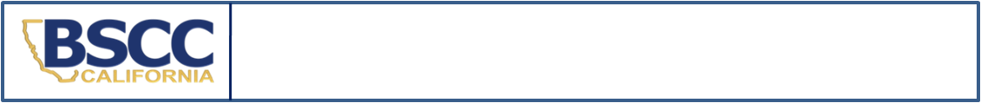
California Board of State and Community Corrections
2024 Status Offender and Non Offender Detention Report

- SEND IN A SEPARATE REPORT FOR EACH STATUS OFFENDER OR NON OFFENDER HELD IN DETENTION.
- SUBMIT REPORT BY THE 10TH OF THE MONTH FOLLOWING STATUS OFFENDER’S OR NON OFFENDER’S RELEASE.
SECTION A. Facility Information
Facility Name:
County:
SECTION B. Youth Information
Youth’s Name: | Gender: M F | Youth’s County ID#:
Intake Date (mm/dd/yy): | Intake Time (Please indicate if this time is AM or PM):
Detention Hearing Date (mm/dd/yy):  Indicate N/A if not applicable. | Detention Hearing Time:  (Please indicate if this time is AM or PM)
Release Date (mm/dd/yy): | Release Time (Please indicate if this time is AM or PM):
TOTAL TIME IN SECURE DETENTION:
Less than 24 Hours 24 Hours or More
SECTION C. Offense Information
Please Check Reason for Detention Below  Indicate Pre- or Post-Disposition at Right | Disposition  (CHECK ONLY ONE)
 | Pre-Disposition | Post-Disposition
Runaway
Indicate Residency: CA Resident Out-of-State Resident (Interstate Compact Filed? YES NO )
Truancy
Curfew
Beyond Control of Parents
Possession of Alcohol - B&P Code 25662(a)
Bench Warrant
Committed to Juvenile Hall (Found in Contempt of Court)  Court Date Court Time  **Attach a copy of the Minute Order specifying terms AND the Valid Court Order Checklist. Please submit separate form for each admission if youth is committed to several weekends. | N/A
Non Offender (indicate below which type of hold applies):
WIC §300 Dependent / Material Witness
SECTION D. Reporting Information
Name and Title of Reporting Person: | Phone: | Date:
Name and Title of Reporting Person: | E-Mail:
Name and Title of Facility Manager: | Phone: | Date:
Name and Title of Facility Manager: | E-Mail:

Submit completed form: |  | This form may be downloaded at https://www.bscc.ca.gov/s_fsoservices/  Questions: Contact the FSO Compliance Monitoring Analyst at analyst@bscc.ca.gov or (916)323-8621
email: | analyst@bscc.ca.gov
mail: | Board of State and Community Corrections
 | ATTN: FSO Report Analyst
 | 2590 Venture Oaks Way, Suite 200 Sacramento, CA 95833
Notice to Reporters: Beginning July 1, 2024, the Office of Youth and Community Restoration (OYCR) will assume responsibility for Compliance Monitoring of JH facilities. All forms and surveys must be submitted to OYCR after July 1, 2024. For updates and information please visit our website.

