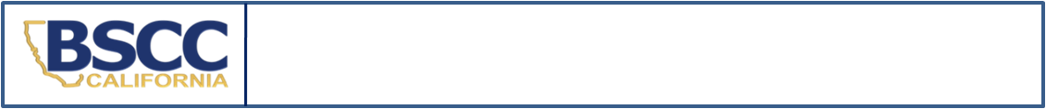
California Board of State and Community Corrections
REPORT ON THE DETENTION OF MINORS IN
COURT HOLDING FACILITIES - CALENDAR YEAR 2022

- SEND IN A SEPARATE REPORT FOR EACH MINOR DETAINED SECURELY OVER SIX (6) HOURS IN A COURT HOLDING FACILITY.
- SUBMIT REPORT BY THE 10TH OF THE MONTH FOLLOWING THE SIX (6) HOUR DETENTION VIOLATION.

SECTION I. Court Holding Facility Information
The “reporting agency” is the agency responsible for the Court Holding Facility. In some facilities minors are supervised by an agency (i.e. Probation) who is not the “reporting agency.” Please continue to work with your partners to establish and maintain a method of documenting the necessary information on minors held securely.
Reporting Agency Name:
Facility Name:
County:

SECTION II. Minor’s Information
The JJDPA prohibits the detention of delinquent minors over six (6) hours. Do not include time spent in the courtroom for trial or hearing. Calculate total time using only time spent in secure detention before and after the trial or hearing.
Name: | Gender: M F |  | County ID#:
TIME IN SECURE DETENTION
Court / Incident Date (m/d/yy):
Arrival Time (Indicate AM or PM): |  | Departure Time (Indicate AM or PM):
Total Time in SECURE Detention (do not include time in courtroom) :
Reason for SECURELY detaining minor for OVER six (6) hours (a reason MUST be provided):

SECTION III. Offense Information
Please Check Reason for Detention Below  Indicate Pre- or Post-Disposition at Right | Disposition  (CHECK ONLY ONE)
 | Pre-Disposition | Post-Disposition
Non Offender (indicate below which type of detention applies):
WIC §300 Dependent / Material Witness
Status Offender
Delinquent Offender
Other (explain):

SECTION IV. Contact Information
Name and Title of Reporting Person: | Phone: | Date:
Name and Title of Reporting Person: | E-Mail:
Name and Title of Facility Manager: | Phone: | Date:
Name and Title of Facility Manager: | E-Mail:

Submit completed form: |  | This form may be downloaded at https://www.bscc.ca.gov/s_fsoservices/
email: | analyst@bscc.ca.gov
fax: | (916) 322-2461
mail: | Board of State and Community Corrections
 | ATTN: FSO Report Analyst
 | 2590 Venture Oaks Way, Suite 200 | Questions? Contact the FSO Report Analyst at
 | Sacramento, CA 95833 | analyst@bscc.ca.gov or (916) 323-8621

