**Edward Byrne Memorial Justice Assistance Grant (JAG)**

**Executive Steering Committee**

**FINAL RATER REVIEW**

**Governors Inn Hotel**

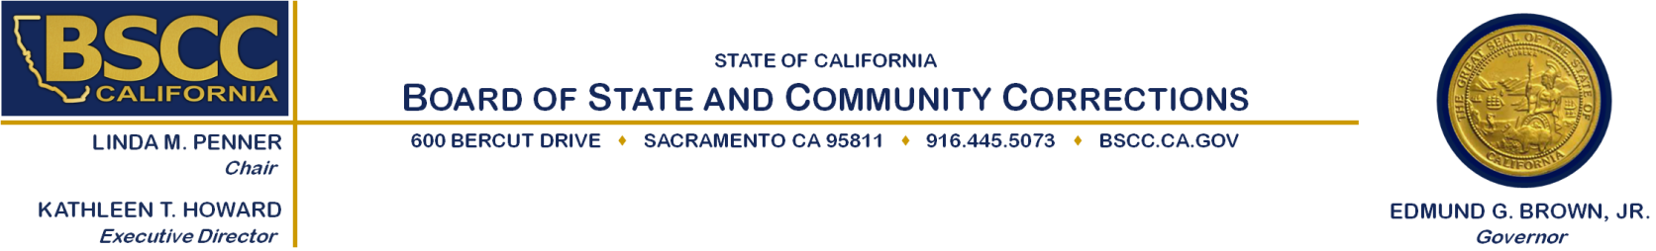**210 Richards Boulevard**

**Sacramento, CA 95811**

**January 30, 2015**

**10:00 a.m. to 4:00 p.m.**

**Agenda Items**

1. Meeting Called to Order: *Co-Chairs David Steinhart and Sheriff Dean Growdon*
2. Overview of the Rater Review Process: *BSCC Staff*
3. Break-Out into Rating Teams to Review and Discuss Scores: *BSCC Staff*

(Working Lunch)

1. Reconvene Full Group to Review Final Recommendations: *BSCC Staff*
2. Public Comment
3. Adjourn

**Note:** There will be an opportunity for public comment prior to any action taken by the committee.

Agenda items may be taken out of order.

**Meeting Contact Information:**

**Please contact Colleen Curtin at (916) 217-1636 or** [colleen.curtin@bscc.ca.gov](mailto:colleen.curtin@bscc.ca.gov) **for additional information about this notice, to submit written material regarding an agenda item or to request special accommodations for persons with disabilities. This agenda and additional information about the Board of State and Community Corrections may be found on our website at** [www.bscc.ca.gov](http://www.bscc.ca.gov).